

March 24, 2020

Dear Braille Readers,
During this year’s summer vacation, the National Federation of the Blind of Connecticut is honoring Betty Woodward by bringing back our “Braille Readers are Leaders” Contest. We hope you will participate.
Reading books can open up a world of adventure and discovery for you. If you wish, we are sure your parents, Braille teacher and/or librarian will help you select books and keep track of the number of pages read.
The enclosed application explains the rules and regulations. If you wish to participate, begin keeping track of the number of Braille pages that you read beginning July 1st. The contest ends on September 1st.
Have a wonderful summer, and we look forward to receiving your application by September 15th.

Sincerely,
Beth Rival,
Braille Readers are Leaders Contest Chairperson

111 Sheldon Road, Unit 420, Manchester, CT 06045
Tel: 860.289.1971 www.nfbct.org Maryanne Melley, President
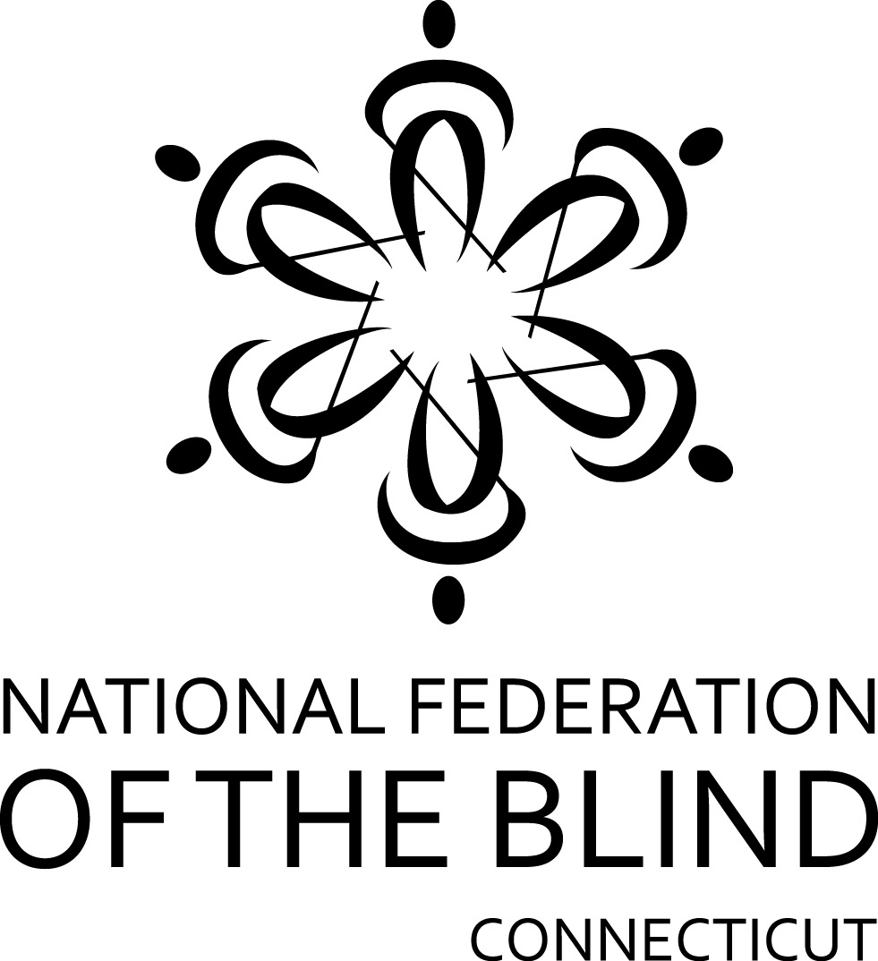
BRAILLE READERS ARE LEADERS CONTEST
Held In Loving Memory of Betty Woodward
July 1 to September 1
CONTEST ENTRY FORM

Student’s Name_______________________________________Age______Grade_______
Address________________________________City____________State______Zip_______
Parent’s Name___________________Home Phone _____________Work Phone_________
E-Mail Address_____________________________________________
Certifying Authority: Name____________________________________________________
Position: Parent [ ] Teacher [ ] Librarian [ ]
Address_________________________________City____________State____Zip________

Home Phone_____________________Work Phone________________________________
E-Mail Address___________________________________________
Category: (Check One)
[ ] Elementary School [ ] Middle School [ ] High School

BOOK/MAGAZINE LIST
Book Title/Magazine Article Author/Volume/Date Braille Pages Read

To the best of my knowledge, this student did read _________number of Braille pages between July 1 and September 1.
_________________________________________ ________________
Signature of Certifying Authority Date

Mail entries to, or for more information:
Braille Readers Are Leaders Contest
National Federation of the Blind of CT

111 Sheldon Road, Unit 420, Manchester, CT 06045
Tel: (860) 289-1971
PURPOSE OF CONTEST

The National Federation of the Blind of Connecticut is bringing back our Annual Braille Readers are Leaders Contest to honor our beloved Betty Woodward. Our goal is to encourage blind children to read more Braille. It is just as important for blind children to be literate as it is for sighted children. Good readers can have confidence in themselves and their abilities to learn and to adapt to new situations through their lives. Braille is a valuable alternative to print for the blind child. Yet, many blind children are graduating from our schools with poor Braille skills and low expectations for themselves as Braille readers. They do not know that Braille readers can be competitive with print readers. The NFB of CT’s Braille Readers Are Leaders Contest helps blind children realize that reading Braille is fun and rewarding. They discover that “Braille Readers Are Leaders”.

WHO CAN ENTER THE CONTEST
School age children from kindergarten through the twelfth grade are eligible to enter. A student will compete within his/her grade level category. The categories are: Elementary, Middle and High School age.

PRIZES FOR THE CONTEST
There will be one winner in each of 3 categories: high school, middle school & elementary school. The $250 prizes will be awarded at the annual National Federation of the Blind of Connecticut banquet of our state convention on October 31, 2020.

RULES FOR THE CONTEST
Winners will be chosen based on the number of Braille pages read. The contest entry form MUST be COMPLETELY filled out and received by the judges no later than September 15th. With their entry forms, contestants MUST submit a list of books and magazines they have read. Please use an extra page, if necessary.

CERTIFYING AUTHORITY
The Certifying Authority is responsible for:
- verifying that the student has actually read the Braille material that he or she reports reading and that the material was read between July 1 and September 1 (contestant may NOT count material read before the contest begins);
- completing and sending in the contest entry form in an accurate, complete and timely fashion.
Teachers, librarians and parents may serve as Certifying Authorities. The Certifying Authority must also be prepared to cooperate with the judges if the judges have any questions or need additional information about an entry.

All decisions of the judges are final.
Sponsored by the National Federation of the Blind of Connecticut

