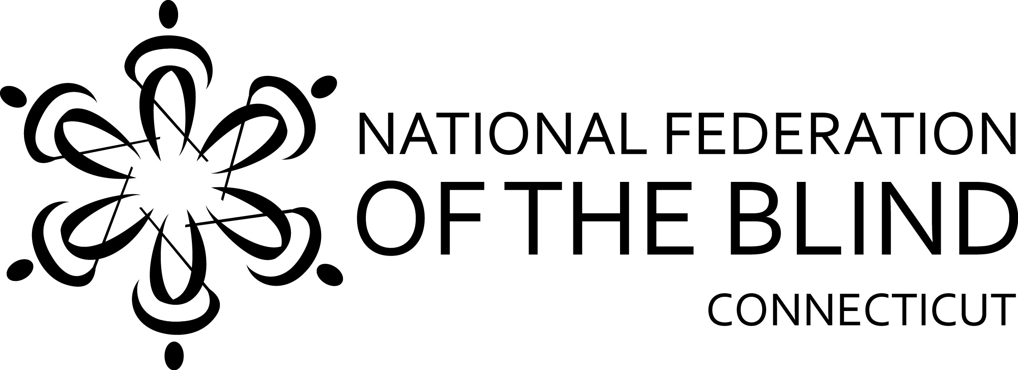

2020 ACADEMIC SCHOLARSHIP PROGRAM

The National Federation of the Blind of Connecticut (NFB of CT) is an organization dedicated to creating opportunities for all blind persons. In the furtherance of this goal, we have established our scholarship program. Recipients of NFB of CT scholarships need not be members of the National Federation of the Blind of Connecticut. NFB of CT scholarships are judged on the basis of academic quality, service to the community and financial need.

C. Rodney Demarest Memorial Scholarship, in the amount of $3000, is given in loving memory by his family and friends. Blind since 18, he ran his own business for many years, read NFB-Newsline® faithfully, was always well-informed and was admired by his many friends.

Additional scholarships will be offered if more funding becomes available

Eligibility
All applicants must be (a) legally blind, and (b) a Connecticut resident or attending school in Connecticut.

Deadline – Notification
Completed applications must be submitted by September 15, 2020. The scholarship committee will review all applications and notify winners during the second week of September. The scholarships will be presented at the banquet of the National Federation of the Blind of Connecticut State Convention. ANY WINNERS ARE REQUIRED TO ATTEND OUR VIRTUAL CONVENTION ON OCTOBER 31 & NOVEMBER 1, 2020, INCLUDING ANY CT ASSOCIATION OF BLIND STUDENTS ACTIVITIES.

2020 APPLICATION FORM

Please print or type clearly.

Applicant’s Name________________________________________________________
Permanent Address______________________________________________________
_________________________________Telephone_____________________________

Current Address (if different from above)_____________________________________
_________________________________Telephone_____________________________
E-mail address __________________________________________________________
Are you currently enrolled full-time ____ or part-time ____?
College/University Name & City_____________________________________________
Year of Study in 2020-21 _________________________________________________
List Institutions Previously Attended (High School and/or College)

Attach the following documents:
- Applicant’s Letter: Describe your career goals and how our scholarship might help you in achieving them. Give us a brief biographical sketch – tell us about your academic interests, your extracurricular activities, awards/honors you may have received and any community service you have been involved in. Also please describe your financial need.
- Two Letters of Recommendation: From teachers, professors, employers or other professionals who know you well.
- Certification of legal blindness, or letter from a treating physician confirming legal blindness
- Official academic transcripts: Post-secondary students should obtain transcripts from all colleges/universities attended.
- State Officer’s Letter: A letter from a state officer of the National Federation of the Blind of Connecticut confirming that you have discussed your application with him or her. Call our state office for help on this.

Applicant’s Signature_______________________________Date____________

Mail or email your completed application and/or address any questions to:
National Federation of the Blind of Connecticut
111 Sheldon Road, Unit 420, Manchester, CT 06045
(860) 289-1971
www.nfbct.org
info@nfbct.org

