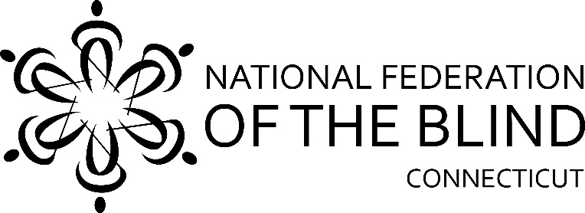
49th Annual
State Convention
The National Federation of the Blind of Connecticut will hold our 49th Annual State Convention on Saturday, October 31st and Sunday November 1st virtually for the first time due to COVID-19 for everyone’s safety.

We are happy to announce that Amy Ruell, a National Federation of the Blind Board Member, will be representing President Riccobono this year.

Saturday morning, our general session starts promptly at 9:00am. We will hear from National Representative Amy Ruell followed by a variety of inspiring speakers.

The Guide Dog Division will be held from 1:00pm-2:00pm

The Student Division will meet 2:00pm-5:00pm

Our Banquet will begin at 6:00pm. Our Master of Ceremonies Deb Reed will introduce National Representative Amy Ruell who will address our convention during the banquet Saturday evening. Also, Mary Silverberg will present Academic Scholarship Awards.

There will be a pumpkin contest. Decorate, paint, or carve a pumpkin for a chance to win! First place, $75.00, Second place, $50.00 and third place, $25.00. Everyone who enters must make a video description of their pumpkin that is no longer than one minute.

Sunday morning, at 9:00am we will have elections followed by our Annual Business Meeting. Elections will be held for the positions of President, 1st Vice President, 2nd Vice President, Treasurer, Secretary and two Board members. We will also vote on one change to our State Constitution, this change will be in the agenda for everyone to read the day before.

Enter to win a free convention weekend in 2021

For $20.00 you could be the lucky winner of free registration and two night stay at the hotel where we will be holding our 2021 50th State Convention. Pleaase make checks payable to NFB of CT or use PayPal Giving to enter. Checks should be mailed to; 111 Sheldon Road, Unit 420, Manchester, CT 06045

Registration Form

Name: ______________________________________________________
Address: _____________________________________________________
Phone: ______________________________________________________
E-mail: ______________________________________________________

Indicate how many will be attending the following:

Division meetings Saturday afternoon.
_____ CT Association of Guide Dog Users; _____ CT Association of Blind Student

______ I realize registration is free this year, but I am enclosing a donation to the NFB of CT. Send your check payable to the NFB of CT to: NFB of CT, 111 Sheldon Road, Unit 420, Manchester, CT 06045. Please make sure to use PayPal Giving if you choose to donate this way.

Registration deadline is October 2nd. There will be no late registrations accepted this year. We will be voting by phone. This system was used at the National Convention. Please make sure you have paid your dues by the time you register, or you will not be allowed to vote on Sunday.

Thank you,

Maryanne Melley,
President, National Federation of the Blind of Connecticut

