***YOU ARE CORDIALLY INVITED TO***

***THE NATIONAL ASSOCIATION OF BLIND MERCHANTS***

***IT’S 5:00 O’CLOCK SOMEWHERE HOLIDAY MIXER***

FRIDAY, DECEMBER 18, 2020

5:00 - 6:30pm (EST)

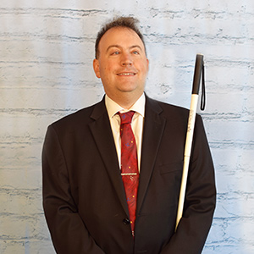

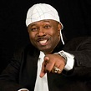

**Come join NABM President Nicky Gacos & Board Members in thanking our sponsors, supporters and loyal members as we gear up for new beginnings in 2021.**

**_______________________________________________**

**SPECIAL GUEST SPEAKERS**

**S**

**Mark Riccobono Lou George aka Bowlegged Lou of Full Force**

**President, National Federation of the Blind & Co-Star of the Movie Classic - House Party**

**Spread the word about this Fun-Filled Event!!!**

**Bring Your Favorite Spirited Drink for Our Special Holiday Toast.**

Join Zoom Meeting  
https://zoom.us/j/91085807266  
Meeting ID: 910 8580 7266  
One tap mobile  
+16468769923,,91085807266# US (New York)  
+13017158592,,91085807266# US (Washington D.C)

Dial by your location  
+1 646 876 9923 US (New York)  
+1 301 715 8592 US (Washington D.C)  
+1 312 626 6799 US (Chicago)  
 +1 408 638 0968 US (San Jose)  
+1 669 900 6833 US (San Jose)  
+1 253 215 8782 US (Tacoma)  
+1 346 248 7799 US (Houston)  
Meeting ID: 910 8580 7266

Join by Skype for Business  
<https://zoom.us/skype/91085807266>