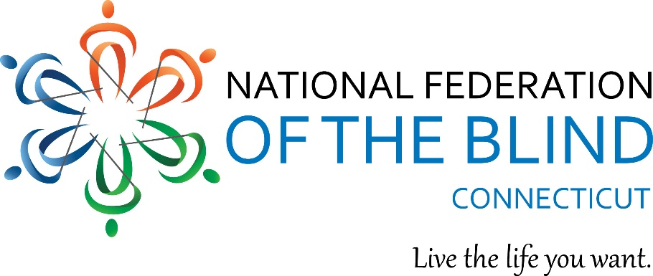

DATE: September 2, 2021 CONTACT: Maryanne Melley, President
860-212-5549

On October 29, 30 and 31, 2021, the members of the National Federation of the Blind of Connecticut are excited to hold our 50th Annual State Convention at the Sheraton Hartford South in Rocky Hill. We will also be on Zoom if meeting in person is not yet comfortable for you. If you are struggling with vision loss or know someone who is, please join us to learn more about living a full life with visual impairments. Come for the weekend or just for the day on Saturday!

For more information, visit our website at www.nfbct.org or contact Lucia Lee at our Outreach Office at 860-289-1971 or info@nfbct.org

111 Sheldon Road, Unit 420, Manchester, CT 06045
Tel: 860.289.1971 www.nfbct.org Maryanne Melley, President

