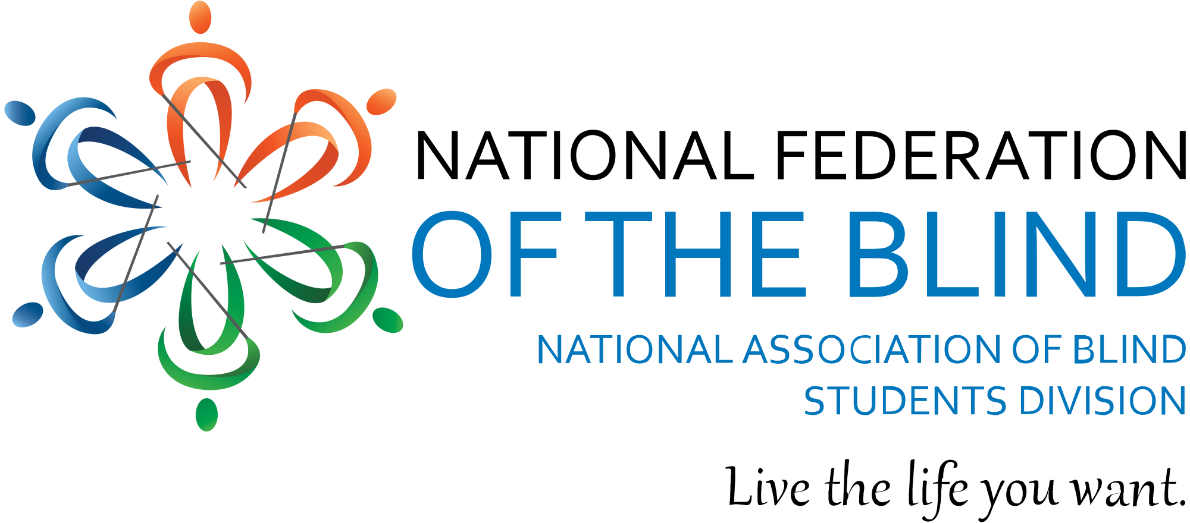

Blind Equality Achievement Month
Virtual Trivia Night Fundraiser

The month of October is recognized as Blind Equality Achievement Month, formally known as Meet the Blind Month, and is a celebration of the movement of the organized blind. Blind Equality Achievement Month, BEAM, is a time to commemorate the progress made towards advancing the position of blind people in society while working towards a future where all blind people are treated equally. The National Federation of the Blind is the largest advocacy organization comprised of blind people for blind people fighting to live the lives we want!

Join the National Association of Blind Students, a proud division of the National Federation of the Blind, on Saturday, October 16th at 8:00 pm Eastern for a fun night of trivia, fascinating facts about the organized blind movement, and participation prizes!

You won’t want to miss out on the event! Not only will you learn a lot and have loads of fun, but you can also support blind students in your very own state! The state that performs the best during trivia will be receiving a portion of the proceeds generated from the nationwide event!

The registration fee is a $5 donation to the National Association of Blind Students, and it makes you eligible for prizes at the event!

Not blind? Not a problem! This is an open event, and we would love to have as many people there as possible! So, invite your friends, family, and fellow trivia fanatics! The event will be a great way to learn about the National Federation of the Blind, have some fun in the process, and potentially win a prize!

Get more info at: https://nabslink.org/basic-page/blind-equality-achievement-month and sign up by Thursday, October 14th at 11:59 pm Eastern!

