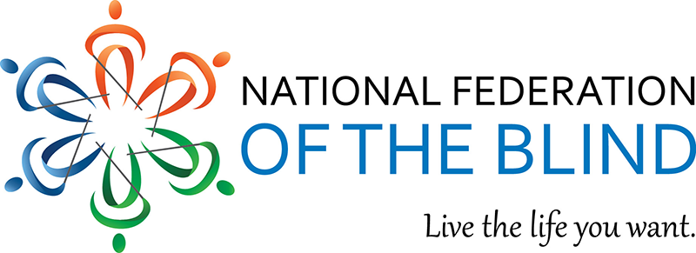

Membership Recruitment:
Open House Gathering Calls—Mini Tool Kit

We are offering quarterly open house gathering calls for prospective members to learn about becoming a member and the benefits of being one. We ask that affiliates, chapters, and divisions post to your social media and encourage people who may not yet know us to check us out! These calls are specifically for those who are not yet members. The membership team will connect anyone who signs up and attends the calls with their local affiliate and chapter.
The open house gathering calls are hosted by President Riccobono and other Federation leaders. Presentations about the Federation, who we are, and what we do are followed by an opportunity for participants to ask questions in a neutral and safe environment.

How to Use this Toolkit
In this mini toolkit you will find the dates for the rest of the calls for this year along with suggested dates to plug in social media posts to advertise the open house gathering calls. Additionally, we have provided sample social media posts for use across platforms. Make sure to change the dates as appropriate when posting to your platforms.
Let’s go build the National Federation of the Blind!

Dates for 2022 Open House gathering calls
Please note that the topics associated with each open house date listed below is not the title of each event. Instead, we hope it serves to help you to be mindful of events in our Federation calendar that can be used for vehicles of recruitment.
- Wednesday, February 23, 2022, at 8:00 p.m., eastern: post-2021/pre-scholarship
- Wednesday, April 27, 2022, at 8:00 p.m., eastern: post-scholarship and pre-convention season
- Wednesday August 31, 2022, at 8:00 p.m., eastern: post-national convention and pre-state convention seasons
- Wednesday November 2, 2022, at 8:00 p.m., eastern: following Blindness Equality Achievement Month and well into state convention season

Timeline for Advertising
The following are suggested timelines to promote the open house gathering calls.

Winter Open House Gathering Call
- Send out first announcement by February 2, 2022, to gather interest.
- Send out more information and reminder to sign up by February 9, 2022.
- Send out final reminder by February 16, 2022.

Spring Open House Gathering Call
- Send out first announcement by April 6, 2022, to gather interest.
- Send out more information and reminder to sign up by April 13, 2022.
- Send out final reminder by April 20, 2022.

Summer Open House Gathering Call
- Send out first announcement by August 10, 2022, to gather interest.
- Send out more information and reminder to sign up by August 17, 2022.
- Send out final reminder by August 24, 2022.

Fall Open House Gathering Call
- Send out first announcement by October 12, 2022, to gather interest.
- Send out more information and reminder to sign up by October 19, 2022.
- Send out final reminder by October 26, 2022.

Sample Posts
Here are several examples of content to share—simply copy and paste the content to the corresponding platform. Please be sure to check or update the dates as needed. Excluding the email content, each bullet point represents one post to share at a time. If you have questions, please reach out to Danielle McCann at mailto:dmccann@nfb.org.

Twitter Posts – choose one at a time
- Learn about becoming a member. Attend the open house gathering call on Wednesday, February 23, 2022, at 8:00 p.m., eastern with Federationists who will highlight the benefits of membership. Sign up by emailing membership@nfb.org.
- Not sure if attending a chapter meeting is right for you? Learn about the National Federation of the Blind on Wednesday, April 27, 2022 at 8:00 P.M. ET. Sign up by calling 410-659-9314 and ask to be registered for the open house gathering call.
- Are you curious about why it is beneficial to be a member of the National Federation of the Blind? Join our 1-hour long call on August 31 at 8:00 P.M. Eastern time. Sign up by going to https://nfb.org/form/open-house-gathering-call-regist?q=form%2Fopen-house-gathering-call-regist
- Have you been thinking about becoming a member of @NFB_Voice and need more information? Join an hour-long call on Wednesday, November 2, 2022, at 8:00 p.m., eastern and learn about the organized blind movement. Sign up by calling 410-659-9314.

Facebook Posts – choose one at a time
- Be a member of the movement. We are the transformative membership and advocacy organization of blind people. Join us for an open house gathering call to learn about becoming a member of the National Federation of the Blind. https://nfb.org/form/open-house-gathering-call-regist?q=form%2Fopen-house-gathering-call-regist
- Have you been curious about the National Federation of the Blind? Are you wondering if becoming a member is the right choice for you? Would you like an opportunity to have some of your questions answered by leaders in the Federation? If so, we would love to have you join us for an open house gathering call on Wednesday, February 23, 2022 at 8:00 p.m.,eastern time. Sign up by calling 410-659-9314 or emailing membership@nfb.org.

Email Content
Thank you for your interest in the National Federation of the Blind. Become a member of the organized blind movement. Attend an open house gathering call to learn why we need you and why you need us as well.
Wednesday, February 23, 2022 at 8:00 p.m., eastern
Wednesday, April 27, 2022 at 8 p.m., eastern
Wednesday, August 31, 2022 at 8 p.m., eastern
Wednesday, November 2, 2022 at 8:00 p.m., eastern

Choose a date that works best for you. Learn more about the Federation and why membership is crucial. Join the only organization that believes in the full capacity of blind people.
Our open house gathering calls are for individuals who are curious about the National Federation of the Blind. They offer opportunities for the following:
- meet our National President, Mark A. Riccobono
- receive information from and ask questions of other Federationists
- become informed about the benefits of membership
- dispel myths and misconceptions about the National Federation of the Blind

Sign up by going to
https://nfb.org/form/open-house-gathering-call-regist?q=form%2Fopen-house-gathering-call-regist
or by emailing membership@nfb.org or calling 410-659-9314. We look forward to your participation!
Thanks for your help in the success of the open house gathering calls. If you have ideas about how to find new members, please e-mail membership@nfb.org

