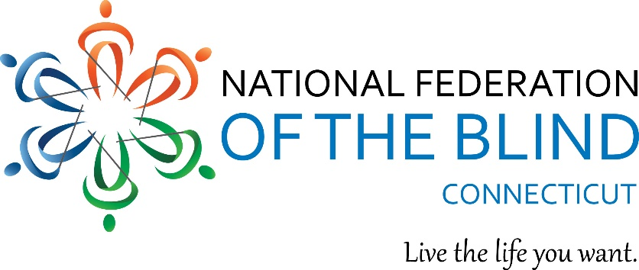

The National Federation of the Blind of Connecticut will be holding our free in-person NFB-BELL (Braille Enrichment for Literacy and Learning) Academy for blind and low vision children ages 4 – 12 who do not receive enough Braille and nonvisual instruction during the school year, could benefit from more Braille exposure during the summer and/or would enjoy connecting with blind role models. NFB BELL Academy in Connecticut will be a day program held in Berlin this summer, hopefully the week of August 8th through 12th.

Our Connecticut NFB BELL Academy provides children with Braille and nonvisual skills instruction through fun, hands-on learning activities. Participants will learn some vital independent living skills and interact with blind mentors. Our Academy will offer math, music, art, parachutes and much, much more. All materials will be supplied by the National Federation of the Blind of Connecticut. Our volunteers and teacher of the visually impaired have all had background checks.

We are looking forward to holding our summer program once again! If your child is interested in attending, please contact us as soon as possible by either calling 860-289-1971 or emailing info@nfbct.org.

111 Sheldon Road, Unit 420, Manchester, CT 06045
Tel: 860.289.1971 www.nfbct.org Maryanne Melley, President

