EYE DROP WEBINAR
On June 22, 2022, please join us as we discuss tips and techniques for blind eye drop users. Speakers will include experts from The Chicago Lighthouse and Accessible Pharmacy Services for the Blind.
This webinar will have a live ASL interpreter, and closed captioning.
If you are unable to attend, still be sure to register to receive access to the webinar audio and video straight to your inbox!

CLICK TO REGISTER
Speakers:
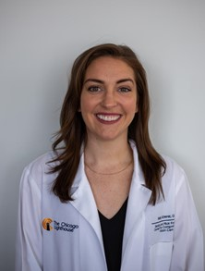
Dr. Kelly Scherer is a low vision optometrist and has served as the Director of Clinical Services at The Chicago Lighthouse for over 3 years. She is an adjunct clinical professor for three schools of optometry providing training for the next generation of low vision providers. She completed her doctorate at The New England College of Optometry and her residency at the Boston VA in Primary Care Optometry, Low Vision, and Traumatic Brain injury. She is active in her community volunteering in her free time.
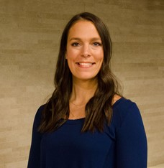
Laura Hayes is the Director of Occupational Therapy services at the Chicago Lighthouse. She has worked as a full-time occupational therapist in the clinic providing therapeutic services for individuals with visual impairments. She graduated with a Master of Science in Occupational Therapy from Boston University. She has over 11 years of experience providing care in the Low Vision Clinic and has lectured locally to universities, senior living buildings and OT professionals on topics of low vision rehabilitation, fall prevention, diabetic management and home modification. Laura earned an Executive Certificate in Home Modification (ECHM) from the USC Leonard Davis School of Gerontology as well as has experience working with adults with neurological disorders such as multiple sclerosis, stroke, and Parkinson’s disease at inpatient, outpatient and skilled nursing settings.

