***12th Annual Disability Resource Fair***

***In recognition of Disability Employment Awareness Month***

d o l.com/o d e p
Access to good jobs for all. national disability employment awareness month**October 25, 2024**  
**In-Person Event**

**9:00 am – 12:00 pm**

**Oak Hill’s** **NEAT (New England Assistive Technology) Building**

**33 Coventry St., Hartford, CT**

IDEAL FOR INDIVIDUALS WHO ARE:

• Unemployed or under - employed

• Transitioning from school to work or higher education

• Receiving Social Security Disability & are considering work

• Reliant on public transportation or needing public transportation information

• Interested in learning how assistive technology can help

• Unsure of your legal rights in the workplace

• Networking opportunities

* Exploring careers in Manufacturing, IT, Healthcare & Transportation/Distribution

**Presented By…**

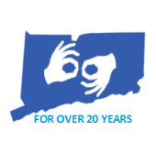

**LifeBridge will be providing American**

**Sign Language Interpreting for this event.**

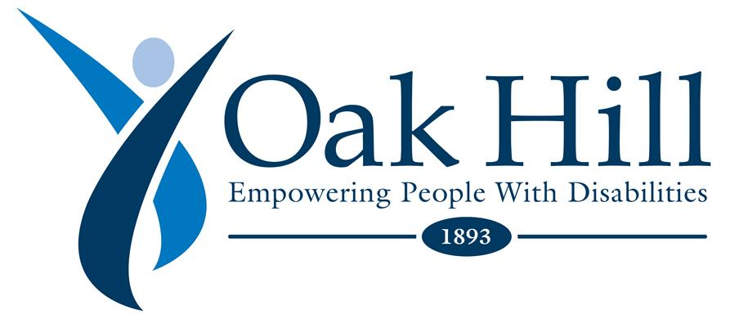

american job center 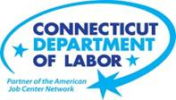  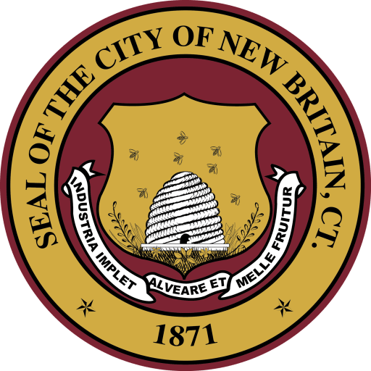 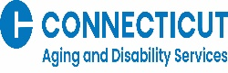  disability rights of Connecticut

**All are welcome to come & learn about North Central CT Resources**

If you need a reasonable accommodation, please contact Jill Larmett at

860-899-3446 or jlarmett@capitalworkforce.org

All are welcome to learn about the available resources in the North Central Region such as free employment services, transportation, legal rights, assistive technology, education & more!

***(Please let us know if you need an accommodation – 860-899-3446)***