**2024 53rd Annual State Convention  
November 1, 2, and 3, 2024**

**Courtyard by Marriott**

**780 Bridgeport Avenue**

**Shelton, CT 06484**

**Door Prizes: Door prizes will be awarded throughout the convention. To be eligible, you must be registered and be in the conference room when your name is drawn.**

**50/50 raffle tickets will be sold throughout the day and the winner will be announced at the end of the Banquet. There will also be a Basket Raffle. Be prepared to buy tickets to try and win your favorite Chapter Basket.**

**Guide Dog Relief Area: To get to the relief area from the elevators, take your first left and then your first right. Continue straight down the hall until you come to the outside door. There are no steps. Unfortunately, the only spot for the dogs to go is a thin strip of mulch on either side of the door. Fortunately, it is quite long. There is a trash receptacle on the right side before you come back inside. From our general meeting room, the door is on the left, just past where Lucia will be sitting. Please pick up after your dogs!!**

**Please remember some of our members and guests are allergic to scents. The best perfume or aftershave is none at all. Thank you.**

**We would like to thank our generous sponsors:**

**Platinum Sponsor:**

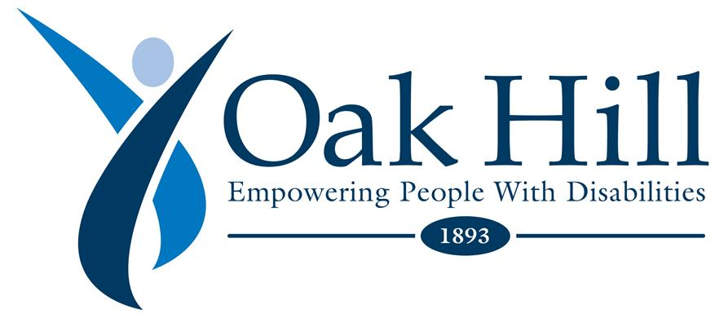[**www.oakhillct.org**](http://www.oakhillct.org)

**Vanda Pharmaceuticals**

**](file:///C:\Users\Lenovo\AppData\Local\Microsoft\Windows\INetCache\Content.Outlook\JZ83YE81\non-24.com)**

[**Non-24**](https://www.non-24.com)

**Gold Sponsor:**

**Achilles International**

**](file:///C:\Users\Lenovo\AppData\Local\Microsoft\Windows\INetCache\Content.Outlook\JZ83YE81\achillesinternational.org\connecticut)**

[**Achilles Connecticut**](https://www.achillesct.org)

**Silver Sponsor: Jim Cronin**

**President, South Fairfield County Chapter**

**National Representative: Chris Danielsen; Director of Public Relations National Federation of The Blind**

**President: Maryanne Melley  
National Federation of the Blind of Connecticut**

[**www.nfbct.org**](http://www.nfbCT.org)

**Facebook: National Federation of the Blind of Connecticut**

**Friday, November 1st, 2024**

**5:00p.m. to 6:00p.m.; Break out Session for all with Chris Danielson in the Ballroom.**

**5:30p.m.-6:00p.m. Breakout Session with Maryanne Melley for our blind members in the Ballroom.**

**5:30p.m. to 6:00p.m.; Breakout session in the Trumbull Room with Linda Melendez, President of the New Jersey Affiliate for our sighted members entitled “Blind at Heart.”**

**6:30p.m. – 10:00p.m.; We will be serving light food and have a have a social gathering in the Ballroom with a cash bar. Al Daniels and his band will be playing.**

**7:00p.m. – 9:00p.m.; The Vendor Fair will be taking place right outside the Ballroom in the hallway. Please take time to visit our vendors.**

**Vendors**

**Newsline – Deb and George Reed**

**CT Rides – Sarah Roy**

**Non 24 – Vicki Preddy**

**Achilles International – Erin Spaulding**

**BESB**

**WISH Radio**

**UR Community Cares – Michele Puzzo**

**Gigi Hamburgger – NFBCT Member**

**Saturday, November 2nd Convention Sessions**

**CTABS (Connecticut Association of Blind Students) will be held in the Fairfield Boardroom from 2:00p.m. to 3:30p.m.**

**CTAGDU (Connecticut Association of Guide Dog Users) will be held in the Trumbull Room from 3:30p.m. to 4:30p.m.**

**8:00a.m.- 9:00a.m. - Full Breakfast Buffet in the Ballroom. (This is not the hotel breakfast)**

**9:00a.m. - Call to order. Benediction by Ermi Feleke**

**9:05a.m. Pledge of Allegiance, NFB Pledge****.**

**I Pledge to participate actively in the efforts of the National Federation of the Blind to achieve equality, opportunity, and security for the blind; to support the policies and programs of the Federation; and to abide by its constitution.**

**9:10a.m. – Announcements; I would like to extend my sincere thanks to this years’ convention committee, Jim Cronin, Chair, Allison Arbuckle, Kristen Dockendorf, Marilyn Wenzel, Melissa Thompson, Gary Allen, and Marchele Davis. In addition, we need to thank our donation mailers. Charlie Rival, Cheri Duquette, Glenn Miller, Carol Lemieux, George Reed, Mary Silverberg, and Joe Kolczynski. Without all their work and dedication, we would not be in the strong financial position we are in.**

**Let us observe a moment of silence for Henrietta Bernal. She was a member of the Central Connecticut Chapter and was still working tirelessly for blind patients’ rights in hospitals when she passed away, and Ethel Demerest, one of our student scholarship donors for the past 20 years.**

**9:20a.m. – Jim Cronin; Nominating Committee Report**

**9:25a.m. – Chris Danielsen; National Report**

**9:55a.m. – Lauren Altman; National Association of Blind Students (NABS) Representative**

**10:10a.m. - Maryanne Melley; President’s Report**

**10:20a.m. – Linda Melendez Fit Break**

**10:25a.m. - Mike Whilby; Disability Rights Connecticut**

**10:45a.m. – Hear from our Harlow Grant and NFB of CT Technology Grant Winners**

**10:55a.m. – Vicki Preddy: Vanda Pharmaceuticals, NON 24**

**11:05a.m. – Matt Geeza; CT Library for Accessible Books**

**11:15a.m. – Paul Schroeder; American Printing House for the Blind**

**11:30a.m. – Carol Jenkins; Bureau of Education & Services for the Blind**

**11:45a.m. – Jeffrey Rumpf; Pegasus Therapy Horses**

**12:00p.m.- 1:00p.m. - Break for lunch**

**1:00p.m. - Kristen Sims; NFB Education Centers and opportunities at our Professional Development and Research Institute on Blindness**

**1:15p.m. - Jaclyn Pinney, Executive Director; Independence Unlimited**

**1:30p.m. – Amy Donaldson; Connecticut Tech Act**

**1:45p.m. – Carolyn Dodd, Deb Reed, and Johnston Cheong; What has the NFB Done for Me**

**2:15p.m. - Linda Melendez; Fit Break**

**2:20p.m. - Melissa Thompson; Rideshare Rally Update**

**2:35p.m. – Michele Puzzo; Ur Community Cares**

**2:50p.m. – Allison Arbuckle and Delores Roman; Our First National Convention**

**3:05p.m. – Mary Silverberg; Legislative Initiatives**

**Belief Message**

**The National Federation of the Blind advances the lives of its members and all blind people in the United States. We know that blindness is not the characteristic that defines you or your future. Every day we raise the expectations of blind people, because low expectations create obstacles between blind people and our dreams. Our collective power, determination, and diversity achieve the aspirations of all blind people.**

**4:00 - 6:00p.m. - Break**

**6:00 p.m. - Banquet Dinner, Ballroom**

**Invocation; Pastor Jack Richards**

**Master of Ceremonies; Melissa Thompson**

**Keynote Address; Chris Danielsen**

**Presentation of 2024 Scholarships; Mary Silverberg, Nathanael Wales, Beth Rival**

**Jan Feyen**

**Mia Giantonio**

**Scholarships: Steve Famiglietti Memorial Scholarship**

**C. Rodney Demarest Memorial Scholarship**

**Zukowski Family Foundation Scholarship**

**Sunday, November1, 2024**

**8:00a.m.-9:00a.m. Breakfast**

**9:00a.m. - Call to order; Business Meeting**

**Roll Call**

**NFB Pledge**

**Reports:**

**Reading of 2023 Business Meeting Minutes: Charlie Rival, vote on acceptance.**

**Treasurers Report: Cheri Duquette; vote on report.**

**ABPVI (Advisory Board Persons with Visual Impairments): Beth Rival**

**SRC (State Rehabilitation Council): Deb Reed**

**BCAC (Bureau Consumer Advocacy Committee): Melissa Thompson**

**New Business:**

**New Editor for The Federationist**

**New Members for Convention Committee**

**Birdies for Charity: Mary Silverberg**

**Washington Seminar Appointments: Mary Silverberg and Joe Kolczynski**

**Vote on Grant/Travel Expense Amount for Washington Seminar: Maryanne Melley**

**Location for our 2025 State Convention**

**January Board Meeting, where and when?**

**Chapter News**

**Elections; Chris Danielsen, Moderator**

**Any member nominated from the floor should have already agreed to serve prior to this convention.**

**Nominees from the committee and from the floor will have one minute to state why they feel the affiliate should vote for them. The one-minute time will be strictly enforced.**

**Maryanne Melley; President**

**Nathanael Wales; 1st Vice President**

**Mary Silverberg; 2nd Vice President**

**Cheri Duquette; Treasurer**

**Becky Ireland; Secretary**

**Deb Reed; Board Member**

**Beth Rival; Board Member**