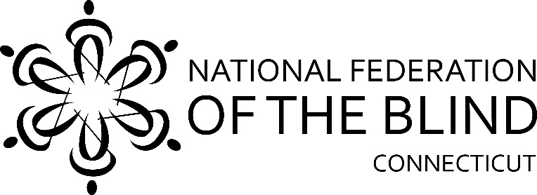

**54th Annual State Convention!!**

**November 7, 8, and 9 2025**

**The National Federation of the Blind of Connecticut will hold our 54th Annual State Convention on Friday, Saturday, and Sunday, November 7, 8, and 9 2025** at the **Hartford Sheraton South, 100 Capital Boulevard, Rocky Hill, CT 06067**. Rooms will be available for Friday and Saturday nights for a convention discounted rate of $119.00 plus tax, per night. **To reserve a room, call the Sheraton at 860-257-6000 and use our group code National Federation of the Blind.** **The deadline for reserving a room for the convention is October 23, 2025.**

Friday night dinner will be available at the hotel restaurant .We will be holding our Vendor Fair on Friday evening from 7:00pm to 9:00pm. There will also be a live auction.

On Saturday morning, a full breakfast buffet will be served at 8:00am followed by our general session which starts promptly at 9:30am. We will hear from our National Representative National Board Member Marilyn Green, Affiliate President Maryanne Melley, and a variety of innovative speakers.

Lunch will be served from 12:30p.m.-1:30p.m. Speakers will continue after lunch. The CT Association of Guide Dog Users meeting will be held from 3:00pm to 4:00pm in the Hartford room.

Our Banquet will begin at 6:00pm. All members must purchase a ticket to enter the room. There will be no exceptions. National Representative Marilyn Green will address our convention during the banquet Saturday evening. Also, we will present Academic Scholarship Awards. At the conclusion of the please join us for karaoke!

We will, of course, have our 50/50 and basket raffles!

On Sunday morning at 8:00am, a full breakfast buffet will be served before our 9:00am Annual Business Meeting. We will elect two board positions.

**The National Federation of the Blind of Connecticut acknowledges**

**With gratitude our convention sponsors are listed below:**

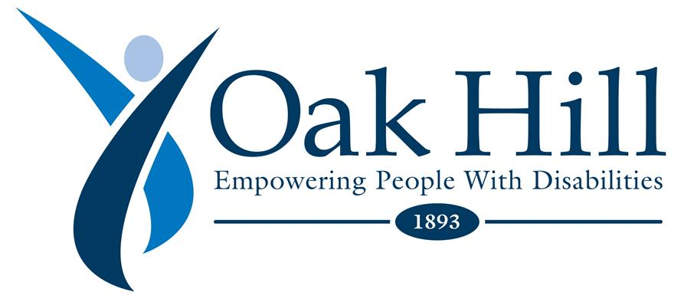

**Vanda Pharmaceuticals**

**](file:///C:\Users\Lenovo\AppData\Local\Microsoft\Windows\INetCache\Content.Outlook\JZ83YE81\non-24.com)**

[**Non-24**](https://www.non-24.com)

Retina Consultants

The Cronin Family

**Registration Form**

Attendees who register at the door will be charged an additional $10. Please note that online registrations will be available at [www.nfbct.org](http://www.nfbct.org), following the link to State Convention information.

**Name**:

**Address**:

**Phone**:

**E-mail**:

**Indicate how many will be attending the following:**

**Division meeting Saturday Afternoon**

_____ **State Convention Registration Fee: $25 per person**

**Meals:**

Saturday & Sunday breakfasts, Saturday lunch, and banquet dinner. This includes the registration fee and represents a $10 discount per person.

_____ Full convention package, $ 101.00 Eggplant/$106.00 Chicken per person.

$19.00 Saturday Morning Breakfast Buffet, with eggs.

$19.00 Saturday Lunch Choices: ____ Roast Beef Wrap, ____ Turkey Wrap,

___ Southwestern Wrap (Vegetarian)

$34.00 Saturday Night Banquet Meal Choices: ____ Chicken Piccata

$29.00 ____ Eggplant

$19.00 Sunday Morning Breakfast Buffet with eggs.

**Total payment (registration fee and meals): $**

**______ No, I cannot attend the 2025 state convention, but I am sending a donation to the NFB of CT.**

**Registration deadline is October 15th.** Send your pay to the NFB of CT with your registration form to:

**NFB of CT, 111 Sheldon Road, Unit 420, Manchester, CT 06045**