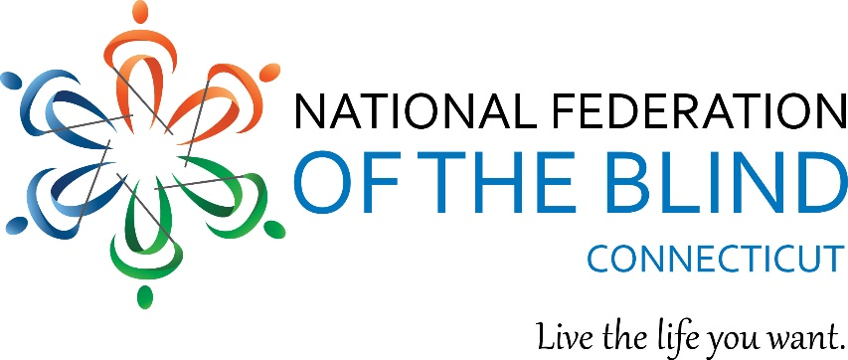

Date: Sept 17 2025 Contact: Christina Thompson

860-289-1971

info@nfbct.org

Are you or someone you know experiencing vision loss? If low vision or blindness is part of your life, an upcoming event may just be for you. The National Federation of the Blind of Connecticut is holding **its 54th Annual State Convention** on **November 7th, 8th and the 9th** at the **Hartford Sheraton South, 100 Capital Boulevard Rocky Hill, Ct 06067**.

On Friday evening, from 7:00 pm-9:00 pm we will host a Vendor Fair with goods and services of interest to members of the blind and low vision community and there will be a LIVE auction! Saturday, starting at 9:00AM, there will be speakers on a variety of topics of interest to those experiencing vision loss. These include technology, recreation as well as motivating achievements.

On Sunday morning at 8:00am, a full breakfast buffet will be served before our Annual Business Meeting.

To register, please contact our Outreach Office at 860-289-1971 or at [info@nfbct.org](mailto:info@nfbct.org).

***111 Sheldon Road, Unit 420, Manchester, CT 06045  
860-289-1971*** [***www.nfbct.org***](http://www.nfbct.org) ***Maryanne Melley, President***