13th Annual Disability Resource Fair
In recognition of Disability Employment Awareness Month
October 17, 2025
In-Person Event
9:00 am – 12:00 pm
Oak Hill’s NEAT (New England Assistive Technology) Building
33 Coventry St., Hartford, CT
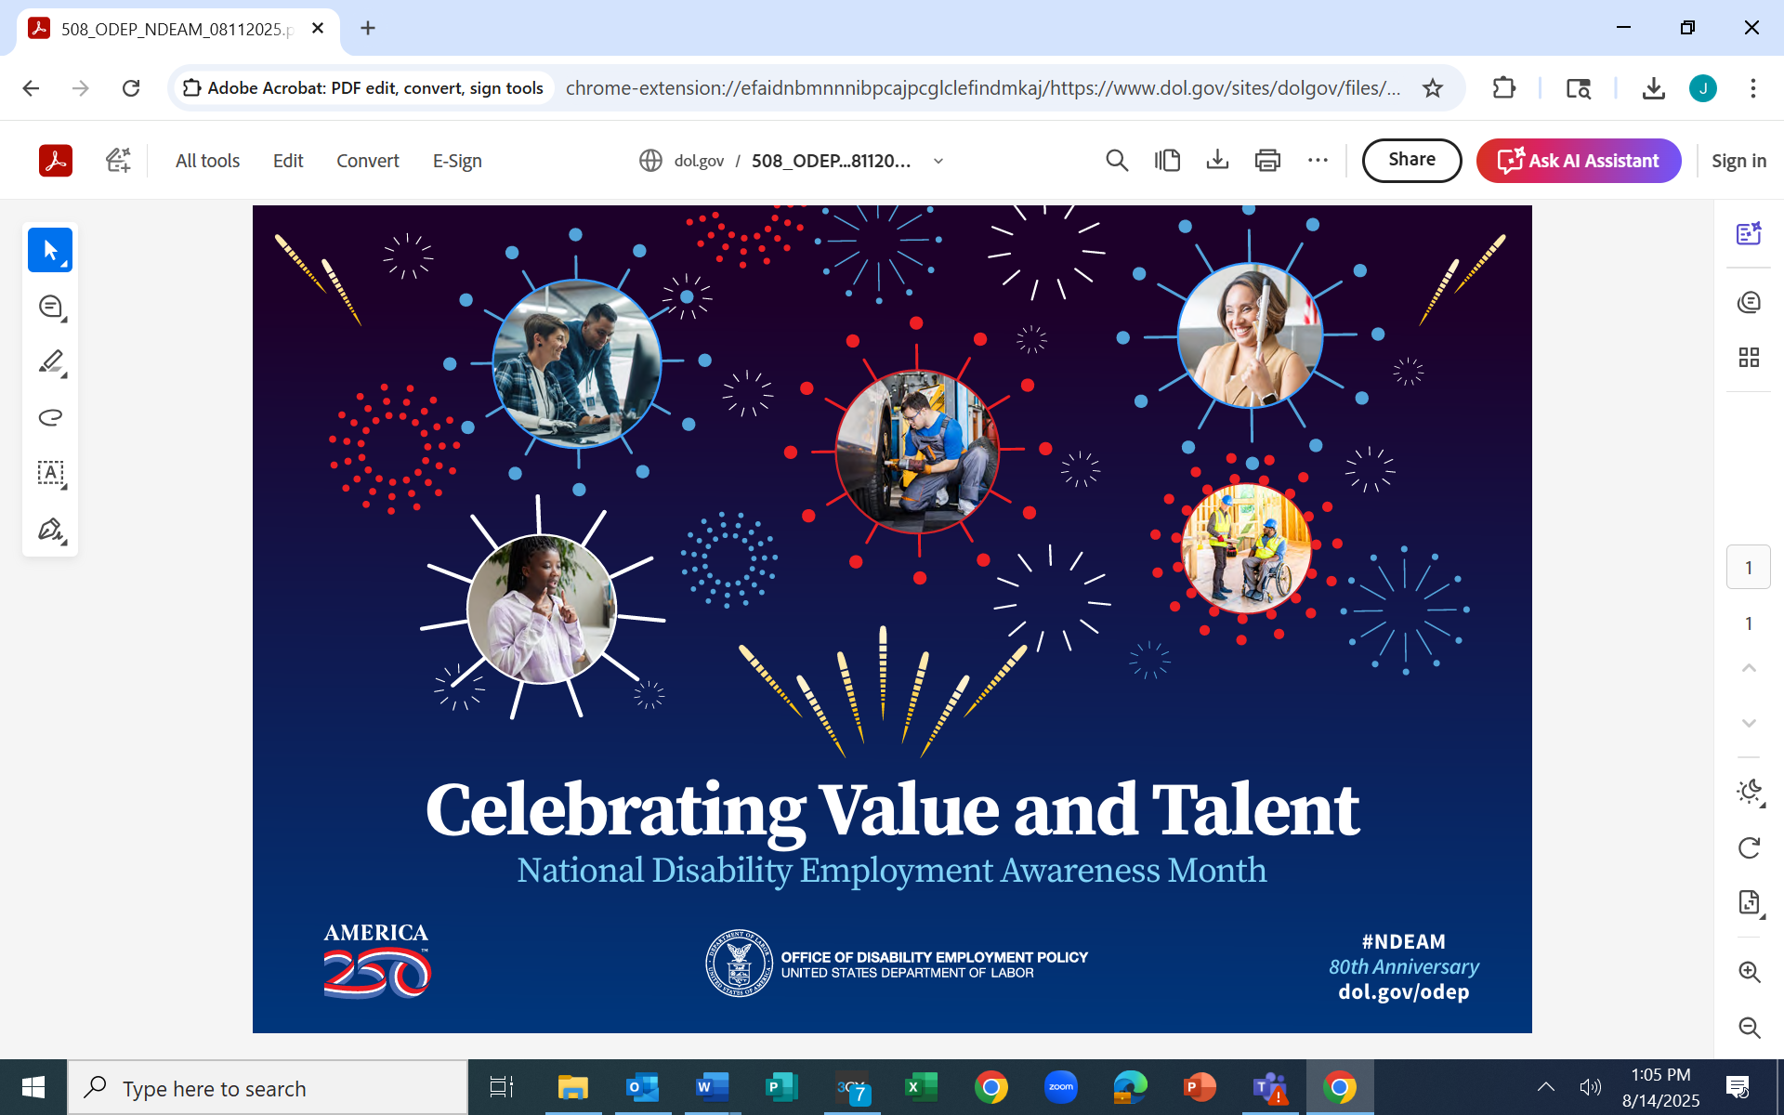
IDEAL FOR INDIVIDUALS WHO ARE:
• Unemployed or under - employed
• Transitioning from school to work or higher education
• Receiving Social Security Disability & are considering work
• Reliant on public transportation or needing public transportation information
• Interested in learning how assistive technology can help
• Unsure of your legal rights in the workplace
- Exploring careers in Manufacturing, IT, Healthcare & Transportation/Distribution

Presented By…
LifeBridge will be providing American
Sign Language Interpreting for this event.
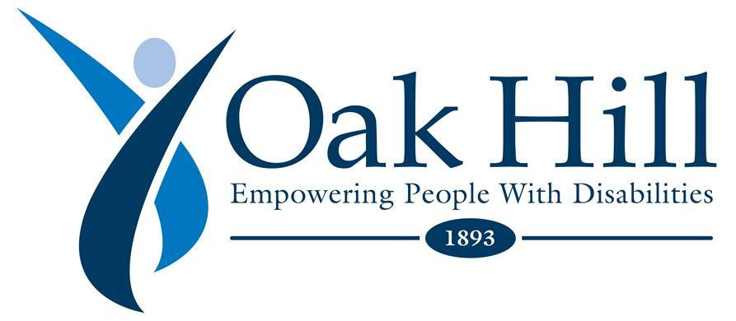
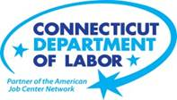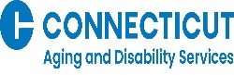
All are welcome to come & learn about North Central CT Resources
If you need a reasonable accommodation, please contact Jill Larmett at
860-899-3446 or jlarmett@capitalworkforce.org
All are welcome to learn about the available resources in the North Central Region such as free employment services, transportation, legal rights, assistive technology, education & more!
(Please let us know if you need an accommodation – 860-899-3446)

