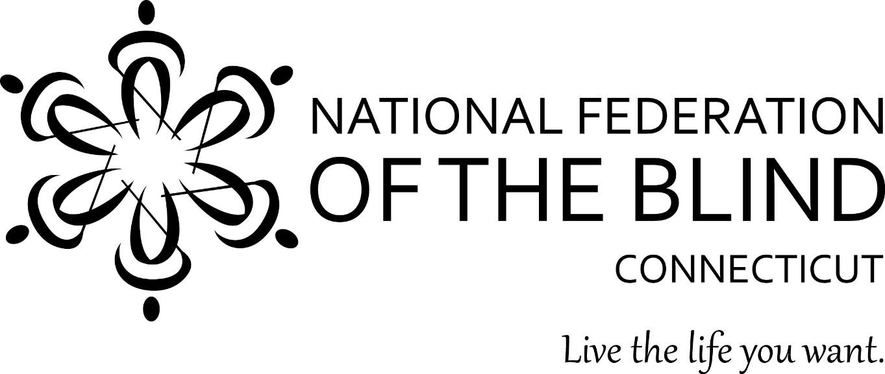
54thAnnual State Convention
November 7, 8, and 9, 2025
Hartford Sheraton South
100 Capitol Boulevard
Rocky Hill, CT 06067

Get Your Steps In! We are taking a page from the National convention and are asking those that can to monitor their steps throughout our convention. The person that walks the most will win a prize at the end of the banquet. Total Steps must be given to President Melley. So, make sure your pedometers are working!
Chocolate Paw Pops, a delicious treat for people, not dogs are back! Purchase your Dark chocolate or white chocolate Pop for $5.00 apiece and support the Guide Dog Division!
Door prizes will be awarded throughout the convention. To be eligible, you must be registered and be in the room when your name is drawn.
50/50 raffle tickets will be sold throughout Friday and Saturday, the winner will be announced at the end of the Banquet. There will also be our annual Basket Raffles. Be prepared to buy tickets to try and win your favorite Chapter Basket. Winners must be in the room as well.

Therese Wales will be available from 12:00P.M. – 5:00p.m. on Saturday, November 8th to speak with parents of blind children. She can be reached at therese@gmail.com. Or please look for her husband Nathanael Wales at the convention and he will give you her phone number.

Guide Dog Relief Area: From our main conference room take a slight left and an immediate right once you exit. Follow the hall straight until you come to the outside doors. The relief area is on your left. PLEASE pick up after your dog. Thank you.

Remember some of our members and guests are allergic to scents. The best perfume or aftershave is none at all. Thank you.

We would like to thank our generous sponsors:
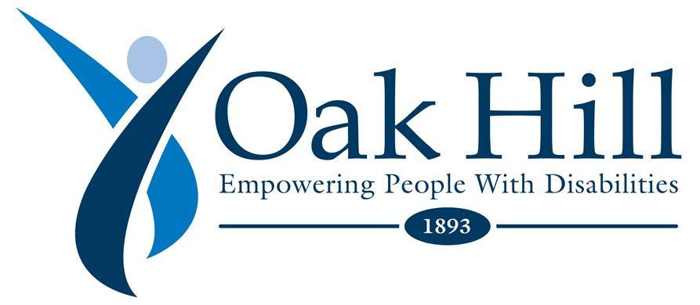
Platinum Sponsor:
www.oakhillct.org
Gold Sponsor:
Vanda Pharmaceuticals
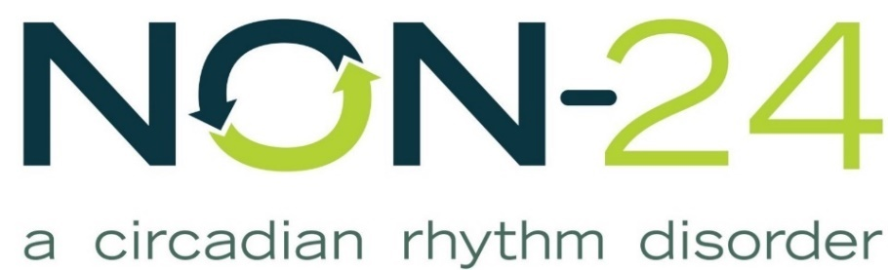
Non-24
Achilles International
www.achillesinternational.org/connecticut

Silver Sponsor:
The Cronin Family
Retina Consultants

National Representative: Marilyn Green, National Board Member.
President: Maryanne Melley
National Federation of the Blind of Connecticut
www.nfbct.org
Facebook: National Federation of the Blind of Connecticut

Friday, November 7, 2025
7:00p.m. – 8:00p.m. Chapter Building meeting with National representative Marilyn Green for all Chapter and Division presidents.

8:00p.m. - 9:00p.m. Live Auction in the Nutmeg ballroom. Please come bid on your favorite items. All bidding starts at $5.00 and increases by $1.00. No coin bidding.

7:00p.m. – 9:00p.m.; The Vendor Fair will be taking place right outside the Ballroom in the hallway. Please take time to visit our vendors.

Vendors
Vanda Pharmaceuticals – Vicki Preddy
Achilles International – Erin Spaulding
BESB - Gary Allen
UR Community Cares – Michelle Puzzo
Carroll Center for the Blind – Isabel Rosario
Meant2beMovers – Steve & Sue LePack
New England ADA Center - Morgan Mulkern
Oak Hill – Gannon Olsen
Southeast Connecticut Community Center – Renee Labonte
CRIS Radio -Scott Baecker
Siyanni Allure LLC – Merly Ballesteros
CT independent Living Council -Molly Cole

Saturday, November 8th Convention Sessions
Student Division will be held from 2:00p.m.-3:00p.m. in the Rocky Hill room.
CTAGDU (Connecticut Association of Guide Dog Users) will be held from 3:00p.m. to 4:00p.m. on the Hartford room.
8:00a.m.- 9:30a.m. - Full Breakfast Buffet in the Ballroom. (This is not the hotel breakfast)
9:30a.m. - Call to order. Benediction by Father Chris Ford
9:40a.m. Pledge of Allegiance, NFB Pledge.

I Pledge to participate actively in the efforts of the National Federation of the Blind to achieve equality, opportunity, and security for the blind; to support the policies and programs of the Federation; and to abide by its constitution.
9:45a.m. – Announcements; I would like to extend my sincere thanks to this years’ convention committee, Jim Cronin, Chair, Allison Arbuckle, Melissa Thompson, and Deb Reed. In addition, we need to thank our donation mailers. Charlie Rival, Cheri Duquette, Glenn Miller, Carol Lemieux, George Reed, Mary Silverberg, Joe Kolczynski, and Ralph Dooley.
Without their commitment and effort, our current strong financial position would not be possible.

9:55a.m. – Julie Kulak - Nominating Committee report
10:00a.m. –Marilyn Green - National Report
10:40a.m. Scott White – NFB Newsline and AI
10:55a.m. - Maryanne Melley - President’s Report
11:05a.m. – Jim Cronin - Fit Break
11:10a.m. - Gene Kim - MIT Student
11:20a.m. – Hear from our Harlow Grant, Calypso Grant and NFB of CT Technology Grant Winners
11:30a.m. – Vicki Preddy - Vanda Pharmaceuticals, NON 24
11:35a.m. – Greater Hartford Transit - Pat Williams
11:50p.m. – Morgan Mulkern New England ADA Center
12:05p.m. – Mia Edmanson - TVI
12:15p.m. - Rachael Grider – Louisiana Center for the Blind
12:30p.m.- 1:30p.m. - Break for lunch
1:30p.m. - Erin Spalding – Achilles Connecticut
1:45p.m. – Raul & Stacie Gallegos: President & Secretary of NAGDU (National Association of Guide Dog Users)
2:00p.m. – Isabel Rosario – Carroll Center for the Blind
2:10p.m. – Molly Cole and Gretchen Knauff - State Independent Living Council (SILC)
2:20p.m. - Lorenzo Diurno - Meta Glasses
2:30p.m. – Lorenzo Diurno, Kristen Dockendorf, Gary Allen, Meta Glasses Discussion Panel
2:40p.m. – Mike Hess - Institute of Blind Technology
2:50p.m. – Jim Cronin - Fit Break
2:55p.m. – Semsa Zuskic - Wells Fargo
3:05p.m. – Oak Hill - Gannon Olsen
3:15p.m. - Renee Labonte - Southeast Connecticut Community Center
3:25p.m. – Emily Gindlesperger – IEP’s
3:40p.m. - Keith Hailey - Hartford Braillers
3:50p.m. - Steve & Sue LePack - Meant2beMovers
Belief Message
The National Federation of the Blind advances the lives of its members and all blind people in the United States. We know that blindness is not the characteristic that defines you or your future. Every day we raise the expectations of blind people, because low expectations create obstacles between blind people and our dreams. Our collective power, determination, and diversity achieve the aspirations of all blind people.
Convention Sessions

4:00 - 6:00p.m. – Break. Mobility instruction will be available by Rachel Grider for those who are interested.
6:00 p.m. - Banquet Dinner, Nutmeg Ballroom
Invocation: Pastor Jack Richards
Master of Ceremonies: Melissa Thompson
Keynote Address: Marilyn Green
Presentation of 2025 Scholarships: Mary Silverberg and Nathanael Wales
Scholarship Finalists
Mia Giantonio
Zoe Marsh
Madeleine Babcock
50/50 Raffle winner
Get Your Steps in winner
Karaoke fun for all!

Sunday, November 9, 2025
8:00a.m.-9:00a.m. Breakfast
9:00a.m. - Call to order; Business Meeting
Roll Call
NFB Pledge
Reports:
Reading of 2025 Business Meeting Minutes - Joe Kolcznski. Vote on acceptance.
Treasurers Report: Cheri Duquette - vote on report.
SRC (State Rehabilitation Council) - Deb Reed
BCAC (Bureau Consumer Advocacy Committee) - Melissa Thompson
New Business:
Vote on Purchasing a new Braille Machine – Christina Thompson
New Members of Convention Committee
Birdies for Charity - Merely Ballesteros
Matching Gift Award to NFB – Maryanne Melley
Washington Seminar Appointments - Mary Silverberg
Vote on Grant/Travel Expense Amount for Washington Seminar - Maryanne Melley

RESOLUTION 2025-01
Regarding the Reductions in Force at the United States Department of Education
WHEREAS, the United States Department of Education administers programs essential to promote education, independence, and economic opportunity for millions of blind Americans; and

WHEREAS, contained within the Department of Education is the Office for Civil Rights (OCR) and the Office of Special Education and Rehabilitative Services (OSERS), which houses the Office of Special Education Programs (OSEP) and the Rehabilitation Services Administration (RSA), all of which provide essential resources to aid blind Americans in our pursuit of education and employment; and

WHEREAS, these divisions are responsible for the enforcement and oversight of the Individuals with Disabilities Education Act (IDEA) (20 U.S.C. § 1400 et seq.), vocational rehabilitation services (29 U.S.C. § 701 et seq.), the Randolph-Sheppard program (20 U.S.C. § 107 et seq.), and the Independent Living Services for Older Individuals who are Blind (OIB) program (29 U.S.C. 796j-796l), as well as enforcement of Title II of the Americans with Disabilities Act and Section 504 of the Rehabilitation Act; and

WHEREAS, at 12:00 a.m. on October 1, 2025, after the United States Congress failed to pass either a budget bill or a continuing resolution, the Federal Government was shut down due to lack of funding; and

WHEREAS, on October 10, 2025, during the Federal Government shutdown, Reduction in Force (RIF) notices were issued to OSERS and OCR employees, which decimated both offices to the point of practically eliminating them; and

WHEREAS, the elimination of OSERS will cause a loss of institutional knowledge, possible disruption in the distribution of federal funding that helps supplement critical state programs, and a loss of administrative support and technical assistance for IDEA programs, Rehabilitation Act of 1973 programs, and the Randolph-Sheppard Program; and

WHEREAS, the elimination of the OCR will cause a severe reduction in the capacity to investigate and enforce both Section 504 of the Rehabilitation Act of 1973 and Title II of the Americans with Disabilities Act, which prohibit discrimination on the basis of disability in educational institutions that are funded at the federal, state, and local levels; and

WHEREAS, Vocational Rehabilitation programs are extremely efficient, as a study published by Associate Professor Michelle Yin of Northwestern University in 2024 “suggests that every dollar invested in VR services results in a return of $21.5 over a 43-year working lifespan for VR clients”; and

WHEREAS, without these protection and enforcement mechanisms, blind students, employees, and entrepreneurs will be left vulnerable to discrimination: Now, therefore

BE IT RESOLVED by the National Federation of the Blind of
Connecticut, in convention assembled this 9th day of November, in the city of Rocky Hill, that this organization urge the administration to immediately rescind the Reduction in Force orders issued to the Office of Special Education and Rehabilitative Services and the Office for Civil Rights on October 10, 2025; and

BE IT FURTHER RESOLVED that this organization demand the Department of Education ensure that there is adequate staffing to fulfill its statutory requirement to administer the Individuals with Disabilities Education Act, the Rehabilitation Act of 1973, the Randolph-Sheppard Program, and the Americans with Disabilities Act; and

BE IT FURTHER RESOLVED THAT this organization demand the Department of Education promptly distribute all funds appropriated by Congress and associated with the Individuals with Disabilities Education Act and the Rehabilitation Act of 1973.

Vote on Resolution

Location for our 2026 State Convention
State Scholarship Applications – Nathanael Wales
January Board Meeting, Date, time and location.
Chapter News
Elections - Maryanne Melley, Moderator
Any member nominated from the floor should have agreed to serve prior to this convention.
Nominees from the committee and from the floor will have one minute to state why they feel the affiliate should vote for them. The one-minute time will be strictly enforced.
Board Member Allison Arbuckle
Board Member Veronica Allston

