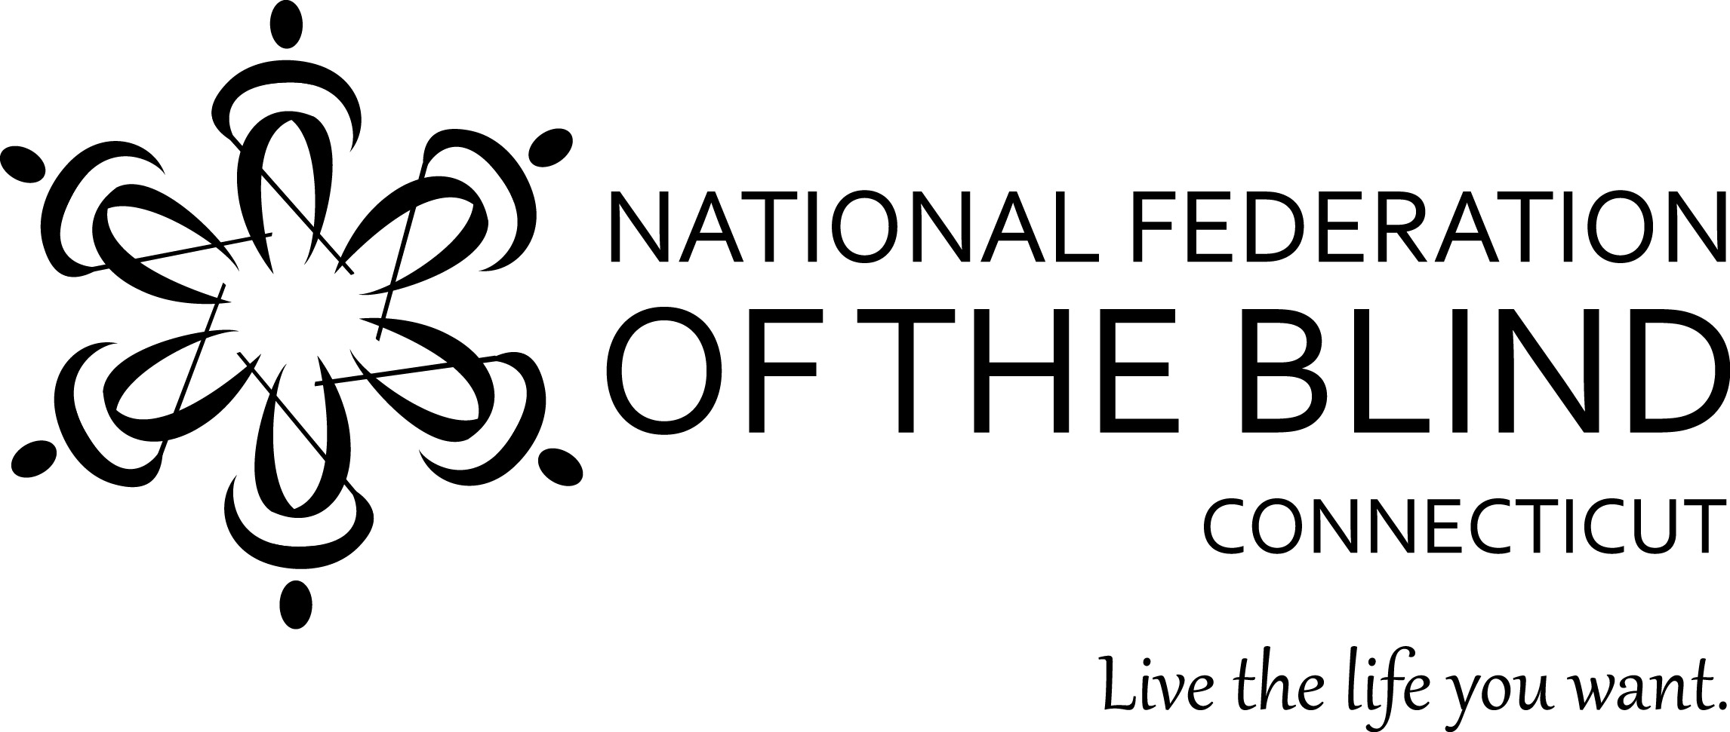
2026 ACADEMIC SCHOLARSHIP PROGRAM

The National Federation of the Blind of Connecticut (NFB of CT) is an organization dedicated to creating opportunities for all blind persons. In the furtherance of this goal, we have established our scholarship program. Recipients of NFB of CT scholarships need not be members of the National Federation of the Blind of Connecticut. NFB of CT scholarships are judged on the basis of academic quality and service to the community.

C. Rodney Demarest Memorial Scholarship, in the amount of $3000, is given in loving memory by his family and friends. Blind since 18, he ran his own business for many years, read NFB-Newsline® faithfully, was always well-informed and was admired by his many friends.
Zukowski Family Foundation Scholarship, in the amount of $2500. The Zukowski Family Foundation is honored to provide a scholarship for a Connecticut blind student.
Doris Higley Memorial Scholarship, in the amount of $2000, is given in loving memory of a friend of Mrs. Higley. Because we recognize that employment, family caregiving, and ongoing medical care, concurrent with post-secondary enrollment, can contribute to a need for students to carry a part-time course load, this scholarship may be awarded to an applicant enrolled part-time who meets all other eligibility requirements.
Additional scholarships may be awarded as funds and opportunity are available.

Eligibility
All applicants must be (a) legally blind, and (b) a Connecticut resident or attending school in-person in Connecticut.

Deadline – Notification
Completed applications must be submitted by September 1, 2026. The scholarship committee will review all applications and notify finalists around September 30. The scholarships will be presented at the banquet of the National Federation of the Blind of Connecticut State Convention. ANY FINALISTS ARE REQUIRED TO ATTEND OUR STATE CONVENTION AT THE HILTON GARDEN INN IN GLASTONBURY ON THE WEEKEND OF NOVEMBER 6, 7 & 8, 2026 INCLUDING ANY CT ASSOCIATION OF BLIND STUDENTS’ ACTIVITIES.

2026 APPLICATION FORM

Please print or type clearly.

Applicant’s Name________________________________________________________
Permanent Address______________________________________________________
_________________________________Telephone_____________________________

Current Address (if different from above) _____________________________________
_________________________________Telephone_____________________________
E-mail address __________________________________________________________
Are you currently enrolled full-time ____ or part-time ____?
College/University Name & City_____________________________________________
Year of Study in 2026-27 _________________________________________________
List Institutions Previously Attended (High School and/or College)

Attach the following documents:
- Applicant’s Letter: Describe your career goals and how our scholarship might help you in achieving them. Give us a brief biographical sketch – tell us about your academic interests, your extracurricular activities, awards/honors you may have received and any community service you have been involved in.
- Two Letters of Recommendation: From teachers, professors, employers, or other professionals who know you well.
- Certification of Legal Blindness, or letter from a treating physician confirming legal blindness
- Official Academic Transcripts: Post-secondary students should obtain transcripts from all colleges/universities attended. You need not wait until spring term transcripts are available to apply now; you may submit spring term transcripts separately when available, and we will contact you if they remain missing and are needed closer to the application deadlined.
- State Officer’s Letter: A letter from a state officer of the National Federation of the Blind of Connecticut confirming that you have discussed your application with her or him. Call our state office for help on this.

Applicant’s Signature_______________________________Date____________

Mail or email your completed application and/or address any questions to:
National Federation of the Blind of Connecticut
111 Sheldon Road, Unit 420, Manchester, CT 06045
(860) 289-1971
www.nfbct.org
info@nfbct.org

