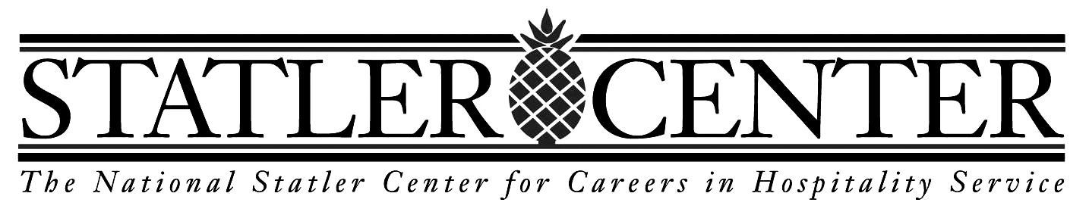
Contact Center and
Customer Service Curriculum

7 week program – April 9-May 29, 2015
Monday – Friday 9:00 AM – 4:00 PM

The National Statler Center and the Perkins School for the Blind are pleased to offer Statler’s Customer Service and Contact Center training program on Perkins’ historic Watertown, MA campus. This course, which has been offered since 2003 at the Statler Center’s facility in Buffalo, NY, provides students with transferrable skills for any service-oriented company that requires phone-based customer skills.
The Statler Center and Perkins are excited to collaborate to provide this special Customer Service and Contact Center employment training. The first and only program of its kind, the Statler Center has provided blind, visually impaired, and physically disabled individuals with the right tools for successful careers in this rapidly growing industry since 2003. Graduates of our comprehensive program are computer-literate and job-ready, equipped with a thorough knowledge of industry standards in both service practice and technology.

In the United States, Customer Service and Contact Centers rank in the top 10 of America’s largest employers. The industry includes a number of interrelated businesses – anywhere that customer service and direct communication is critical. Statler trains people to be capable, motivated, and highly desired job candidates. We provide in-depth skills training and job-preparation services to working-age adults who are sight-impaired or physically disabled, and who are interested in pursuing permanent employment in the customer service and contact center fields.The curriculum is based in real-life Customer Service and Contact Center experiences. We have developed a training program that offers exactly what a company considers to be most important. Included in the Computer and Technology course are elements of the Microsoft Office suite – Word, Excel, and Outlook and the software needed to make them accessible to visually impaired or blind users.
For more information about this program, please contact:
Patrick Keyes, Admissions Coordinator, 716-888-4526 or pkeyes@StatlerCenter.org.
Elizabeth Schmidt, Admissions & Placement Specialist, 716-888-4638 or eschmidt@statlercenter.org

