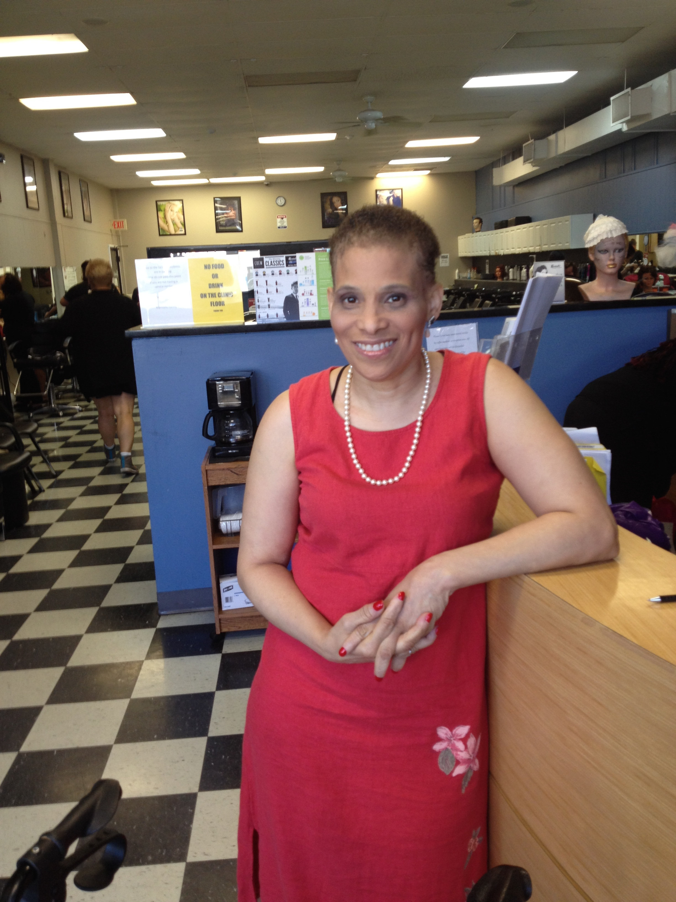

860-938-1584

KIMBERLY’S HOPE

JANUARY 1, 2015

15 LEWIS STEET, HARTFORD, CT 06112[Street Address]

Lorem Ipsum Dolor.

# Kimberly Tindall Presenting KIMBERLY’S HOPE

## A MOTIVATED INDIVIUAL WITH A DOUBLE HANDICAP GENERATING HOPE TO EVERYONE.