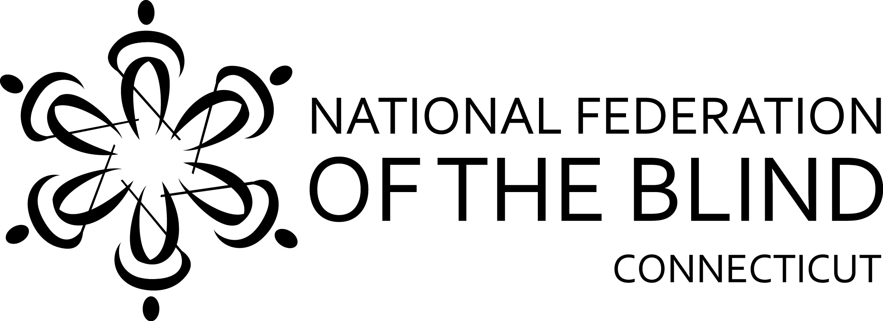

2017 ACADEMIC SCHOLARSHIPS
The National Federation of the Blind of Connecticut (NFB of CT) is an organization dedicated to creating opportunities for all blind persons. In the furtherance of this goal, we have established our scholarship program. Recipients of NFB of CT scholarships need not be members of the National Federation of the Blind of Connecticut. NFB of CT scholarships are judged on the basis of academic quality, service to the community and financial need.

FUNDED BY THE NATIONAL FEDERATION OF THE BLIND OF CONNECTICUT
Howard E. May Memorial Scholarship, in the amount of $5000, is given in memory of Howard E. May, the founding president of the National Federation of the Blind of Connecticut.
Jonathan May Memorial Scholarship, in the amount of $4000, is given in memory of Jonathan May who was widely known for his dedication and his leadership, both in Connecticut and the nation.
Mary Main Memorial Scholarship, in the amount of $3000, is given in memory of Mary Main, inspired leader and founder of the Stamford Chapter of the National Federation of the Blind of Connecticut.

FUNDED BY FRIENDS OF THE NATIONAL FEDERATION OF THE BLIND OF CT
C. Rodney Demarest Memorial Scholarship, in the amount of $3000, is given in loving memory by his family and friends. Blind since 18, he ran his own business for many years, read NFB-Newsline® faithfully, was always well-informed and was admired by his many friends.
Doris Higley Memorial Scholarship, in the amount of $3000, is given in loving memory of a friend of Mrs. Higley’s.

Eligibility
All applicants must be (a) legally blind, and (b) a Connecticut resident or attending school in Connecticut.

Deadline – Notification
Completed applications must be submitted by September 15, 2017. The scholarship committee will review all applications and notify winners during the second week of October. The scholarships will be presented at the banquet of the National Federation of the Blind of Connecticut State Convention. ALL WINNERS ARE REQUIRED TO ATTEND OUR CONVENTION ON NOVEMBER 3-5, 2017, IN WATERBURY, INCLUDING ANY CT ASSOCIATION OF BLIND STUDENTS ACTIVITIES.

2017 APPLICATION FORM

Please print or type clearly.

Applicant’s Name________________________________________________________
Permanent Address______________________________________________________
_________________________________Telephone_____________________________

Current Address (if different from above)_____________________________________
_________________________________Telephone_____________________________
E-mail address __________________________________________________________
Currently enrolled full-time:
College/University Name & City_____________________________________________
Year of Study in 2017-18: ____Freshman ____Sophomore ____Junior ____Senior
List Institutions Previously Attended (High School and/or College):

Attach the following documents:
- Applicant’s Letter: Describe your career goals and how our scholarship might help you in achieving them. Give us a brief biographical sketch – tell us about your academic interests, your extracurricular activities, awards/honors you may have received and any community service you have been involved in. Also please describe your financial need.
- Two Letters of Recommendation: From teachers, professors, employers or other professionals who know you well.
- Certification of legal blindness: or letter from treating physician confirming legal blindness.
- Official academic transcripts: Post secondary students should obtain transcripts from all colleges/universities attended. High school seniors should obtain them from current and any previous high school attended.
- State Officer’s Letter: A letter from a state officer of the National Federation of the Blind of Connecticut confirming that you have discussed your application with him or her. Call our state office for help on this.

Applicant’s Signature_______________________________Date____________

Mail your completed application and/or address any questions to:
National Federation of the Blind of Connecticut
477 Connecticut Boulevard, Suite 217
East Hartford, CT 06108
(860) 289-1971
www.nfbct.org

