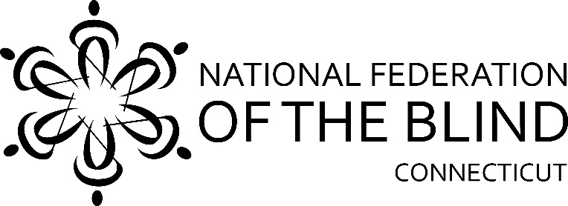
46th Annual
State Convention

The National Federation of the Blind of Connecticut will hold our 46th Annual State Convention on Friday, Saturday, and Sunday, November 3, 4, and 5, 2017, at the Courtyard by Marriott, 63 Grand Street, Waterbury, Connecticut. Rooms will be available for Friday and Saturday nights for a convention discounted rate of $99, plus tax, per night. To offset the cost of the rooms, convention attendees who stay at the hotel both nights will receive a ten dollars discount on a full registration package. To receive the discount, provide your reservation confirmation number when you register. To reserve a room, call the Courtyard by Marriott at 203-596-1000. The deadline for reserving a room and registering for the convention is October 23, 2017.

We are very happy to announce that Mark A. Riccobono, President of the National Federation of the Blind, will serve as our national representative.

The LowViz Guide for indoor navigation will be installed at the hotel. This system aids blind people to navigate a building independently, using an iOS app. A representative from LowViz will explain how to use it during the job seminar and general session.

We will kick things off Friday at noon with a job seminar. Representatives from the National Federation of the Blind, the Connecticut Department of Labor, and Services for the Blind will speak on ways to help to blind individuals obtain employment. Friday evening we will gather for dinner, which will be followed by bingo and a pool party.

Saturday morning, a continental breakfast will be followed by an information-filled general session. We will hear from President Riccobono. Steve Famiglietti will talk about his experiences storm chasing; Esther Levegnale will speak about skiing and cruises she has been on; Anne West will speak about ham radios; and Josefina Martinez will talk about a camp that she and several others from our organization attended this past summer. We will hear from Gary Allen, President of NFB of CT; Jim McCollum, Legislative Co-ordinator; Brian Sigman, Director of the Bureau of Education and Services for the Blind; and Gordon Riddick from the CT Library for the Blind.

After lunch Saturday, we will have a vendor fair, and our various divisions will hold their annual meetings. Also, their will be a car show in the hotel parking garage, where we will have the opportunity to check out some classic cars.

President Riccobono will address our convention during the banquet Saturday night. Also, we will award scholarships to several blind students, and we’ll hear from recipients of the NFBCT-Coccomo Quarterly Grant Program.

During our Sunday morning breakfast, we will hold a chapter-building seminar and discuss ways we can bring new members into our NFB affiliate. Following breakfast, we will hold our business meeting. We will elect two board members, review our past year and discuss our plans for the future.

It’s going to be a convention to remember,
so register and reserve your room soon!
Registration Form

Attendees who register at the door will be charged an additional $10.
Name: ______________________________________________________
Address: _____________________________________________________
Phone: ______________________________________________________
E-mail: ______________________________________________________

Indicate how many will be attending the following:

_____ Job seminar

_____ Full convention package, $50 per person. Includes Saturday and Sunday breakfast, Saturday lunch and banquet dinner. Does not include Friday night dinner. For $10 discount, provide two-night reservation confirmation number: ___________

_____ Saturday general session only, $15. Includes continental breakfast & lunch.

_____ Vendor fair only, $10.

Division Meetings: _____ CT Diabetic Action Network; _____ CT Association of Guide Dog Users; _____ Merchants; _____ CT Association of Blind Student

_____ Saturday night banquet only, $25

_____ Sunday session only, $15. Includes business meeting, breakfast, and chapter-building seminar

Indicate meal choices:
Saturday Lunch Wraps: ___ Ham; ___ Turkey; ___ Roast Beef; ___ Veggie
Banquet Dinner: ___ Petit Chateau; ___ Chicken Piccata; ___ Butternut Squash Lasagna

______ No, I cannot attend the 2016 state convention, but I am enclosing a donation to the NFB of CT.

Registration deadline is October 24th.To make payments through PayPal, go to www.nfbct.org and click on “You Can Help”; then click on “Donate”. Under acknowledgements, please indicate ‘state convention’. Please either mail or email this registration form also. Or, send your check payable to the NFB of CT with your registration form to: NFB of CT, 477 Connecticut Blvd, Suite 217, East Hartford, CT 06108.

For more information, contact our Community Outreach Office at 860-289-1971 or info@nfbct.org.

