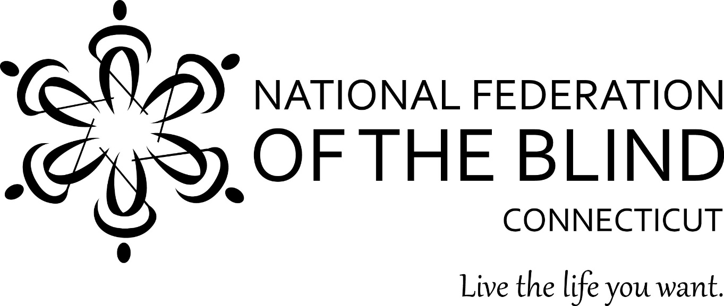
2018 Annual State Convention
November 2, 3 and 4, 2017
Courtyard by Marriott
63 Grand Street
Waterbury, CT
President: Gary Allen
National Federation of the Blind of Connecticut
www.nfbct.org
Facebook: National Federation of the Blind of Connecticut
Convention Hashtag: #NFBCT18
National Representative: Patti Chang, Outreach Director, National Federation of the Blind
The National Federation of the Blind of Connecticut knows that blindness is not the characteristic that defines you or your future. Every day we raise the expectations of blind people, because low expectations create obstacles between blind people and our dreams. You can live the life you want; blindness is not what holds you back.
Dog Relief Area: There is a grassy lawn outside the hotel’s main entrance on Grand Street. There are trash cans near the entrance.
Drawings for our 50/50 and Basket Raffles will take place at the banquet. Tickets will be on sale throughout the day on Saturday until the time of the drawings.
50/50 raffle tickets are $1 each or 6 for $5.
Basket Raffle tickets are $5 per envelope of 10 tickets.
There will be an auction on some baskets and other items.
Door Prizes: Door prizes will be awarded throughout the convention. To be eligible, you must be registered and in the room when your name is drawn.
The Connecticut Association of Guide Dog Users (CTAGDU) will be selling Ghirardelli chocolate PAW POPS for $3.00 each throughout the convention until supplies last. We usually sell out of PAW POPS ever year.
Friday November 2, 2018:
All events will be held in the Grand Ballroom
1:00 p.m. Advocacy Seminar
We will have a panel discussion moderated by Patti Chang, Outreach director National Federation of the Blind. Each person will talk about their agency and what they do.
Guests include:
Eileen Healy, Executive Director
Independence Northwest
Gretchen Knauff, Executive Director
Disability Rights Connecticut
Don Overton, Advocate for
Blind and Disabled Veterans
Phillip Magalnick, Peer Advocate
PRESIDENTS AND TREASURERS MEETINGS
5:00 p.m. - 6:00 p.m: Patti Chang
National Federation of the Blind will meet with the State President and Chapter Presidents.
5:00 p.m. - 6:00 p.m: Nathanael Wales, Treasurer of the National Federation of the Blind of CT, will meet with the Chapter Treasurers.

DINNER & EVENING ACTIVITIES
6:00 p.m. - 7:30 p.m. Dinner will be in the same room as the Advocacy Seminar.
7:30p.m. – 10:00 p.m. Game Night Family Feud and Cards Against Humanity.
Students will also be available to answer questions that we have on assistive technology. i.e. JAWS, ZoomText, and iPhone & Android apps that visually impaired people use.
10:00 p.m: This will be a time for friends to get together and socialize, catch up, relax and have fun.

Saturday Morning, November 3, 2018
Morning Session & Lunch will be held in Salons A & B.
8:00 a.m. Registration & Continental Breakfast
9:00 a.m. Call to order; NFB Pledge.
9:05 a.m. Opening Ceremonies & Invocation.
Welcome from the Waterbury Chapter: Josefina Martinez
Convention arrangements/announcements
Nominating Committee Report
9:10 a.m: National Report: Patti Chang, Outreach Director of the National Federation of the Blind
9:40 a.m: Brian Sigman, Bureau of Education and Services for the Blind (BESB): The Future of the Agency That Serves the Blind Here in CT and Around the US.
10:00 a.m: President's Report: Gary Allen, President, National Federation of the Blind of Connecticut
10:10 a.m: Jim McCollum, Legislative Coordinator, National Federation of the Blind of CT
10:20 a.m: Tiffany Healey, Waterbury Police Department: Public Safety
10:40 a.m: Gordon Reddick, Director, Library for the Blind & Physically Handicapped
10:50 a.m: Vendor Roundup
11:10 a.m: Dina Rosenbaum, Director, Carroll Center
11:30 a.m: Aira. Aira will be available in the hotel from Thursday through Monday, free of charge.
11:40 a.m: Chris Kelly, CRIS Radio: New projects around the state, including kids' programming and CRIS for in-patients in hospitals around CT.
11:55 a.m: Chelsey Duranleau, BLIND, Inc
12:05 p.m: Janae Burgmeier, National Association of Blind Students
12:15 p.m: Announcements for Lunch

Saturday Afternoon Events:
Division meetings: Salon A
1:00 p.m. - 1:50 p.m: CTAGDU
2:00 p.m. - 2:50 p.m.
3:00 p.m. - 5:00 p.m: Student Division.
Vendor Fair: 1:00 p.m. – 4:00 p.m. Clock Tower Ballroom
This is a chance for attendees to meet some of the speakers as well as vendors who did not get a chance to speak in the morning. You will be able to purchase their items or get information about their services. A vendor list is on the back page
Seminars: Waterbury Meeting Room
1:00 p.m. – 1:50 p.m. Live the Life You Want! Build strength and confidence through fitness!
Trainers from Chapter 126 will show us how!
Christy Bosley, exercise physiologist
Larissa Yost, exercise physiologist
They will talk briefly about what they do and then lead us in a workout, complete with props
2:00 p.m. – 2:50 p.m. Athlete's Forum
How have sports helped you to live the life you want? Moderator-Mary Silverberg, Ballroom Dancing and Kayaking,
Guests:
Erin Spaulding, President, Achilles International.
Steven Famiglietti, Team Oak Hill
Melissa Carney, Accomplished Equestrian
Brianna Rigsbee, Track & Field, Chearleader
Christy Bosley, exercise physiologist
Larissa Yost, exercise physiologist
Each participant will have five minutes to tell their story, then Q & A, and discussion.
3:00 p.m. – 3:50 p.m. Dog Guides: What is the process. What you need to know.
Guests:
Kathy Rooney, Guiding Eyes, CT
Ellen Ringle, Seeing Eyes, NJ

Saturday Evening, November 3, 2017:
5:00 p.m. Social Hour/Cash Bar in The Bistro
Salon B & C
6:00 p.m. Banquet Dinner
Invocation: Father Frederick Aniello, Our Lady of Mt. Carmel, Waterbury
Introduction of head table
Woodward Award Presentation
Keynote Address: Patti Chang, Outreach Director, National Federation of the Blind
Presentation of 2018 NFB of Connecticut Scholarships
Basket Raffle Drawing
50/50 Raffle Drawing
Auction
Cash Bar will follow the Banquet in The Bistro.

National Federation of the Blind of CT
Business Meeting Agenda
Saturday November 4, 2018
Salon C
8:15 a.m: Full Breakfast

Roll Call
Elections: we will have elections for the President,
1st Vice President, 2nd Vice President, Treasurer, Secretary, and two Board Positions.
Secretary’s Report
Treasurer’s Report
Reports:
SRC-
BCAC-
BESB-
Committee Reports:
Birdies for Charity: Debbie and George Reed
PAC Plan: Marie Beaulier
Vehicle Donation Program:
NFB-Newsline: Gary Allen
Federationist: Maryanne Melley

2019 National Federation of the Blind of Connecticut Convention.
Convention committee
Chapter News: At-Large, Central CT, East of the River, Hartford, Middletown, Shoreline, Southern CT, Stamford, Waterbury.
Washington Seminar-
Adjournment at noon

Vendor List
BLIND, Inc, Chelsey Duranleau:
Brenda Elliott: Homemade knitted items
Bureau of Education and Services for the Blind (BESB): Display of services offered
Carroll Center, Dina Rosenbaum: Training programs including computer instruction & employment experiences.
Dominicanos – USA, Karime Pimentel: Arts & crafts items; Dominicano y flan
Guiding Eyes, Kathy Rooney
Humanware, Joel Zimba: BrailleNote Touch, Brailliant 14, VR Trek, Stream Explore 5 & 8
Jehovah’s Witnesses, Jim Fennessy: free info on Bible
Library for the Blind and Physically Handicapped, Gordon Reddick
Logan Tech, Gary Tilbe: 6-dot Braille Label Maker and Braille Coach
NEAT Center, Steve Famiglietti: Display of technology for daily use.
NFB of CT: buy your NFB of CT t-shirt for just $10!
NFB-Newsline: Gary Allen
Project Ray, Patrick Olsen: Smartphones & services for low-vision & blind consumers
St. Mary’s Physical & Occupational Therapy and Lions Low Vision Center, Raechaell Corbett: Items from the Lions Low Vision Center
Seeing Eye: Ellen Ringold
Silver Lining Technologies, Stephen DelTatto: Low vision & blindness technologies
That’s My Handbag, Lavonne Womack: Handbags, purses, fannypacks, bookbags
VisionCam, Marilyn Davidson: OrCam, a small camera that attaches to a pair of glasses

