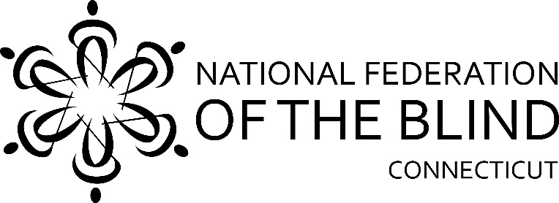
48th Annual
State Convention

The National Federation of the Blind of Connecticut will hold our 48th Annual State Convention on Friday, Saturday, and Sunday, November 1st, 2nd and 3rd at the Four Points Meriden, 275 Research Parkway, Meriden, Connecticut. Rooms will be available for Friday and Saturday nights for a convention discounted rate of $90.00, plus tax, per night. To reserve a room, call the Four Points Meriden at 203-238-2380 and give them the code CTF or go to Book your group rate for CT Federation of the Blind 11.01-03.2019 to book online. The deadline for reserving a room for the convention is October 1, 2019.

We are very happy to announce that Everette Bacon, Disability Advisory Committee to the Federal Communications Commission (FCC) & Board Member of the National Federation of the Blind, will serve as our National Representative.

Jasmine Rezai, Marketing Manager at Aira will make the service available in the hotel from Thursday through Monday, free of charge. You can download the app from the App Store or Google Play. You can use the service on your iPhone or Android.

We will kick things off Friday afternoon from 3:00pm to 4:30pm in the Hanover Room with a panel discussion called “Let’s TOC” which stands for Technology, Outreach and Chapter Building. This panel will consist of Everette Bacon on technology, Gary Allen on Outreach and Phil Magalnick on Chapter Building. From 4:30pm - 5:30pm there will be a combined Chapter presidents and Treasurers meeting in the Hanover Room.

Dinning is at your leisure in the Silver City Grill inside the hotel. After dinner we will have Bingo for prizes in Charter Oak A. The Silver City Bar will be having Karaoke as well.

Saturday morning, a continental breakfast starting at 8:00am will be followed by our general session which starts promptly at 9:00am. We will hear from National Representative Everette Bacon followed by a variety of new and innovative speakers.

A boxed lunch will be served from 12:pm-1:00pm. From 1:00pm-4:00pm there will be a Vendor Fair in Ballroom C, please visit the vendors and see all that is being offered this year! The Guide Dog Division will meet in the New Haven Board Room from 1:30pm-2:30pm. There will be a gathering for sighted parents, partners, children and anyone else who is at the convention with someone who is blind. This will be held in the New Haven Board Room from 2:30pm-3:30pm. The Student Division will meet in the Hanover Room from 2:00pm-5:00pm

Everette Bacon will be available to answer your technology questions throughout the afternoon.

Our Banquet will begin at 6:00pm in Charter Oak A. National Representative Bacon will address our convention during the banquet Saturday evening. Also, we will present Academic Scholarship Awards.

There will be basket raffles and baskets to auction along with other items, and of course our 50/50 raffle!

Sunday morning at 8:00am an expanded continental breakfast will be served. At 9:00am we will hold our Annual Business Meeting. We will elect two board positions, and the secretary position for a one-year term. We will also vote on changes to our State Constitution. These changes will be in the agenda for everyone to read the day before.

The National Federation of the Blind of Connecticut acknowledges
with gratitude our convention sponsors listed below:

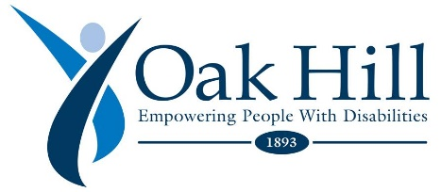
Central CT Chapter, NFB of CT
Inclima Eye Care, LLC, West Haven CT
Phil Magalnick & Honorata Kazmierczak
Registration Form

Attendees who register at the door will be charged an additional $10.

Name: ______________________________________________________
Address: _____________________________________________________
Phone: ______________________________________________________
E-mail: ______________________________________________________

Indicate how many will be attending the following:

Division meetings Saturday Afternoon
_____ CT Association of Guide Dog Users; _____ CT Association of Blind Student

_____ Full convention package, $60 per person. Includes Saturday and Sunday breakfasts, Saturday lunch and banquet dinner.

_____ Saturday general session only, $15. Includes continental breakfast & lunch.

_____ Vendor fair only, $10.

_____ Saturday night banquet only, $25.00 **

_____ Sunday session only, $10.00. Includes business meeting and expanded continental breakfast

**Please indicate meal choices:
Saturday Lunch Wraps: ___ Turkey; ___ Roast Beef; ___ Veggie
Banquet Dinner: ___ Chicken Roulade with Spinach and Fontina Cheese ___ Moroccan Cous Cous with Grilled Seasonal Vegetables and Balsamic Glaze (Vegan)

______ No, I cannot attend the 2019 state convention, but I am enclosing a donation to the NFB of CT.

Registration deadline is October 23th.Send your check payable to the NFB of CT with your registration form to: NFB of CT, 111 Sheldon Road, Unit 420, Manchester, CT 06045

