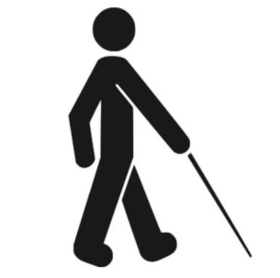

South East CT Community
CENTER OF THE BLIND, INC.
45 Broad St.,
New London, CT 06320-5724
PHONE (860) 447-2048
e-mail: centeroftheblind@gmail.com

March 13, 2020

A message from the Executive Director of the Center of the Blind

Over the past few weeks, it’s become clear that the world is facing an unprecedented challenge with this virus. Like you, we are all deeply concerned and want to do what we can to help keep our community, families, and members safe and healthy.
On behalf of the Center of the Blind, I wanted to send a personal note to you and let you know how we are responding to this situation. We are humbled by your loyalty and we take our responsibility to our members and their families very seriously.
From the onset of this situation, we have been listening to the appropriate sources for accurate and up-to-date information. As more and more schools, colleges, non-essential business’ close as well as cancelations of large events, we have decided to be proactive rather than reactive to this situation. With that in mind, the Center will be CLOSED to the members effective Monday, March 16 until such time that we can re-open in a safe environment. During this time, I will continue to review and respond to emails and phone calls as they come in. The mail will be retrieved on a regular basis and the Center will be thoroughly cleaned and disinfected! Our intention is to re-open on the 2nd of April unless otherwise advised to stay closed. We will continue to keep you updated.
We appreciate your understanding to this difficult decision to close the Center.
Please be safe, cautious, and healthy.

Sincerely,
Wendy Lusk
Executive Director

