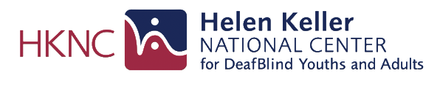

Helen Keller National Center

DEAFBLIND AWARENESS WEEK
June 26th to July 2nd

Online Learning on Us

To encourage awareness about the DeafBlind community, HKNC offering the following courses for free from 6/26-7/2.

- Tech Solutions for Older Adults: TechSolutions4683
- Ensuring Access to Communication: DirectProviders752
- Assistive Tech in the Workplace: AssistiveTechFREE937
- Equal Access and Participation: EnsuringAccess8345

Enter the corresponding code during checkout to access the course for free.

Info and Contact
If you have any questions, you can contact us at: PLD@hknc.org
Or visit helenkeller.org for more information.

