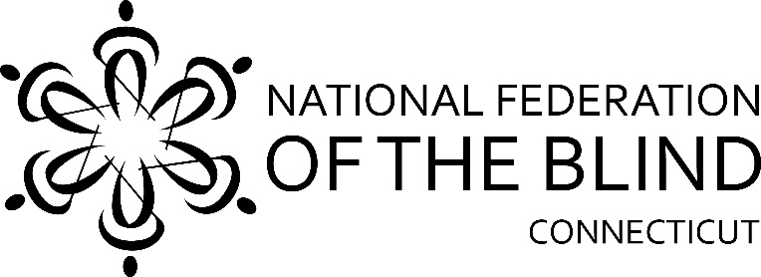

51st Annual State Convention!!
November 4, 5 & 6, 2022

The National Federation of the Blind of Connecticut will hold our 51st Annual State Convention on Friday, Saturday, and Sunday, November 4, 5 & 6, 2022 at the Sheraton Hartford South, 100 Capital Boulevard, Rocky Hill. Rooms will be available for Friday and Saturday nights for a convention discounted rate of $99.00, plus tax, per night. To reserve a room, call the Sheraton Hartford South at 860-257-6000 and mention that you are attending the National Federation of the Blind of CT State Convention. The deadline for reserving a room for the convention is October 13, 2022

We will kick things off Friday evening, November 4th, at 5:00pm with a cash bar and a Slider Station followed up with a Sing Along with Jim Cronin and Judy Potter. We will be holding our Vendor Fair on Friday evening from 7:00pm to 11:00pm.

On Saturday morning, a continental breakfast starting at 8:00am will be followed by our general session which starts promptly at 9:00am. We will hear from Affiliate President Maryanne Melley, our National Representative Second Vice President Ron Brown and a variety of new and innovative speakers.

A boxed lunch will be served from 12pm-1:00pm. Speakers will continue after lunch. The CT Association of Blind Students meeting will be held from 2:00pm to 4:00 pm and the CT Association of Guide Dog Users meeting will be held from 4:00pm to 5:00pm.

Our Banquet will begin at 6:00pm. National Representative Ron Brown will address our convention during the banquet Saturday evening. Also, we will present Academic Scholarship Awards.

We will, of course, have our 50/50 raffle! And, we are bringing back our popular Basket Raffle this year!

On Sunday morning at 8:00am, a continental breakfast will be served before our 9:00am Annual Business Meeting. We will elect all officer and two board positions.

The National Federation of the Blind of Connecticut acknowledges
with gratitude our convention sponsors listed below:

OakHill: Empowering People with Disabilities

Youthful Images, Bloomfield, CT

Retina Consultants, PC, Manchester, CT

Registration Form

Attendees who register at the door will be charged an additional $10. Please note that registrations can be made online at www.nfbct.org following the link to State Convention information.

Name: ______________________________________________________

Address: _____________________________________________________

Phone: ______________________________________________________

E-mail: ______________________________________________________

Indicate how many will be attending the following:

Division meetings Saturday Afternoon
_____ CT Association of Guide Dog Users; _____ CT Association of Blind Students

_____ Full convention package, $75 per person. Includes Saturday and Sunday
breakfasts, Saturday lunch and banquet dinner.

_____ Saturday Morning Continental Breakfast, $15

_____Saturday Boxed Lunch: ____Roast Beef Wrap, $20; ____Turkey Wrap, $20;
____Vegetarian Wrap, $20

_____ Saturday Night Banquet: Salad Choice: ____Caesar Salad; ____Garden Salad
Meal Choice: ____Chicken Picatta, $35; ____Chicken Marsala, $35; or
____Pasta Primavera, $33

______Sunday morning continental Breakfast, $15

______ No, I cannot attend the 2022 state convention, but I am sending a donation to the NFB of CT.

Registration deadline is October 15th. Send your check payable to the NFB of CT with your registration form to:
NFB of CT, 111 Sheldon Road, Unit 420, Manchester, CT 06045

