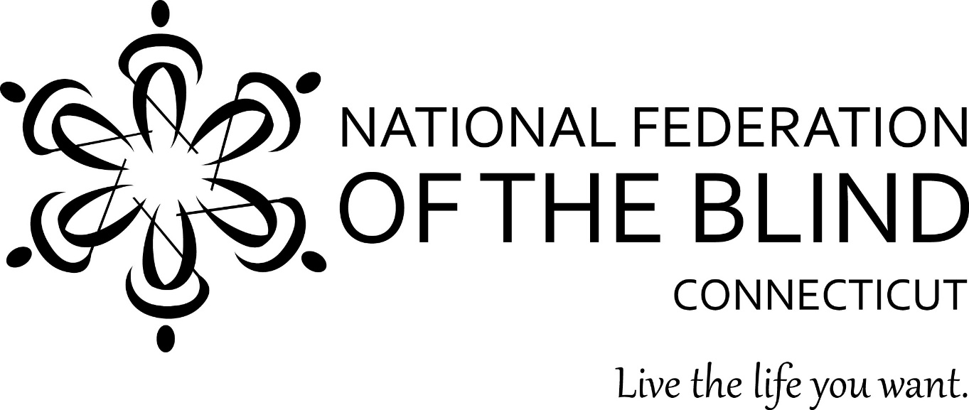
2022 51st Annual State Convention
November 4, 5, and 6, 2022
Sheraton Hartford South
100 Capital Boulevard
Rocky Hill, CT 06067

Door Prizes: Door prizes will be awarded throughout the convention. To be eligible, you must be registered and in the conference room when your name is drawn.
50/50 raffle tickets will be sold throughout the day and the winner will be announced at the end of the Banquet. Basket raffles are back this year! Be prepared to buy tickets to try and win your favorite chapter basket.
Guide Dog relief area: As you leave the conference room turn right. At the end of the hall take another right and then a quick left. Continue straight to the exit doors. Walk down the sidewalk until you come to a set of three stairs. At the bottom of the stairs there is grass on both sides for relieving. PLEASE pick up after your dog and deposit the waste in the trash receptacle back at the doors.

We would like to thank our generous sponsors:
Platinum Sponsor:
www.oakhillct.org

Gold Sponsor: Youthful Images

Silver Sponsor: Retina Consultants, PC
National Representative: Ron Brown, 2nd Vice President, National Federation of the Blind
President: Maryanne Melley
National Federation of the Blind of Connecticut
www.nfbct.org
Facebook: National Federation of the Blind of Connecticut

Friday, November 4th
Dinner and entertainment in Salon II starting at 6:00p.m. Please feel free to join in with Judy Potter, Jim Cronin and our National Representative for an evening of entertainment. Also bring your extra cash for Jailhouse Karaoke. For $1.00 or any amount you want, put someone in “jail”. That person has to either sing a song or pay at least $1.00 to get out of “jail.” Have fun putting people on the spot! Also, there will be a cash bar available.
In Salon I the Vendor Fair will be happening from 7:00p.m. through 11:00p.m. Take your time to visit our vendors.

Saturday, November 5th, 2022
Connecticut Association of Blind Students Meeting: 2:00p.m. – 4:00p.m. Rocky Hill Room
Connecticut Association of Guide Dog Users Meeting 4:00p.m. – 5:00p.m. Rocky Hill Room

7:00a.m.- 9:00a.m. Continental Breakfast, Nutmeg Ballroom (This is not the hotel breakfast)
9:00a.m. - Call to order
Invocation – Father Ed Pryzgocki - Holy Apostle Church
9:05a.m. - Pledge of Allegiance, NFB Pledge
9:10a.m. – I would like to thank our donation mailers: Charlie Rival, Pam Taylor, Glenn Miller, Rich Ireland, George Reed, Cheri Duquette, Carol Lemieux, and Karime Pimental. Without their hard work we would not be in the strong financial position we are in today. Today let us have a moment of silence for two members that passed away this year, they are Marcia Baran and Jackie Billey. Carolyn Dodd wrote an article for the Braille Monitor regarding Jackie Billey, and she would like to read it for us now.

Change to our State Constitution.
CURRENT wording.
Article IV: LOCAL CHAPTERS
Paragraph two regarding dues now reads “At the same time, each local Treasurer shall forward to the State Treasurer its dues in the amount of $3.00 for each member of the chapter.”

NEW Wording.
Article IV: LOCAL CHAPTERS
Paragraph two regarding dues change to “At the same time, each local Treasurer shall forward to the state Treasurer its dues in the amount of $5.00 for each member of the Chapter.”

9:20a.m. – Melissa Thompson - Nominating Committee Report
9:25a.m. – Ron Brown - 2nd Vice President, National Federation of the Blind
9:55a.m. – Elizabeth Rouse - Treasurer, National Association of Blind Students (NABS) -Update from the National Student Division
10:10a.m. - Hear from our Scholarship Finalists:
10:20a.m. – Maryanne Melley – President’s Report
10:30a.m. – Fit Break
10:45a.m. - Father Ed Przygocki – Holy Apostle Church, Outreach with Blind Children in Peru
11:00a.m. – Congressman John B. Larson, representing Connecticut’s 1st District
11:45p.m. – Matt Geeza – LBPH

12:00p.m.-1:00p.m. Break for lunch

1:00p.m.- Amy Porter - Commissioner Connecticut Department of Aging and Disabilities, DORS
1:15p.m. – Justin Salisbury – Explaining Blind Rehabilitation to Health Professionals using their Language
1:30p.m. – Marilyn Davidson – VisionCam, Distributor of OrCam
1:45 – Diane Weaver Dunne, CRIS Radio
2:00p.m.- Fit Break
2:15p.m.- Andy Bernstein - Accessible Pharmacy Services for the Blind
2:30p.m. – Todd Sweet - Hartford Braillers Hockey Team
2:45p.m. - Shonda Rosetta – My Experiences Working for Amazon
2:50p.m. – Steve Famiglietti - What’s New with NEAT
3:05p.m. Jennifer Harnish - Carroll Center for the Blind
3:20p.m. – Noreen Grice - NFBCT BELL Academy

One Minute Message
The National Federation of the Blind knows that blindness is not the characteristic that defines you or your future. Every day we raise the expectations of blind people, because low expectations create obstacles between blind people and our dreams. You can live the life you want; blindness is not what holds you back

4:00p.m.- 6:00p.m. Break

6:00 p.m. Banquet Dinner - Nutmeg Ballroom
Invocation: Reverend Harold Williston - Crossroads Community Cathedral
Master of Ceremonies: Deb Reed
Keynote Address - Ron Brown, 2nd Vice President, National Federation of the Blind
Thank you to our BELL Academy Volunteers
Presentation of 2022 Scholarships:
Beth Rival, Mary Silverberg, and Nathanael Wales
Scholarship Finalists:
Lizzy Cappelli
Isabel Rosario
Yew Siang Cheong
Lydia Randall
Scholarships:
C. Rodney Demarest Memorial Scholarship
Doris Higley Memorial Scholarship
Zukowski Family Foundation Scholarship
Brian Cummins Memorial Scholarship

Please join our students in the Rocky Hill Room for card playing and relaxation. The room will be open through midnight.

Thank you for being here tonight for our 51st annual banquet!

Sunday, November 6, 2022

7:00a.m.-9:00a.m. Breakfast, Nutmeg Ballroom

9:00a.m. Call to order: Business Meeting
Roll Call
NFB Pledge
Recommended changes to Constitution
CURRENT wording:
Article IV: LOCAL CHAPTERS
Paragraph two regarding dues now reads “At the same time, each local Treasurer shall forward to the State Treasurer its dues in the amount of $3.00 for each member of the chapter.”

NEW Wording.
Article IV: LOCAL CHAPTERS
Paragraph two regarding dues change too “At the same time, each local Treasurer shall forward to the state Treasurer its dues in the amount of $5.00 for each member of the Chapter.”

Vote on Constitution changes
Reports:
Reading of 2021 Business Meeting Minutes, Vote on Acceptance: Joe Kolczynski
Treasurers Report: Nathanael Wales, vote on report.
ABPVI (Advisory Board Persons with Visual Impairments): Beth Rival
SRC (State Rehabilitation Council): Deb Reed
BCAC (Bureau Consumer Advocacy Committee): Korrine Herlth
PAC (Pre Authorized Contribution) Plan: Len Schlenk
Federationist: Brianna Rigsbee
New Business:
Washington Seminar Appointments: Volunteer/Volunteers Needed
Washington Seminar: Vote on Subsidy amount
Donation Mailings: Two more volunteers needed. Should we go to a mail merge format where everything is typed or keep requests handwritten.
Committee for new location for our 2023 State Convention needed
NFBCT Technology Grant: should we increase amount by adding funds from affiliate? More advertising is needed. All members on the committee should receive applicant emails.
Credit Card Payments: How would we go about receiving this form of payment? Your input is needed
Creating a support group for partners of blind members: Richard Ireland
January Board meeting, where and when?
Chapter News
Elections; Ron Brown, Moderator
Any member nominated from the floor should have already agreed to serve prior to this convention.
Nominees from the committee and from the floor will have one minute to state why they feel the affiliate should vote for them. The one-minute time will be strictly enforced.
Elections: Results will be given to our national representative Ron Brown.
Each member that has paid dues for 2022 will receive eight index cards, one for each election. If you wish to vote for a person nominated from the floor you will tear off one corner of the card for that person. If you wish to vote for the person nominated by the committee, leave the card whole. If two people are nominated from the floor, you will tear one corner to vote for the first person and two corners to vote for the second person, still leaving your card whole to vote for who was nominated by the committee.
This is much more efficient than handing out slate and styluses, pens, different colored cards, Brailling and writing down votes, and having them counted by two people. It was suggested to me by John Pare last year.
Positions up for election:
President
1st Vice President
2Nd Vice President
Treasurer
Secretary
Board Member
Board Member
Board Member – One Year Term
Meeting adjourned

