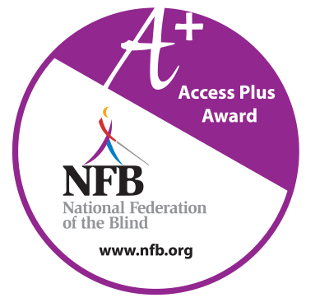
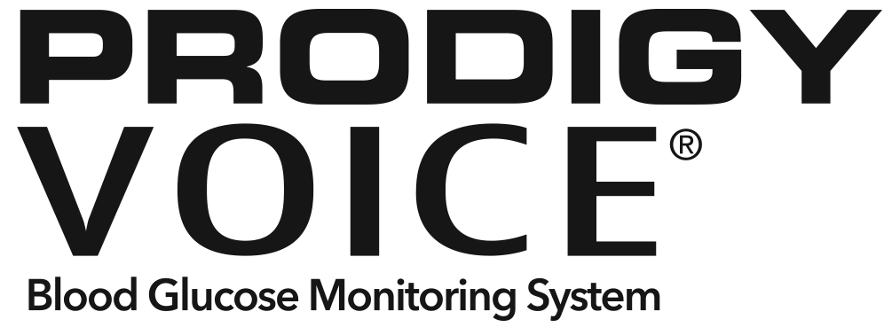

NFB + AFB Award Winning, Blind-Friendly
Blood Glucose Meter for Blind Diabetes Patients
Carefully designed with help from the NFB, the AFB, and Certified Diabetes Educators.
NFB and AFB Access Award Winning Meter
Allows complete independence for blind and low vision patients.
No coding required, which decreases the danger of false results.
Fully audible setup and testing: enables the user to set up the meter and perform blood glucose tests without sighted assistance.
Tactile buttons make it easy to navigate and blind-friendly.
Cost effective enabling diabetics to test often and manage their diabetes health.
Standard USB port to easily upload test results.
Stores 450 test results into the memory.
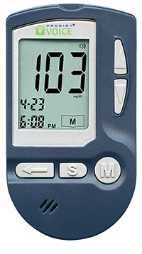

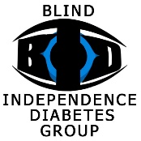
About the Blind Independence Diabetes Group

The BID Group is for Blind Diabetics who want to learn new diabetes
and blindness living skills, gain independence, and make new friends!

The BID Group website provides FREE:
• “Living with diabetes and blindness” audio training materials from top medical and blindness professionals.
• Friendly nationwide support groups where blind diabetics gather weekly to learn, laugh, and do life together.

The BID Group is sponsored by Medicare Bid Winner Advanced Diabetes Supply which provides the blind-friendly Prodigy Voice® Blood Glucose Meter to Medicare and private health plan customers. Prodigy no Coding Blood Glucose Test Strips are also available for $6.87 per 50 count box for the uninsured. To order a Prodigy Voice Meter or testing supplies call Bob Bourdette, Director of Sales, at 760-579-7230.
BID Group Facilitator: Jerry Munden 980-253-0949 jerrymunden@carolina.rr.com www.bid.northcoastmed.com

