Do you have diabetes and low vision or blindness?

Insulin pens and pumps, continuous glucose monitoring systems, medications and other diabetes treatments are available for diabetes management. However, many of these devices were not designed for users with low vision or blindness and have serious accessibility problems. We want to support these users by learning more about how low vision/blind individuals manage their diabetes.

Are you interested in participating in this study?

Participation in this research involves completing a survey about diabetes management. Participation will last approximately 20 minutes. Participants will receive a $10 tango gift card for their time and effort.

How can you find out more?

Go directly to: <https://ohio.qualtrics.com/jfe/form/SV_b119QA0WOpWpWcu>

Or scan QR code here:

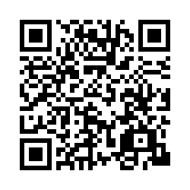

You can also call and leave a message, or email:

[Dr. Allyson Hughes](mailto:Hughes,%20Allyson%20%3cashughes@ohio.edu%3e)

Phone: 740.593.0465

Email: ashughes@ohio.edu

1. Facebook: Complete a survey about your diabetes and earn $10. The study is expected to take less than 20 minutes for most people to complete. Contact the research team at [ashughes@ohio.edu] with any questions and to request a personalized link to the survey. #diabetes #doc #dsma. The purpose of the study is to identify the chronic disease self-management practices used by adults who have diabetes and are blind or have low vision. This study is being conducted to inform later development of education and intervention for persons with chronic diseases and their healthcare providers.

1. **Twitter:**  Complete a survey about your diabetes and blindness and earn $10. Contact the research team at [ashughes@gmail.com] with any questions. #diabetes #doc #dsma. The purpose of the study is to identify the chronic disease self-management practices used by adults who have diabetes.

**IRB # 22-E-195**