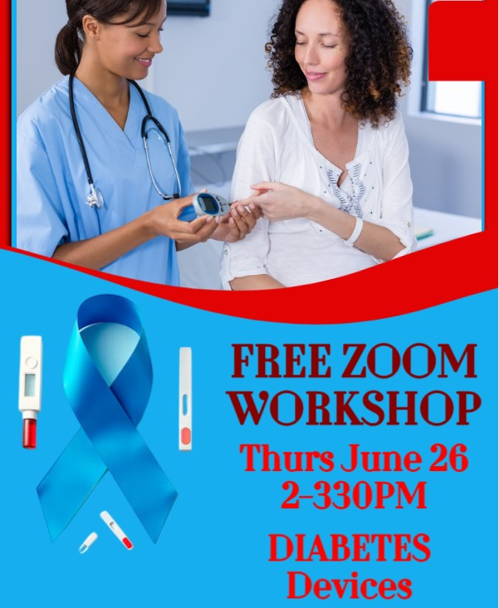

**FREE ZOOM WORKSHOP ON ACCESSIBLE DIABETES DEVICES**

**Thursday, June 26, 2025**

**2PM to 330PM (EST)**

**Join the Florida Outreach Center for the Blind for an informative ZOOM lecture with special guests, TOM TOBIN, PATRICIA MADDIX, & VERONICA ELSEA.**

Our guests are with the Accessible Insulin Pump Task Force, formed several years ago to advocate for the accessibility of insulin pumps and other devices. Chairman Veronica Elsea will explain what this group has been doing and the success it has had so far. Tom Tobin will discuss other advocacy efforts including governmental legislation, working with health professionals, and encouraging patients to advocate for their personal needs.

Over the past three years, the Taskforce has worked with Tandem and Insulet, both insulin pump manufacturers, to make their Durable Medical Equipment, DME, more accessible to blind and low vision diabetics and they’ve had great success! So much so, that they now have individuals using the Tandem Mobi and Insulet Omnipod Five insulin pumps, completely independently!

ZOOM Meeting ID: 835 8160 5488

Passcode: 182630

**BY PHONE:**

1-312-626-6799

**BY COMPUTER**

[https://us02web.zoom.us/j/83581605488?pwd=UWYvTVZ2Q2RRejhJamVJREF4Rlltdz09 [us02web.zoom.us]](https://urldefense.com/v3/__https:/us02web.zoom.us/j/83581605488?pwd=UWYvTVZ2Q2RRejhJamVJREF4Rlltdz09__;!!COIdcu9TKnUF_QTdrw!JiD21OsK47Ux7j7fntI2JUtAq-NYi2H9HiqiQv9iEfA1OtAOBNs6ZkofuAkmfOwTETQ$)

The Florida Outreach Center for the Blind is a nonprofit organization/training facility that is nationally accredited by the Association for Education & Rehabilitation of the Blind & Visually Impaired (AER). Classes/training are available in English, Spanish, Creole and French.

FOR INFO on this and other workshops, FOCB’s FREE CLASSES, TRAINING & MORE, contact us: 561-642-0005, email: [Info_FOCB@bellsouth.net](mailto:Info_FOCB@bellsouth.net)

2315 South Congress Avenue, Palm Springs, FL 33406.

Website: <http://blindfocb.org>

Like us on Facebook! <https://www.facebook.com/FOCBInc>

Join us on Twitter! <https://x.com/FlaOutreachCtr>