0t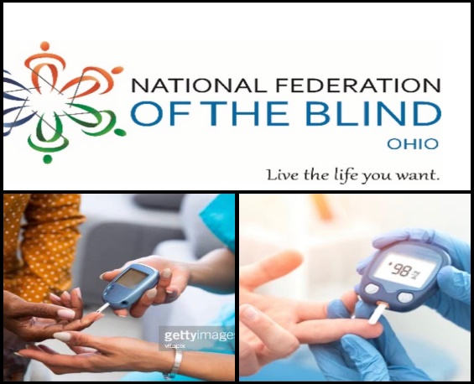

The National Federation of the Blind of Ohio
Diabetic Action Network Division Presents:
An Integrated Approach to Health
Understanding the Interconnected Systems of the Heart, Kidneys, and Metabolism

Featured Guest Speaker:
Kyia Mountain, DNP, APRN-CNP, NBC-HWC Associate Nurse Practitioner, ACHIEVE/CINEMA UH Advance Practice Provider System Committee Vice Chair University Hospitals Harrington Heart and Vascular Institute

Join us for an in-depth exploration of how our vital systems work together. We will dive into critical health questions, including:
- The Interconnected System: How heart, kidney, and metabolic health function as one.
- The Power of Technology: Utilizing Continuous Glucose Monitors (CGMs) to improve patient outcomes.
- Holistic Management: The roles of physical activity, nutrition, mental health, and emotional well-being in disease prevention.
- The Intersection of Chronic Illness: Understanding complications arising from obesity, diabetes, and chronic kidney disease.
- The "Integrated Team" Advantage: The benefits of having your cardiologist, nephrologist, and endocrinologist working in sync.
- Practical Daily Management: How to effectively manage your heart, kidneys, and metabolism simultaneously in your daily life.

Date: Monday May 11
Time: 6:30 p.m.
Where: Ohio zoom hall
Join by:
https://zoom.us/j/4081850851

Meeting ID: 408 185 0851

One tap mobile +1-646-876-9923, 4081850851# US

Find your local number: https://zoom.us/u/abdqTMSdcy

Live The Life You Want!
For more information contact,
Joann Williams, Ohio DAN President
williams.joann054@gmail.com
Or
Delcenia Brown, Ohio DAN Vice President
delcenia@prodigy.net

