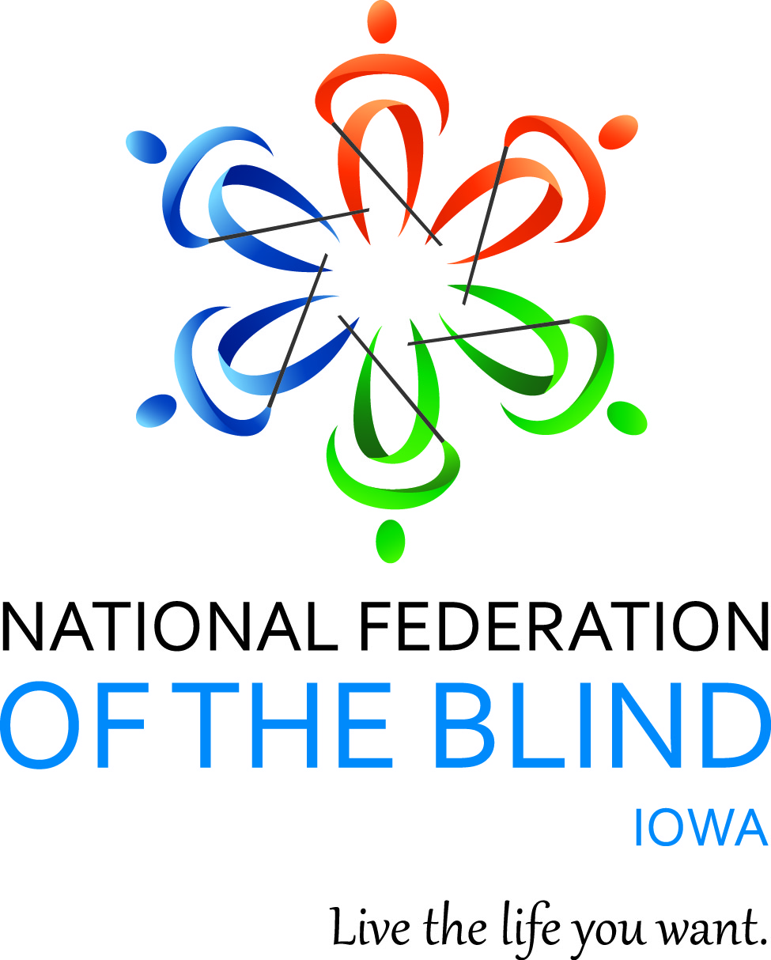

NATIONAL FEDERATION OF THE BLIND OF IOWA
2020 STATE CONVENTION
October 30–October 31, 2020

Anywhere and Everywhere on Zoom

Scott Van Gorp, President
E-Mail: svangorp@nfbi.org
Cell: (515)720-5282
Website: www.nfbi.org
If you have questions or need assistance during the convention, contact Convention Coordinator Cindy Ray (Cell: 515-208-2351)
If you need assistance with using Zoom please contact the following:
David Hammel: 515-822-4236
Mike Harvey: 615-554-0695
Joe Goode: 720-339-1501
Sharonda Goode: 602-281-5955

The members of the planning committee welcome you to the 2020 National Federation of the Blind of Iowa state convention!

Scott Van Gorp, President, National Federation of the Blind of Iowa

Cindy Ray, Convention Coordinator, Secretary; National
Federation of the Blind of Iowa

Chelsea Page, Door Prize Coordinator and Fund raising chair, Des Moines Chapter; National federation of the Blind of Iowa

Joe Goode, Des Moines Chapter; National Federation of the Blind of Iowa

Sharonda Goode, des Moines Chapter; National Federation of the Blind of Iowa

Bob Ray, Des Moines Chapter; National federation of the Blind of Iowa

Committee Chairs
Bob Ray, Nominating
Sharonda Goode, Resolutions
Karen Clayton, Auditing
Chelsea Page, Door Prizes
Terrie Wilcox and Cindy Ray, Outreach

2019-2020 OFFICERS AND BOARD ,

Scott Van Gorp, President, Des Moines, svangorp@nfbi.org
Mike Harvey, First Vice President, Des Moines, mharvey@nfbi.org
Vacant, Second Vice President,
Cindy Ray, Secretary, Des Moines, cindyray@gmail.com
David Hammel, Treasurer, Urbandale, dhammelia@aol.com
Terri Wilcox, Board Member, Des Moines, trising1943@gmail.com
Karen Clayton, Board Member, Sioux City, kjeanette1978@gmail.com
Michael Barber, Board Member, Des Moines, m.barber817@gmail.com
Kim Brown, Board Member, kimbeth@mchsi.com

Use the hashtag: #NFBIA2020
Like us on Facebook: National Federation of the Blind of Iowa
Follow us on Twitter: @NFB_Iowa
Sign up for the Tall-Corn mailing list to get our latest information
AGENDA

Friday, October 30, 2020

Exhibits and Presentations
Join Zoom Meeting
https://zoom.us/j/4133859067?pwd=NFNhS21UYWF0Z2ZZYkJMb1FUS1k4Zz09
Meeting ID: 413 385 9067
Passcode: 6324692
One tap mobile +16468769923,,4133859067# US (New York)
Dial by your location +1 312 626 6799 US (Chicago)

9:00-10:00 A.m. Pat Fischer – Nanopac
10:00-11:00 A.M. Chris Grabowski – Mystic Access
11:00 A.M. 12:00 P.M. Video presentations
- Norma Boge – Lifetech Iowa
- National Federation of the Blind Independence Market
1:00-1:30 P.M. Jennifer Lyman – Vanda Pharmaseuticals
2:00-3:00 P.M. Jeff Gardner – Irie AT

Meetings
1:00-3:00 p.m. At Large Chapter Meeting April Enderton, President
Abbie Taylor, a blind author, will be the guest speaker for this year’s convention meeting. Annual chapter elections will also be held. Of course, there’s much more in store, so make plans to be there!
Join Zoom Meeting:
https://zoom.us/j/7941099792?pwd=UHRXTEZLamFoNzA1djg1dEdpQVl3UT09
Meeting ID: 794 109 9792 Passcode: 6324692
One tap mobile +13126266799,,7941099792# US (Chicago)
Dial by your location +1 312 626 6799 US (Chicago)

3:30-5:30 p.m. Iowa Association of Blind Students Katy Olsen, President

See separate agenda for details on the student meeting
Join Zoom Meeting : https://zoom.us/j/3764592130?pwd=MlFtWlZTeDlHbEZtcWs5SmpCUWN2QT09
Meeting ID: 376 459 2130 Passcode: 6324692
One tap mobile
+16468769923,,3764592130# US (New York)
Dial by your location +1 312 626 6799 US (Chicago)

5:45-6:30 p.m. Resolutions Committee Meeting Sharonda Goode, Chair
Open to all. Hear the resolutions before they come to the convention floor for a vote.
Join Zoom Meeting:
https://zoom.us/j/7941099792?pwd=UHRXTEZLamFoNzA1djg1dEdpQVl3UT09
Meeting ID: 794 109 9792 Passcode: 6324692
One tap mobile +13126266799,,7941099792# US (Chicago)
Dial by your location +1 312 626 6799 US (Chicago)

7:00 P.m.-9 P.m General Session
Join Zoom Meeting:
https://zoom.us/j/7941099792?pwd=UHRXTEZLamFoNzA1djg1dEdpQVl3UT09
Meeting ID: 794 109 9792 Passcode: 6324692
One tap mobile +13126266799,,7941099792# US (Chicago)
Dial by your location +1 312 626 6799 US (Chicago)

7:00 P.m. Call to Order: Scott Van Gorp, President, National Federation of the Blind of Iowa

7:05 P.m. Opening Ceremonies
Invocation: Cindy Ray, Secretary, National Federation of the Blind of Iowa
Pledge of Allegiance

National Anthem: Terri Wilcox, Bord Member, National Federation of the Blind of Iowa; David
Hammel, Treasurer, National Federation of the Blind of Iowa; Cindy Ray,
Secretary, National Federation of the Blind of Iowa;
Sharonda Goode, Des Moines Chapter

National Federation of the Blind Pledge
Welcome (TBD)
7:20 P.M. Convention Arrangements: Cindy Ray, Convention Coordinator and Secretary, National Federation of the Blind of Iowa

7:25 P.m. National Report: What’s Happening in the Federation?
Adelmo Vigil, National representative; National board member and president, National Federation of the Blind of New Mexico

8:15 P.M. NABS Report: What has NABS been up to this year?
Kenia Flores, FirstVice President, National Association of Blind Students

8:30 P.M. Building the National Federation of the Blind – an open discussion on how we can add more members to the family and how to support the ones we already have? – Scott van Gorp, President, National Federation of the Blind of Iowa

9:00 P.M. Adjourn

9:05 P.M. Hospitality – Convention planning committee
Come join us for some Karaoke!
Join Zoom Meeting : https://zoom.us/j/3764592130?pwd=MlFtWlZTeDlHbEZtcWs5SmpCUWN2QT09
Meeting ID: 376 459 2130 Passcode: 6324692
One tap mobile +16468769923,,3764592130# US (New York)
Dial by your location
+1 312 626 6799 US (Chicago)

Join us here for networking and mix and mingle!
Join Zoom Meeting:
https://zoom.us/j/7941099792?pwd=UHRXTEZLamFoNzA1djg1dEdpQVl3UT09
Meeting ID: 794 109 9792 Passcode: 6324692
One tap mobile +13126266799,,7941099792# US (Chicago)
Dial by your location +1 312 626 6799 US (Chicago)

Saturday, October 31, 2020

8:00-8:45 a.m. Affiliate Board Meeting Scott Van Gorp, President
Open to all
Join Zoom Meeting:
https://zoom.us/j/7941099792?pwd=UHRXTEZLamFoNzA1djg1dEdpQVl3UT09
Meeting ID: 794 109 9792 Passcode: 6324692
One tap mobile +13126266799,,7941099792# US (Chicago)
Dial by your location +1 312 626 6799 US (Chicago)

GENERAL SESSION
9:00 A.M. Call to Order

9:05 A.M. Presidential Report

9:35 A.M. Iowa Department for the Blind Report Emily Wharton, Director, Iowa Department for the Blind

10:05 a.m. Report from Iowa Educational Services for the Blind and Visually Impaired (IESBVI)
Steve Gettel, Superintendent, IESBVI

10:40 A.M. Accessible Absentee voting update in Iowa from the perspective of the National Federation of the Blind of Iowa – Scott van Gorp, President, National Federation of the Blind of Iowa

10:50 A.M. Disability Rights Iowa’s work on accessible absentee voting and other initiatives of interest – Jane Hudson, Executive Director, Disability Rights Iowa
11:20 A.M. Why I’m a Federationist – Members from around the National Federation of the Blind of Iowa share what draws them to the Federation and why it is important to them.

11:40 A.M. How can I prepare for an emergency and how can I help as a blind person when one strikes? Richard Webb, Secretary/Treasurer, Southeast Iowa chapter

12:00 p.m. Recess

12:05-1:15 P.M. Parent meetup – Open discussion time for educators and parents of blind children to discuss issues in education and other settings and possibly form a parents division in Iowa – Chelsea Page, Des Moines chapter
Join Zoom Meeting
https://zoom.us/j/4133859067?pwd=NFNhS21UYWF0Z2ZZYkJMb1FUS1k4Zz09
Meeting ID: 413 385 9067
Passcode: 6324692
One tap mobile +16468769923,,4133859067# US (New York)
Dial by your location +1 312 626 6799 US (Chicago)

Business Session

2:00 P.M. Call to Order

2:05 P.m. Business Meeting
- 2019 Meeting Minutes – Cindy Ray, Secretary, National Federation of the Blind of Iowa
- Treasurer’s Report – David Hammel, Treasurer
- Auditing Committee Report – Karen Clayton, Chair
- Resolutions Committee Report – Sharonda Goode, Chair

2:00 P.m. Report from the Friends of the Library

2:10 P.M. Chapter, Division, and Committee Reports

2:30 P.m. Elections – Bob Ray, Nominating Committee Chair

Election of 5 2-year terms for officers, and 2 2-year terms for board members. Election of Delegate and Alternate to the 2021 National Convention

- Old Business
- New Business
4:30 P.m. Final Remarks –Adelmo Vigil, National Representative, Kenia Flores, First Vice President, National Association of Blind Students and Scott Van Gorp, President, National Federation of the Blind of Iowa

5:00 P.M. Adjourn

6:30 p.m. Annual Banquet
- Master of Ceremonies: Mike Harvey – First Vice-President, National Federation of the Blind of Iowa
- Invocation: Cindy Ray – Secretary, National Federation of the Blind of Iowa
- Banquet Address: Adelmo Vfigil, – National Representative
PAC Plan: Adelmo Vigil, – National Representative and Chelsea Page, Pac Chair for Iowa
- Awards – Scott Van Gorp, President, National Federation of the Blind of Iowa
Following Banquet:
Convention Planning Committee host hospitality
After the banquet, stop by for some karaoke!
Join Zoom Meeting : https://zoom.us/j/3764592130?pwd=MlFtWlZTeDlHbEZtcWs5SmpCUWN2QT09
Meeting ID: 376 459 2130 Passcode: 6324692
One tap mobile
+16468769923,,3764592130# US (New York)
Dial by your location +1 312 626 6799 US (Chicago)

Join us here for networking and mix and mingle!
Join Zoom Meeting:
https://zoom.us/j/7941099792?pwd=UHRXTEZLamFoNzA1djg1dEdpQVl3UT09
Meeting ID: 794 109 9792 Passcode: 6324692
One tap mobile +13126266799,,7941099792# US (Chicago)
Dial by your location +1 312 626 6799 US (Chicago)

Convention Notes:
We will be having a 50-50 drawing through the convention. Below is a note from Joe Goode, Des Moines Chapter, National Federation of the Blind of Iowa
CASH for the CAUSE:
Play 50/50 during the Convention to support the National Federation of the Blind of Iowa and win some cash. Tickets will be sold for $2 a piece during all general sessions and banquet throughout the 2020 NFBI Convention. Once the pot is up to $200, a drawing will occur, with half of those funds going to the affiliate and the other half to the winner. This drawing resets the 50/50, thus the process begins again. Tickets can then be purchased for a new 50/50 game, and every time the total reaches $200, we reset!
The more games you play and the more tickets you buy for each game contributes to our cause and increases your chance to win cash!
Tickets can be purchased on cashapp by sending funds to Sharonda Goode, (cashtag $ShariRockz) and her phone number is 602-281-5955. Feel free to text with questions about the game.
Life is nifty when you play 50/50!

MISSION OF THE NATIONAL FEDERATION OF THE BLIND OF IOWA

The National Federation of the Blind of Iowa knows that blindness is not the characteristic that defines you or your future. Every day we raise the expectations of blind people, because low expectations create obstacles between blind people and our dreams. You can live the life you want; blindness is not what holds you back.

THE NATIONAL FEDERATION OF THE BLIND PLEDGE

I pledge to participate actively in the efforts of The National Federation of the Blind to achieve equality, opportunity, and security for the blind; to support the policies and programs of the federation; and to abide by its constitution.

