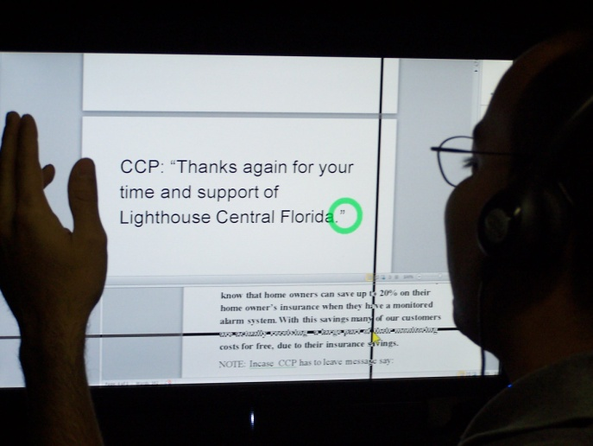
Jump start your earning power!
Put your skills to work…
And learn new skills!
You may know Lighthouse Central Florida as a first class rehabilitation provider for individuals with sight impairment, but do you also know we offer state of the art job training programs to prepare you for a job in the customer service field or contact center industry? Florida-based employers are expanding their customer service operations; Lighthouse can help you get the training and support you need to land a position in this growing industry.
NEXT Basics CLASS: August 13-23, 2012
Sound interesting? Here’s what you need to do:
Lighthouse offers two programs to meet your needs and interests:
1. Customer Service Basics, 56 hours over 2 weeks; prepares you for jobs like receptionist, front desk clerk, office assistant and more.
2. Contact Center Excellence, COMING SEPTEMBER, 2012! 72 hours over 3 weeks; prepares you for jobs in contact centers with heavy emphasis on technology. Prerequisite: Customer Service Basics.
Classes meet Monday through Thursday, from 9:00 to 4:00 at our downtown Orlando location, 421 E. Robinson St., Orlando 32801.
To learn more, contact your Division of Blind Services counselor OR a Lighthouse Central Florida Case Manager at 407/898-2483.
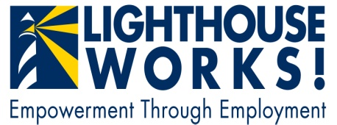
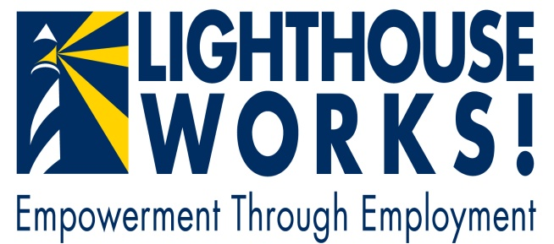
Lighthouse Central Florida is dedicated to creating meaningful employment opportunities for people with vision loss.

