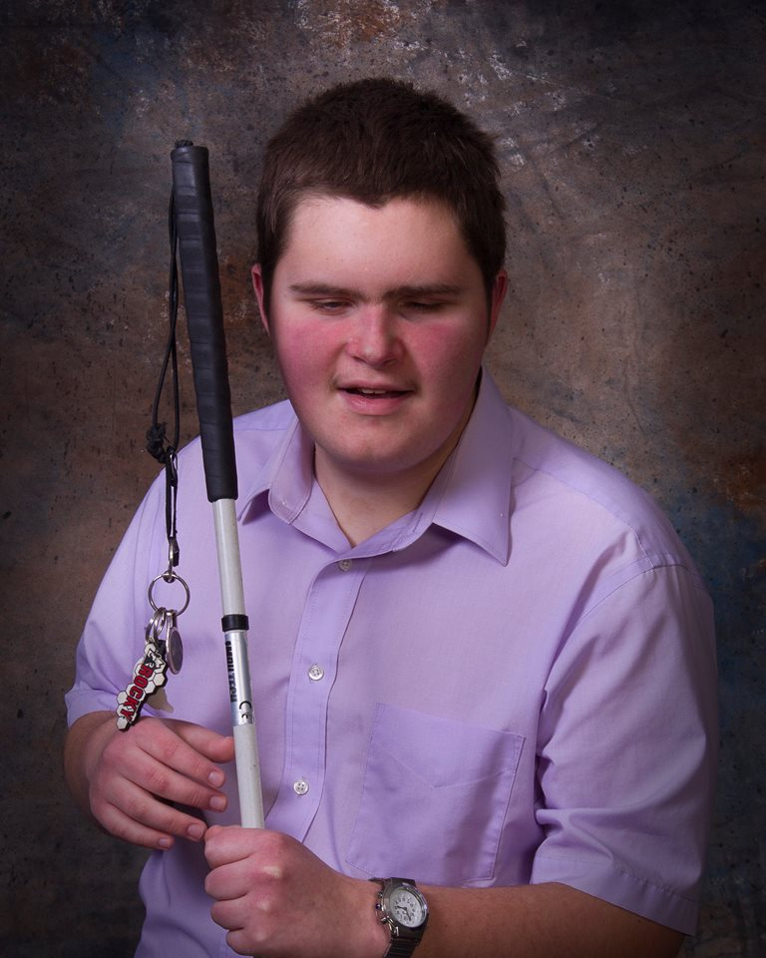
Caption: Rocky Hart

For those of you who don’t recognize me, let me introduce myself.

My name is Rocky Paul Hart. In 2002, I was born 10 weeks early to Kristy Brown, who at the time, was married to my father, Rocky A Hart. After many challenges with her pregnancy, my parents were beyond proud the day I was born. I spent nearly a month in the NICU of St. Cloud, MN and was finally able to go home where I was surrounded with love. At 4 months old, I was diagnosed with Norrie’s Disease, causing bilateral blindness and hearing loss. My Grandparents, Dwight & Mabel Semler lived nearby and I spent many days with them while my parents worked. My Great-Grandmother, Bonnie George was also there to support us as well as the love I could never forget from my Great-Great Grandma Louise Emmert who passed on when I was only 4.

My parents divorced when I was only 5 and my mom moved to Browerville, MN which was 90 miles west of Crosby. Because I was doing so well in my current school, she made the difficult decision to allow me to continue my education at CRES in Crosby. Once I reached the 6th grade, I knew it was time to find a place that could help me get thru the challenges of being completely blind accompanied by a degenerative hearing loss. Now, it was my turn to move on – and I chose to attend the Minnesota State Academy for the Blind, (MSAB.) Here is where I have grown into my own purpose and found that even though some see me as “unqualified” to achieve many of my dreams, I know that God can and will use me as long as I continue to work for him.

In the last 4 years I have been able to accomplish so many things. At MSAB, I was middle school representative, Vice President, and now President of Student Council as well as being active in many other activities to help encourage other students here. In January 2018 I traveled to Washington DC with Blind, Inc., an adjustment to blindness training center, and the National Federation of the Blind of Minnesota for discussions with members of congress to ensure compliance and access for all disabled people. I have been honored to attend many events at the MN State Capital and am a member of both the National Federation of the Blind and American Council of the blind.

I have a passion for writing, speaking and helping others – especially those that have been challenged with visual and hearing impairments amongst many other things. I have incredible dreams and goals and am always listening to what God is telling me. I have just recently completed my Pre ACT exams that will enable me to attend online college courses through North Central University while attending my last two years of High School. Through our membership with the Eagle Bend Assemblies of God Church, I am also preparing for the Minnesota Fine Arts Festival, where I received high honors in 2018 for my writing and sermon. I fully anticipate another successful event for 2019.

I would truly enjoy having you join me in my continued journeys through life. I may only be 16, yet I want to make a difference in millions of lives – and you can help me do this! Please take a few moments to visit my website. I am continually adding different stories, events and pictures to my site so feel free to visit often! www.godusestheunqualified.com

Blessings to you,
Rocky Hart

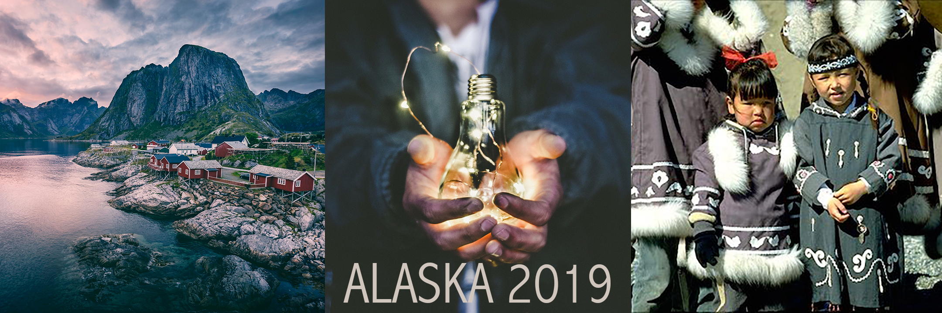
Caption: Mountains and Natives in Alaska

Dear Friends and Family,
For as long as I can remember, my passionate faith has always been the foundation upon which I live. I have seen firsthand how having a relationship with Jesus Christ can make a difference in one’s life. My life started out very “rocky” and at just 4 months of pregnancy, my mother nearly lost me twice. I was born at just 31 weeks and my challenges continued. The fact that I do not have my sight did not stop God from using me. With my faith and trust in him, I have triumphed over many adversities in life. Although I have been heavily influenced with the gospel from a very young age, it was at age 11 that I accepted Jesus Christ as my personal Lord and Savior. Since then, God has given me the strength and guidance to serve and follow him. Now more than ever, I do not find myself asking, “Why would God use me?” Instead, I ask, “How will God use me,” After all, I would have every reason to say, “I am not qualified.” One thing I am certain of, however, is God has created me to fulfill a mission for his purpose.
While at services during the National Fine Arts Festival in Houston last summer, I had the privilege of listening to a speaker from Speed the Light, an organization dedicated to missions. At the end of the service, anyone who felt called to missions’ work was asked to come forward. I stood immediately as I believe missions is a calling God has placed on my heart and it is my duty to obey him.
In June of 2019, I will have the great honor and privilege of traveling to Point Hope, a remote village in Northern Alaska which is only accessible by plane or boat. We will be serving with Mark & Heidi Zweifel and the team of Alaska Outreach to begin the journey of reaching 100 villages with no gospel witness. Our ministry will be primarily focused on youth and children. There, I will be part of a team that will provide a Children’s ministry that includes Vacation Bible School and sports camp. I believe that we are all ministers, and we are called in scripture to pass the good news on to others. I further believe that if we are to raise a Godly generation in our oppressive culture, we must start with the children.
In order to walk through this open door, I need some assistance. Primarily, I need friends and family to pray. Would you please commit to pray for me as I go? I need you to pray for my strength emotionally, physically, and spiritually. Pray that the Lord will meet my financial needs. I know the Lord will not give me passion without giving me provision. Pray also for everyone on our team, not only in our preparation but also in our going.

Secondly, I need friends and family to partner with me financially. Considering my physical challenges and being only 16 years old, my stepfather, Jeff, is also traveling with me. Our total trip cost will be $6000. I cannot raise all this alone, so thank you in advance for your partnership. Any gift, whether big or small, will help tremendously. In doing so, you are giving to God in order to build his kingdom. I am nearly a disciple that God is using to reach these children, and I could not have a more humbling and rewarding calling and opportunity.

You may visit my website at https://globalpassion.managedmissions.com/Donations/Donate/36910 and donate directly online to Global Passions where the funds will be used to purchase our airfare, food, lodging and other needs. If you prefer to mail in your gift, I have included a giving form and addressed, stamped envelope. Feel free to call me with any questions you might have as my number is included below. I will prayerfully await your decision concerning your part in this project.

Finally, I would be honored to visit your church and share my story and passion for Missions. If this is something you would be interested in, please contact us to make appropriate arrangements. I also have a website that contains several articles, a blog, and the heart felt sermon that I gave at the State and National Fine Arts Festival.

Thank you for taking the time to read this letter. I pray that you can be God’s extended hand to the people of Alaska.

Blessings,

Rocky Hart
Rockyhart1221@gmail.com
218.839.4544

Kristy Brown (mother)kaosworks@yahoo.com
218.838.2379

