**NFB of Georgia  Logo with tag line, "Live the life you want."
**

**2018 State Convention**

The National Federation of the Blind of Georgia

*Building our future. Building our movement.*

October 5-7

Hilton Garden Inn

101 South Front Street

Albany, GA 31701

# Welcome to the 2018 State Convention

The board of directors, convention committee, and I want to welcome you to the 45th annual state convention of the NFB of Georgia. Many people have worked hard over the last several months to create a dynamic and engaging agenda with something for everyone. If you have any questions or concerns while you are here, feel free to find a board member or member of the convention committee and we will help you take care of whatever you need. Patrice Lewis is our point of contact with the hotel. If there is a problem with our meeting spaces, please contact Patrice first.

Our convention theme this year is “Building our Future. Building our Movement.” The past year has been an exciting time of growth for the NFB of Georgia. We invested in our movement by training leaders, supporting students, and working to protect our rights in the state legislature. We want to celebrate those accomplishments and plan the next phase of building our movement! So jump in. Your contributions are wanted and needed. We strongly believe that, “Many hands make light work.” Let’s go build the National Federation of the Blind of Georgia!

Sincerely,

Greg Aikens

President, NFB of Georgia

# NFB Pledge

I pledge to participate actively in the effort of the National Federation of the Blind to achieve equality, opportunity, and security for the blind; to support the policies and programs of the Federation; and to abide by its constitution.

# 2018 Convention Sponsors

A big thank you to all of our 2018 Convention Sponsors.

## Diamond Level Sponsor

Georgia Vocational Rehabilitation Agency

## Gold Level Sponsors

B.J.’s Café

We Fit Wellness

## Silver Level Sponsors

Albany Advocacy Resource Center

Limb Support Inc.

Morehead Law Firm LLC

# 2017-2018 NFB of Georgia Officers and Board of Directors

President – Greg Aikens, Decatur Area Chapter

1st Vice President – Stancil Tootle, Bainbridge Chapter

2nd Vice President – Gaylon Tootle, Central Savannah River Area Chapter

Secretary – Dorothy Griffin, Atlanta Metro Chapter

Treasurer – Nata Watkins, At Large Chapter

Board Seat 1 – Marcia Robinson, Cobb County Empowerment Chapter

Board Seat 2 – Jackie Anderson, Georgia Organization for Parents of Blind Children

Board Seat 3 – Lafayette Wood, Atlanta Metro Chapter

Board Seat 4 – Shirley Robinson, Atlanta Metro Chapter

Board Seat 5 – Justin Heard, Georgia Association of Blind Students

Board Seat 6 – Melvin Scott, Southwest Georgia Chapter

## Free Aira Site Access at National Federation of the Blind of Georgia State Convention

The National Federation of the Blind has partnered with Aira to provide free Aira Site Access to NFB members during our 2018 state convention. Aira subscribers who are National Federation of the Blind members can use the service at our convention for free without having minutes deducted from their plans. In addition, those interested in Aira have the unique opportunity to try out the service for free while at our convention. This convention-wide, free site access is available only at NFB state conventions, giving NFB members an exclusive opportunity to test-drive Aira in a convention setting.

Aira allows blind individuals to connect via live video to a trained agent through a mobile app or wearable glasses to get real-time visual information or assistance. Learn more about Aira and special pricing available for NFB members at go.aira.io/NFB.

## How it Works

Before you head to convention or as soon as you get there, download the free Aira app from the App Store, and create a guest account if you are not already an Aira subscriber. Also, make sure your phone’s GPS feature is enabled. When you enter the convention Site Access location, your phone will receive a notification letting you know that the space you are in is part of the Aira Network. When you connect with an agent, he or she will also confirm that you are now covered by the network, and no minutes will be deducted from your account.

When you leave or enter convention areas that are covered by the Site Access network, you will be informed by the Aira agent.

To learn more about Aira and the special plan available exclusively to NFB members, visit go.aira.io/NFB.

# Convention Agenda

# Friday, October 5, 2018

# Seminar Day

## 12:00-6:00 PM – Registration, Flint Foyer

## 12:00-8:00 PM – Exhibit Hall, Flint Foyer

## 1:00-5:00 PM, Senior Possibilities Fair,

## Flint I and II

Registration and displays will begin at 1:00 p.m. Admission is $5.00 per person.    The fair will include a silent auction, speakers with an array of information, helpful hints along with an interesting mix of nonprofit partners, demonstrations, and displays for ALL seniors and adults to enjoy.

## 2:00-5:00 PM – Parents and Teachers of Blind Children Seminar, Radium Springs Room

Come meet other parents of blind children to network and learn about advocating for your child’s needs. We will also hear from speakers on a variety of topics

## 2:00-5:00 PM – Student Seminar, Water’s Edge

Come join with students from across Georgia to network, learn how to advocate for what you need in high school, college, and beyond. WE will also talk about working while in college, Assistive Technology, getting access to textbooks, and getting involved in sports and recreation.

## 7:30-10:00 PM – Blues Night, Flint I and II

Come join your NFB of Georgia family for some casual conversations, light snacks, and good music. The entrance fee is $5, which gets you one plate of snacks. There will be a cash bar and additional plates can be purchased for $5.

# Saturday, October 6, 2018

## 7:30-9:00 AM – Registration, Flint Foyer

## 7:30-8:45 AM – 2018 White Cane Rally, Ray Charles Plaza

Come join us as we raise awareness of and celebrate the independence we gain through the use of the white cane. Our White Cane Rally will be a launching point for other “Meet the Blind month” activities across the state in the month of October. We will meet outside the hotel and then march across the street into Ray Charles Plaza. Carla Heath-Sands from WALB will be the Master of Ceremonies for this event. Bring signs and NFB apparel to show everyone what we represent.

7:30-8:00 – Line up for march in hotel parking lot. A large door prize will be given out at 7:45 AM but you must be present to win.

8:00-8:25 AM – White Cane March to Ray Charles Plaza

8:25-8:45 – White Cane Rally with guest speakers.

## 9:00 AM-12:00 PM – Mini BELL Academy, Radium Springs

## General Session, Flint I and II

9:00 AM – Call to Order

9:05 AM – Invocation   
Pledge of Allegiance   
National Anthem- Carla Heath-Sands, WALB   
NFB Pledge.

9:15 AM –Greetings from Southwest Georgia Chapter, Melvin Scott, President

9:20 AM – Welcome to Albany   
Mayor Dorothy Hubbard  
Freedom Singers, Albany Civil Rights Institute  
Dr. Anthony Parker, President, Albany Technical College

9:50 AM – National Report – Shawn Callaway, Board of Directors, National Federation of the Blind and President, NFB of District of Columbia

10:35 AM – Fit Break

10:40 AM – The Federation Difference: What does quality blindness training look like? – Dr. Edward Bell, Director, Professional Development and Research Institute on Blindness, Louisiana Tech University

11:00 AM – Updates from GVRA - Denine Woodson, Director of Blind and Deaf Services, Georgia Vocational Rehabilitation Agency

11:20 AM – My Journey as a Blind Entrepreneur – Tracy Jackson, Phoenix Elite Solutions

11:40 AM – NFB Newsline, Dorothy Griffin, Outreach Manager, Georgia AUIAS NFB Newsline Service

11:50 AM - Announcements

12:00 PM – Adjourn

## 12:00-3:00 PM – Exhibit Hall, Flint Foyer

## 12:00-1:30 PM – Lunch and Division Meetings

All registered participants will pick up their box lunches in the Flint Foyer and then proceed to eat in one of the rooms below or wherever they choose.

#### Seniors Division, Water’s Edge

#### Parents Division, Radium Springs

#### Students Division, Flint I

#### Diabetes Action Network, Flint II

#### Merchants Division, Flint II

## 1:30-3:00 PM – Breakout Sessions

### 1:30-2:00 PM: Breakout Session 1

#### Fun with Movement!, Water’s Edge

Come stretch your legs, arms, and everything else after a long day of sitting through meetings. Our facilitator will get you dancing, moving, and ready for the rest of the weekend.

Facilitator: Blanch Griffin

#### At Large Chapter Meet-Up, Radium Springs

Are you At Large and in charge? Come join the chapter that knows no boundaries (at least geographically). If you want to get involved with the NFB of GA but do not live in an area with a local chapter, come find out about joining the At Large chapter.

Facilitator: Nata Watkins, President, At Large Chapter

#### VR Unwrapped – Flint I

Come learn at least seven things you may not know about your vocational rehabilitation.

Facilitators: George Vickers and VaShaun Jones

#### Advocacy and the ADA – Flint II

Come learn about your rights under the Americans with Disabilities Act and be empowered with advocacy tips, tools, and techniques.

Facilitator: Gaylon Tootle

### 2:00-2:30 PM – Breakout Session 2

#### Fun with Movement!, Water’s Edge

Come stretch your legs, arms, and everything else after a long day of sitting through meetings. Our facilitator will get you dancing, moving, and ready for the rest of the weekend.

Facilitator: Blanch Griffin

#### VR Unwrapped – Flint I

Come learn at least seven things you may not know about your vocational rehabilitation.

Facilitators: George Vickers and VaShaun Jones

#### The NFB Training Center Difference, Flint II

Are you interested in learning about what training at an NFB Center is like? What’s all the fuss about NFB Training anyway? Are you interested in educational opportunities to teach Orientation and Mobility, Blind Students, or become a Blind Rehabilitation Teacher? Come join Dr. Bell and center alumni to answer all of your questions related to NFB training. Facilitator: Dr. Edward Bell

#### Diabetes and Eye Health, Radium Springs

Gurinder Doad, MD, is with Phoebe Health Care System located in Albany, GA. Dr. Doad will be discussing Diabetes and the effects it has on the eyes.

Facilitator: Gurinder Doad, MD

## 3:00-5:00 PM – Mini BELL Academy, Radium Springs

## 3:00-5:00 PM - General Session, Flint I and II

3:00 PM – State President Report – Greg Aikens, President, NFB of Georgia

3:50 PM – National Student Update – Syed Rizvi, 1st Vice President, National Association of Blind Students

4:05 –Georgia Radio Reading Service – Rebecca Arayan, Executive Director

4:15 – Updates from Project Independence – Kay McGill, Program Manager, Georgia Vocational Rehabilitation Agency

4:30 PM – Centers for Independent Living: Another Resource for Blind Georgians – Panel of representatives from various CILS in Georgia

5:00 PM – Adjourn

## 7:00-11:00 PM – NFB of Georgia 2018 State Convention Banquet, Flint I and II

Master of Ceremonies: Dorothy Griffin, NFB of Georgia Secretary and Atlanta Metro Chapter President

Diamond Sponsor – Georgia vocational Rehabilitation Agency – Shirley Robinson, Assistant Director for Blind Services

White Cane Award

Keynote Speaker: Shawn Callaway, Board of Directors, National Federation of the Blind and President, NFB of District of Columbia

Georgia Derby

# Sunday, October 7, 2018

## 8:00-8:45 AM – Communities of Faith, Flint I and II

## 9:00 AM-12:00 PM Annual Business Meeting, Flint I and II

9:00 AM – Call to Order

9:05 AM – Guest Music

9:20 AM – Roll Call of Chapters and Divisions

9:50 AM – Officer Reports

10:10 AM – Nominating Committee Report

10:15 AM – Elections

10:30 AM – Business Session

12:00 PM – ADJOURN

# Speaker Biographies

## Shawn Callaway

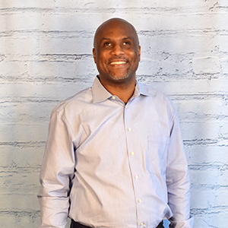

Shawn Callaway was born in Washington, DC and grew up in Prince George’s County, Maryland. When he was a sophomore at South Carolina State University, a classmate was playing with a gun and accidentally shot Shawn in the temple. The accident resulted in the detachment of his optic nerves, which caused total blindness. Shawn returned to the DC area and received blindness training at the Workforce Technology Center in Baltimore. He credits a blind man named Lou Smith with providing his training and being an early mentor. He also credits his parents for encouraging him throughout his transition to life as a successful blind person. After his rehabilitation training, Shawn earned his associate’s degree in psychology from Essex Community College in 1995, his bachelor's degree from the University of Maryland in 1997, and then his master's in social work from Catholic University of America in 2000. He began his professional career working with the homeless at Catholic Charities, and then went on to counsel children in the Washington, DC public schools system for the city's Department of Behavioral Health. He now works as a program specialist for the United States Department of Health and Human Services, specifically in programs of the Administration on Community Living and the Administration on Intellectual and Developmental Disabilities. In 2005 he married Latonya Rollins of Cleveland, Ohio.

Shawn had heard of the National Federation of the Blind in the mid-1990s but was initially convinced by a friend that the organization was too radical for him. In retrospect, he believes he was given bad information and wishes that he had become a Federationist earlier. After being invited to a chapter meeting by Linda Black-White, Shawn finally joined in the spring of 2009. He found himself leading the Washington, DC affiliate when longtime leader Don Galloway died in 2011.

Shawn already had confidence in most of his blindness skills when he joined the National Federation of the Blind, but he says that he was still apprehensive about becoming a parent. The opportunity to observe and talk to blind parents like Mark and Melissa Riccobono and Tracy Soforenco, as well as a DC Federationist named Vicky Smith, gave him confidence that he could be a successful blind parent. He is now the proud father of his daughter Camille who was born in 2014.

Shawn also credits participation in the NFB with opening up other leadership and community involvement opportunities for him. He has served on the boards of the DC Center for Independent Living and the Columbia Lighthouse for the Blind and has chaired the DC rehabilitation council. He currently co-hosts a community radio program called Open Our Eyes on two local stations. In addition, Shawn serves as the President of the DC Friends of the Talking Book and Braille Library and is a member of the DC Blind Bowlers Association. Shawn says, "I am grateful for the opportunity to serve on the NFB Board of Directors, both to give back to the organization as a whole and because so many past and present board members like Fred Schroeder, Anil Lewis, Dr. Joanne Wilson, Sam Gleese, Pam Allen, and Ever Lee Hairston have inspired and mentored me. I will strive to fill the same role for other leaders and members of our great movement, and devote every ounce of my energy to building the Federation and advocating for all blind citizens."

## Mayor Dorothy Hubbard

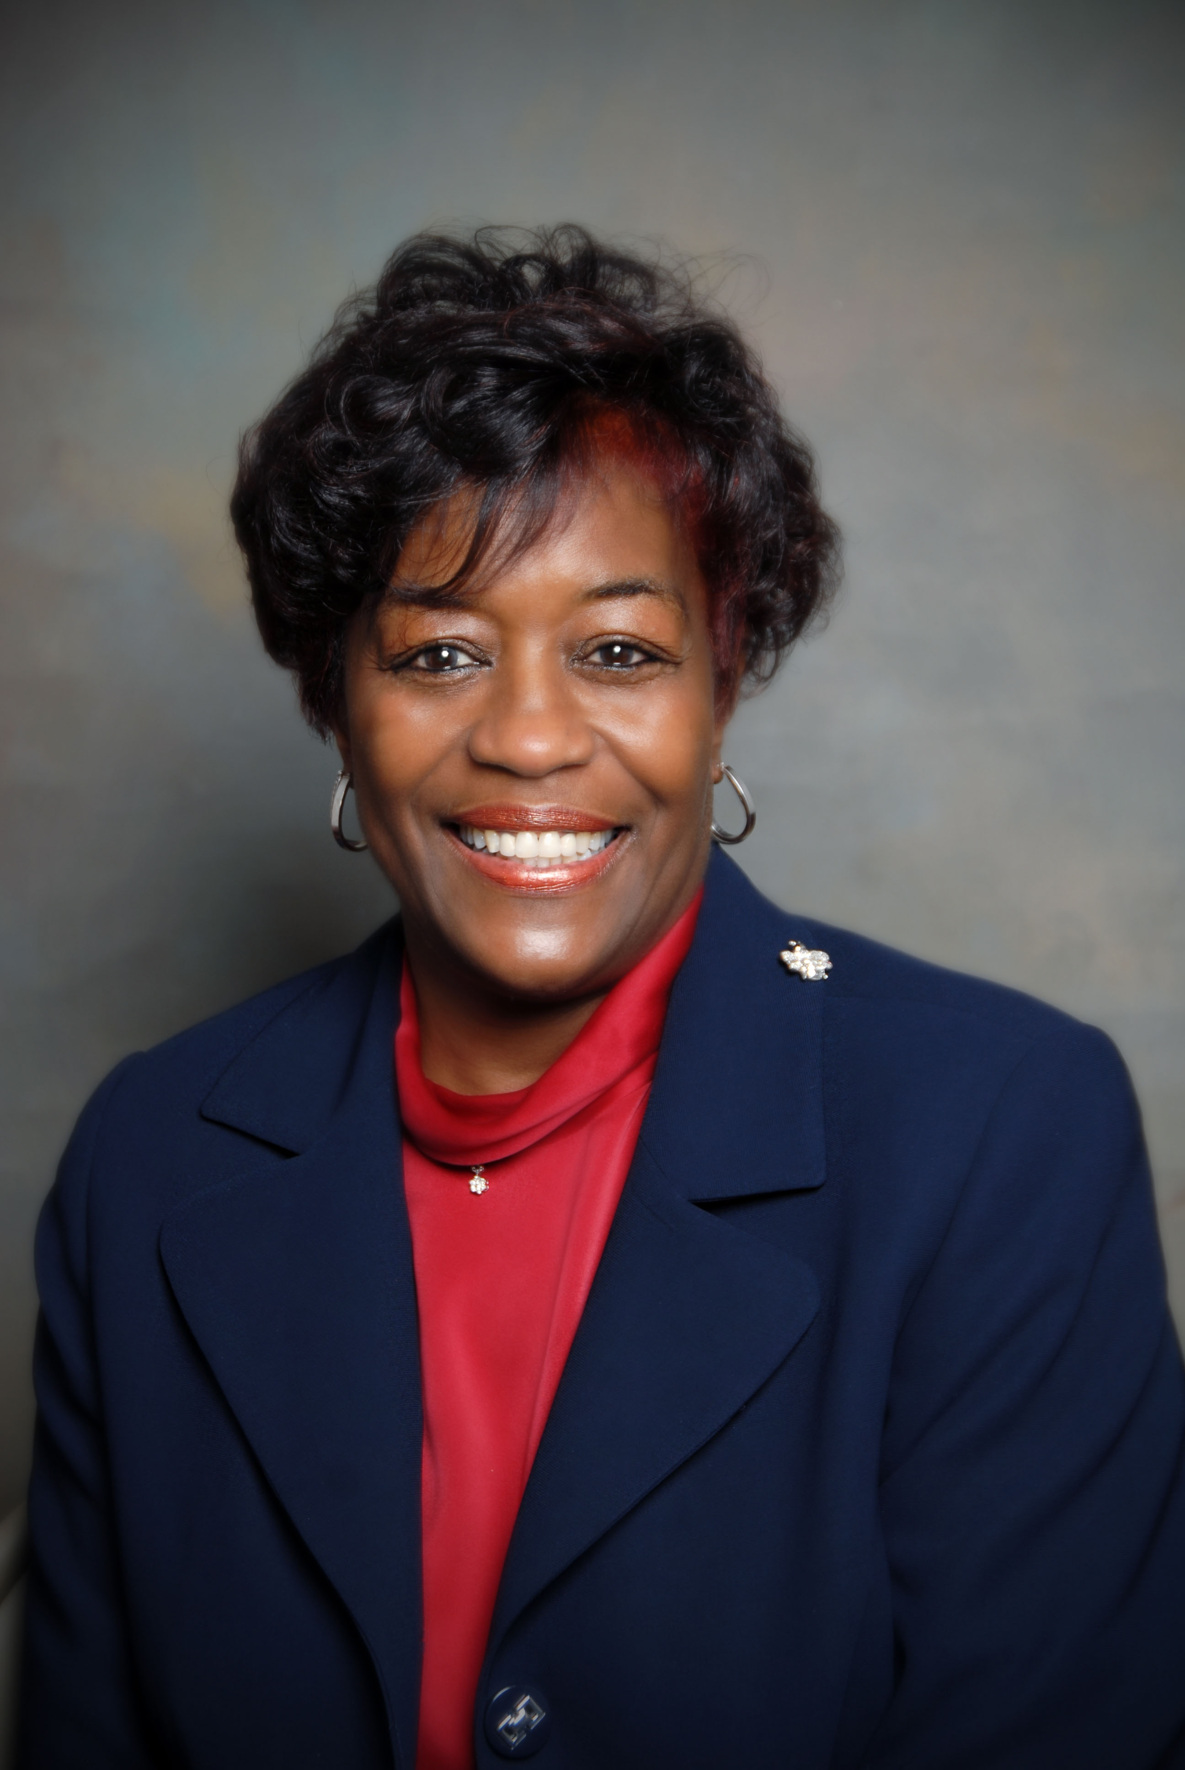Sworn in as Mayor of the City of Albany, Georgia on Monday January 9, 2012, Dorothy Hubbard is an Americus native, and a graduate of Sumter High School. She has a Bachelor of Science Degree in Business Education from Albany State University and a Masters of Education in Administration and Supervision from the University of Georgia. She and her husband, Robert, have four grown children and seven grandchildren.

Mrs. Hubbard retired in 1999 from Albany State University (ASU) as Assistant to the President. Also, in her 29-year tenure at ASU, she served as Registrar and Assistant Vice President for Academic Affairs, Director of Admissions and Records, Assistant Director of Admissions, Admissions Counselor, and Secretary.

Her community service activities include leadership roles which with The American Heart Association, American Cancer Society, Albany Museum of Art, Girls Inc., of Albany, the Semper Fidelis Club, Inc., Chosen to Conquer, Inc., and The Albany Georgia Chapter of The Links, Inc. Mrs. Hubbard is also a member of the First Monumental Faith Baptist Church.

Mrs. Hubbard began her political career when she was appointed by Governor Sonny Perdue to fill the Ward 2 seat in March 2005 and May 2005. She was elected to serve her first full term as Ward 2 Commissioner in November 2005 and continued in that capacity until she resigned in August of 2012 to run for Mayor of the City of Albany.

An active Mayor representing the City of Albany in various capacities, Mayor Hubbard served as President of the Georgia Municipal Association from June 2017 – June 2018.

# Dr. Anthony Parker

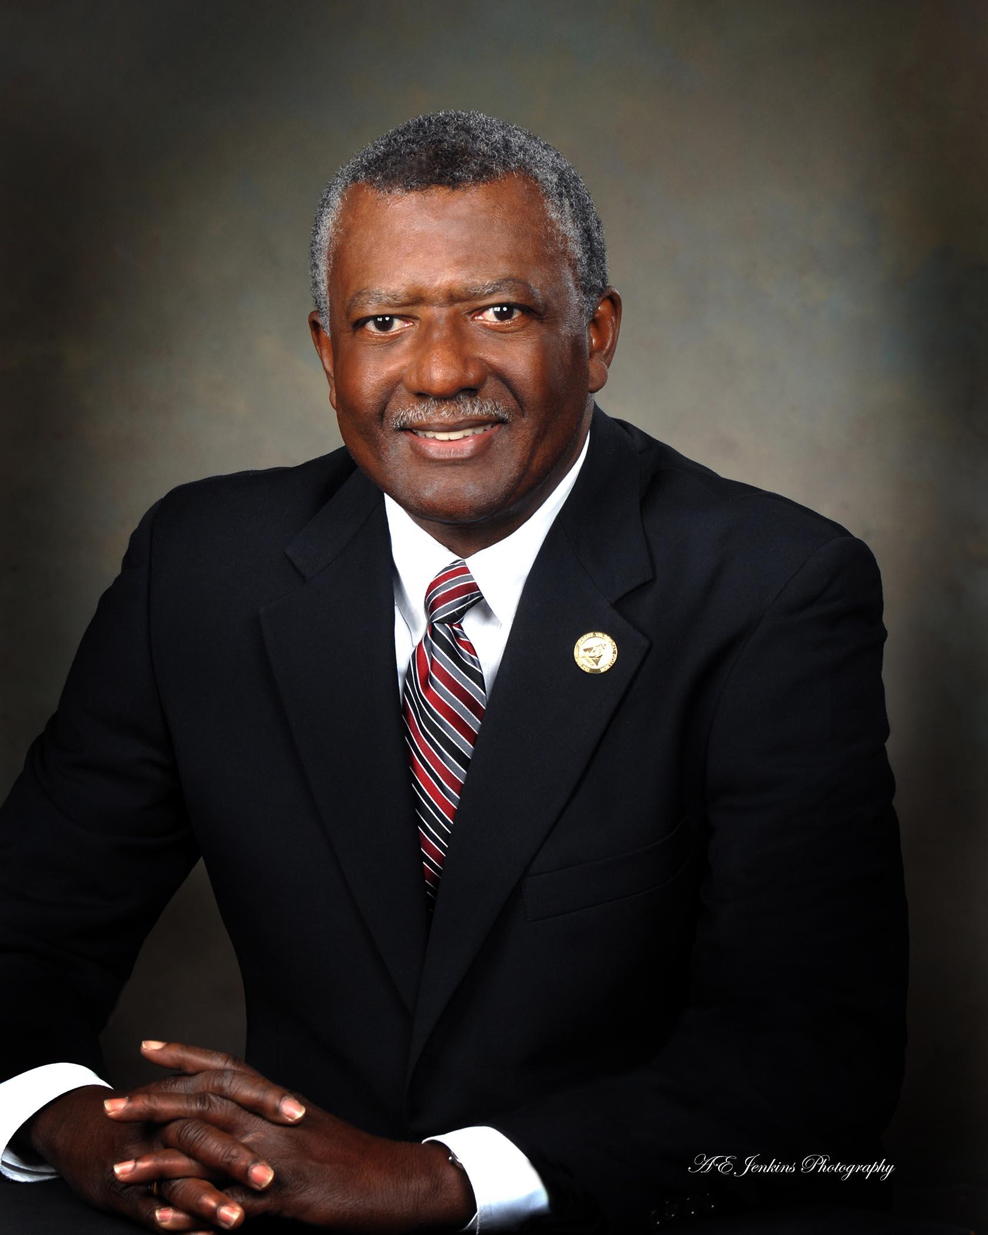

Dr. Anthony O. Parker has been president of Albany Technical College since July 1995. He is the former vice president of student services at Aiken Technical College in Aiken, S.C, and Southeastern Tech in Vidalia, GA. In July of 2005, Parker also assumed the duties of interim assistant commissioner of Adult Literacy for the Technical College System of Georgia in Atlanta serving from July 1, 2005, through April 1, 2006.

Since his arrival, Albany Tech has completed a capital campaign, doubled enrollment, and taken responsibility for adult literacy. New facilities were constructed or renovated on the Dougherty County Campus, a campus was constructed in Early County, and a learning center was built in Randolph County.

Parker received a Bachelor of Science degree in Accounting from South Carolina State University, a master of education degree in counseling and guidance from South Carolina State University, a specialist in education degree in educational administration from Augusta College and a Ph.D. from the University of South Carolina. Parker graduated from the Institute of Educational Management at the Harvard University Graduate School. He graduated from the Executive Leadership Institute at the League for Innovation in the Community College and also served as a faculty member on four occasions.

Parker is married to the former Sandra Pinkney. They have three children, Kimberly, Andrea Parker Smith and Richard Anthony.