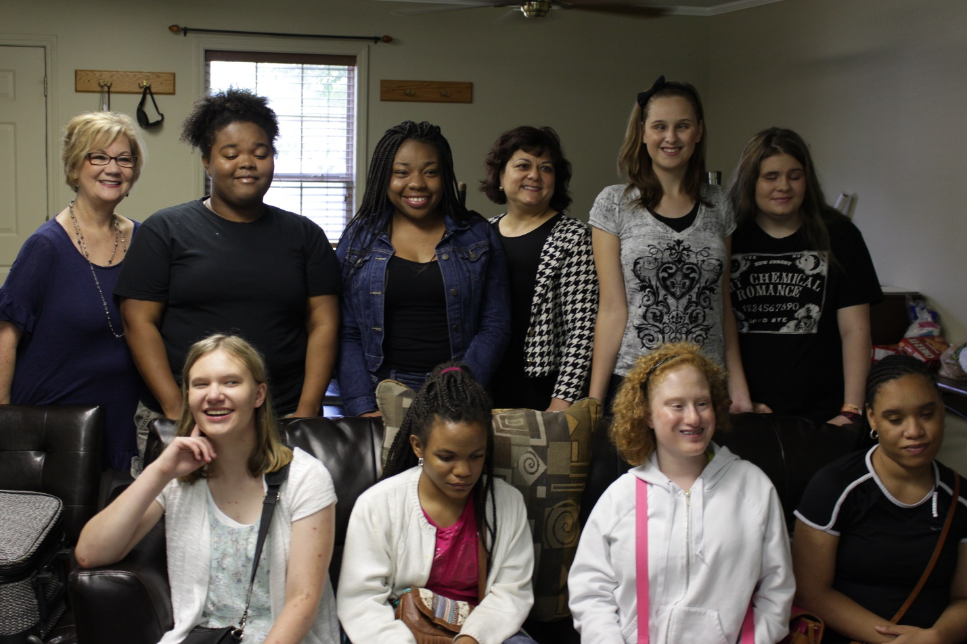

2018 SUMMER TRAINING & EMPLOYMENT PROJECT (STEP) Program
STRIVING FOR SUCCESS

Since 1985, the Louisiana Center for the Blind has been changing what it means to be blind for adults from across America. In 1990, a program was created to address the needs of blind high school students. The Summer Training and Employment Project (STEP) Program is designed to introduce blind teenagers to positive blind role models and to provide participants with summer work experience.

The eight-week summer program will consist of two components. During the first part of the program, competent blind counselors will instruct the students in the alternative techniques of blindness. Classes in Braille, cane travel, computer literacy, and daily living skills will be taught by qualified blind instructors. In addition, seminars will be conducted in the areas of job readiness, job interviewing skills, resume writing and job responsibilities. The second part of the program will continue all aspects of training and expand to include an employment dimension. Students will have the opportunity to participate in 40 hours of internship experience--for which they will receive the Federal minimum wage. Students will be introduced to a broad spectrum of career possibilities as they explore postsecondary options.
The combination of work experience and blindness-related skills--along with fun-filled activities such as cookouts, swimming, mall excursions, and various other outings--will foster self-confidence and independence in blind teens. From July 3-8, students will attend the national convention of the National Federation of the Blind in Orlando, Florida. This exciting conference will allow them to meet thousands of competent blind people from across the country. The students will also have the chance to participate in a wide variety of informative seminars and youth-oriented social and other activities. At the close of the program, parents will be REQUIRED to attend a Parents’ Weekend which will enable them to discover how much their children have learned throughout the summer. The STEP program is designed to provide invaluable work experience, friendships, opportunities for personal growth, and cherished memories.

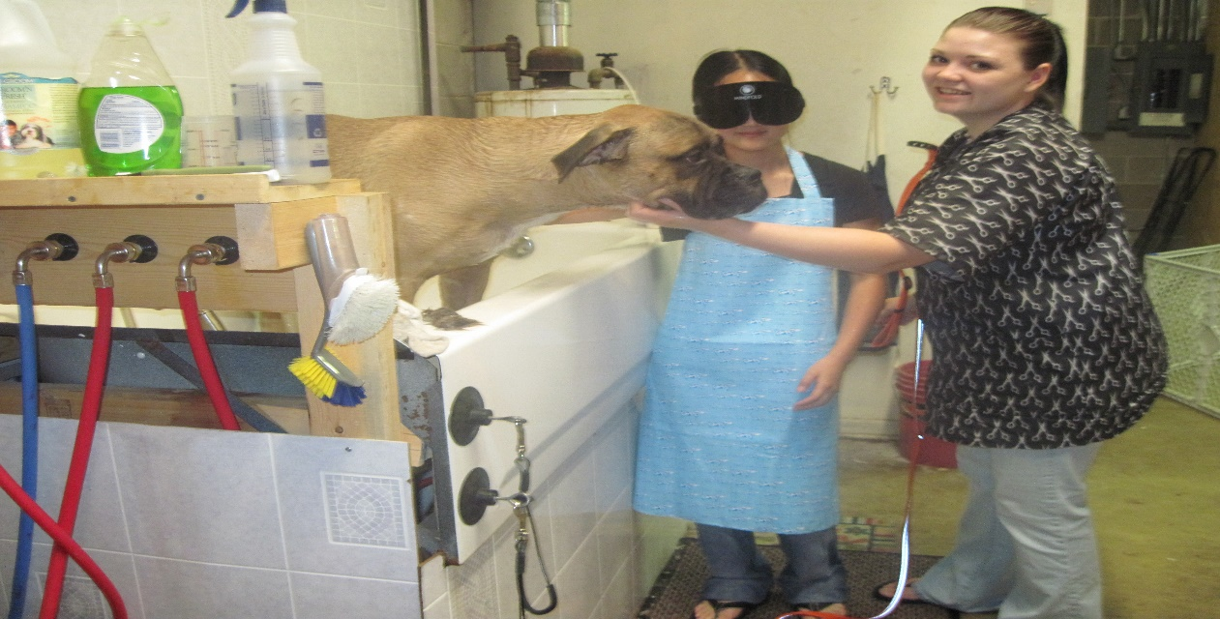

Training will begin June 10 and conclude August 4. We recognize that there may be some overlap between the start and/or conclusion of our program and school district dates. If accepted, we are happy to coordinate with a student’s school district in this regard. Please visit www.louisianacenter.org to learn about more program specifics and to complete an application.
Due to limited space, we cannot guarantee that every applicant will be granted enrollment, and applicants must have an open case with their state’s vocational rehabilitation agency or other funding entity to cover program costs.
Questions? Please call our Director of Youth Services, Eric Guillory at 800-234-4166 or email him at eguillory@louisianacenter.org. "Together, we are changing what it means to be blind." Check out STEP and find out how.

