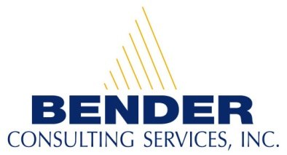
Recruiting and hiring people with disabilities for competitive career opportunities

Career Opportunities for People with Disabilities

Asset Management Specialist Position in Arlington, VA

Contact Person: Brandon Kazmierczak
E-mail address: resume@benderconsult.com
Telephone Number: 412-446-4451
Fax: 412-787-7178

Qualifications:
- Bachelor’s degree in Computer Science, MIS, or related field or equivalent experience.
- Knowledge of systems development or systems analysis. Understanding of Inventory Management a plus.
- Knowledge or experience with programming languages, operating systems, hardware and software. Knowledge of using relational databases to facilitate systems analysis.
- Strong communication and interpersonal skills.
- Strong analytical and problem solving skills. Ability to multitask in a fast-paced environment.
- The successful candidate must be able to gain a security clearance.

Position Description:
- Work with Remedy and a Configuration Management Database to maintain customer and internal asset management systems.
- Coordinate and facilitate internal meetings to gather and document asset management requirements and explore complex solutions.
- Provide expertise in technical reviews and time estimates for project related tasks.

About our Company:
Bender Consulting Services, Inc. specializes in hiring individuals with disabilities for competitive employment opportunities. Positions include careers in information technology, finance, accounting, human resources, engineering, nursing, law, and other general business areas.
Our President and CEO, Joyce A. Bender, is the host of the international web-based talk show, Disability Matters with Joyce Bender. A person with epilepsy and a hearing loss, she has dedicated her life to furthering the employment and empowerment of people with disabilities. Ms. Bender received the New Freedom Initiative Award under the Bush Administration and the President’s Award from President Clinton. For more information, please visit our website at www.benderconsult.com.

3 PENN CENTER WEST - SUITE 223 PITTSBURGH, PA 15276
www.benderconsult.com
Competitive Jobs Mean Freedom

