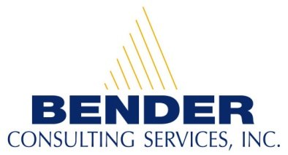
Recruiting and hiring people with disabilities for competitive career opportunities

Career Opportunities for People with Disabilities

Billing Associate Professional in Falls Church, VA

Contact Person: Brandon Kazmierczak
E-mail address: resume@benderconsult.com
Telephone Number: 412-446-4451
Fax: 412-787-7178

Qualifications:
- Bachelor's degree or equivalent combination of education and experience.
- Bachelor's degree in business administration, accounting, finance, or related field preferred.
- Zero or more years of experience in accounting, finance or related field.
- Experience working with generally accepted accounting principles and accounting software.
- Experience working with contacts including government contracts and customer invoicing.
- Personal computer and business solutions software skills.
- Interpersonal and Communication skills for communicating with support personnel and management.
- Analytical and problem solving skills.
- Planning and organizational skills to balance and prioritize work.
- Ability to work independently and as part of a team.

Position Description:
- Bills customers in a timely and accurate manner.
- Ensures bills are in compliance with appropriate contracts, guidelines and regulations.
- Identifies issues, researches same and remedies as appropriate.
- Reconciles unbilled receivables on a scheduled basis. Researches and analyzes information to determine appropriate course of action including recreating or revising bills. Recommends changes to enhance process.
- Reviews various reports such as aged receivables to identify unpaid invoices. Determines appropriate course of action to collect payments and implements same.
- Maintains and updates billing folders in accordance with established guidelines

About our Company:
Bender Consulting Services, Inc. specializes in hiring individuals with disabilities for competitive employment opportunities. Positions include careers in information technology, finance, accounting, human resources, engineering, nursing, law, and other general business areas.
Our President and CEO, Joyce A. Bender, is the host of the international web-based talk show, Disability Matters with Joyce Bender. A person with epilepsy and a hearing loss, she has dedicated her life to furthering the employment and empowerment of people with disabilities. Ms. Bender received the New Freedom Initiative Award under the Bush Administration and the President’s Award from President Clinton. For more information, please visit our website at www.benderconsult.com.

3 PENN CENTER WEST - SUITE 223 PITTSBURGH, PA 15276
www.benderconsult.com
Competitive Jobs Mean Freedom

