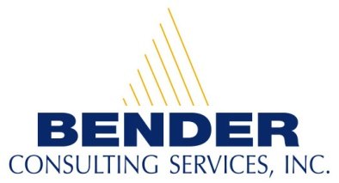
Recruiting and hiring people with disabilities for competitive career opportunities

Career Opportunities for People with Disabilities

Desktop Support in Arlington, VA

Contact Person: Brandon Kazmierczak
E-mail address: resume@benderconsult.com
Telephone Number: 412-446-4451
Fax: 412-787-7178

Qualifications:
- Bachelor’s degree in Computer Science, Information Science, or the equivalent is preferred. An Associate’s degree or equivalent technical training will be considered. Microsoft, Novell, or A+ certification will also be considered.
- Customer service oriented, along with excellent organizational skills.
- Knowledge of PC hardware/software, including internal and peripheral equipment.
- Knowledge of Windows 2000/XP and Microsoft Office, along with strong trouble shooting skills.

Position Description:
- Assist users by troubleshooting hardware and software problems.
- Determine and resolve various problems as well as performing effectively as a member of a project team and function independently.
- Provide 2nd level technical support and escalate unresolved problems when necessary.

About our Company:
Bender Consulting Services, Inc. specializes in hiring individuals with disabilities for competitive employment opportunities. Positions include careers in information technology, finance, accounting, human resources, engineering, nursing, law, and other general business areas.
Our President and CEO, Joyce A. Bender, is the host of the international web-based talk show, Disability Matters with Joyce Bender. A person with epilepsy and a hearing loss, she has dedicated her life to furthering the employment and empowerment of people with disabilities. Ms. Bender received the New Freedom Initiative Award under the Bush Administration and the President’s Award from President Clinton. For more information, please visit our website at www.benderconsult.com.

3 PENN CENTER WEST - SUITE 223 PITTSBURGH, PA 15276
www.benderconsult.com
Competitive Jobs Mean Freedom

