***“Be OK with Blindness”***

**4th Annual**

***Workshop For***

**Parents, Teachers and Para-professionals of Blind**

**And low vision children, teens, and young adults**

**Saturday- April 13, 2013**

**8:00 AM to 5:00 PM**

**National Federation of the Blind Jernigan Institute**

**C:\Users\pickrels\AppData\Local\Microsoft\Windows\Temporary Internet Files\Content.IE5\XLNE9WB1\MC900089086[2].wmf200 E. Wells Street, Baltimore, MD 21230**

**Focus This Year on:**

**O & M**

**Travel and independence**

**Parents and Teachers and Professionals –**

**Workshops with top instructors in the field of Orientation. GPS technology for the Blind, Clicking technique**

**And other workshops on Social and Independence skills.**

**Blind and low vision youth and young adults (9years to 24years) --**

**Hands on Training while enjoying Socialization and fun with their peers.**

**Child care (3mths-8years)-- with a fun class for Pre cane walkers**

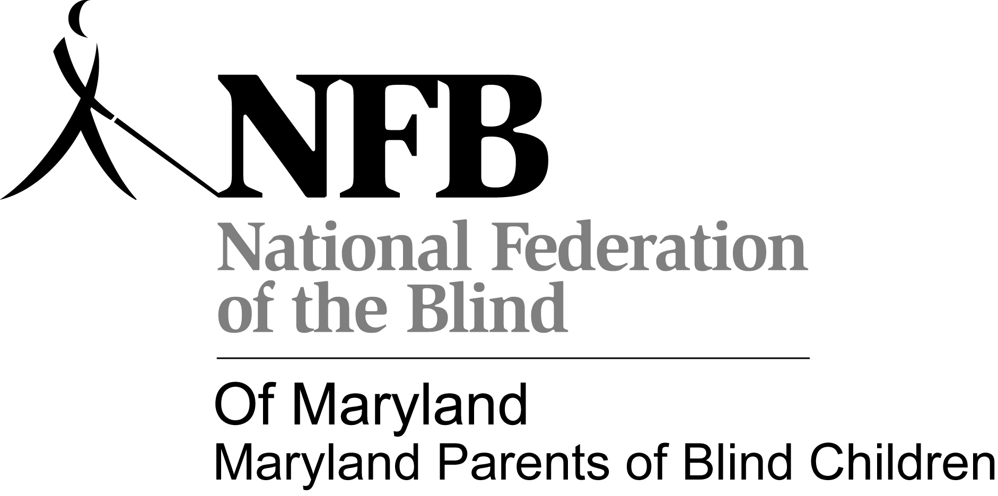**No Cost (Continental Breakfast & Lunch provided)**

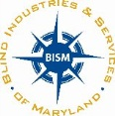 **If you have and questions, please contact:**

**Trudy Pickrel** [**TLPickrel@hotmail.com**](mailto:TLPickrel@hotmail.com) **(301-501-1818**

**Presented by: Dan Wenzel** [**Dwenzel@bism.org**](mailto:Dwenzel@bism.org) **(410)737-2676**

**Maryland Parents of Blind Children**

**And Blind Industries & Services of Maryland**