Fundraiser
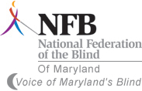
Help Support the Howard County Chapter of the National Federation of the Blind of Maryland and Maryland Parents of Blind Children
We provide hope to the newly blind, opportunities for children to gain independence, encouragement to seniors losing vision, and the full participation of the blind in all aspects of community life.
Please join us for Foundation Monday on
August 12th, 2013
Tino’s Italian Bistro
8775 Centre Park Drive
Columbia, MD 21045
410-730-TINO( 8466)
Hours: 11 a.m. to 10 p.m.
Reservations are recommended for dinner service. Please mention the NFB when making your reservations and carry out orders.

