Distinguish yourself among teachers
of the blind and visually impaired!

Don't miss this unique opportunity to take this
nationally-recognized exam in your own back yard.

The National Certification in Literary Braille (NCLB)
test will be administered by the
National Blindness Professional Certification Board (NBPCB)
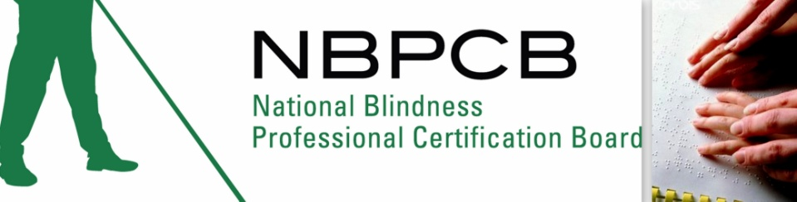

in
Baltimore, Maryland

Saturday, September 28, 2013
9 a.m. – 4:30 p.m.

at
BISM
3345 Washington Blvd

Deadline for registration is September 13

Please go to our website, www.nbpcb.org/nclb,
for more information and to register for this important test.

braille@nbpcb.org Professionals: $200
(318) 257-4554 Students: $100

