Baltimore Orioles
vs. Blue Jays

Thursday, Sept. 26

7:05 p.m. ● Orioles Park at Camden Yards

$15 Tickets ● Left Field Lower Reserve
Ticket Sales in Section 75 benefit the Baltimore Chapter of the National Federation of the Blind
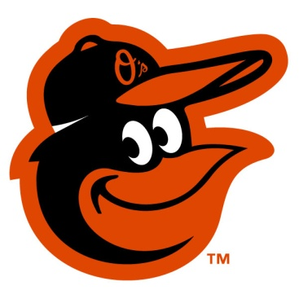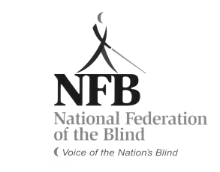
Tickets on sale until Monday Sept 9

For tickets or more information, call
Chris Danielsen 410 262 1281

