**Lobbying for Disability Rights**

*A Disability Awareness Month Roundtable*

**Finding your voice and identifying your message**

**Techniques for Using the Media**



**Building a Lobbying Strategy**

Join us to discuss how **YOU** can get involved!

|  |  |
| --- | --- |
| **Lobbying Basics**  Andrew Smullian, Deputy Chief, Legislative Affairs | **Lobbying the General Assembly**  Delegate Samuel Rosenberg, District 41 |
| **Lobbying the City Council**  Councilman Robert Curran, City Council District 3 | **Using the Media to Generate Support**  Chris Danielsen, National Federation of the Blind |

**Wednesday October 23, 2013**

1:00 pm - 3:00 pm

**City Hall, 100 N. Holliday Street**

Curran Room

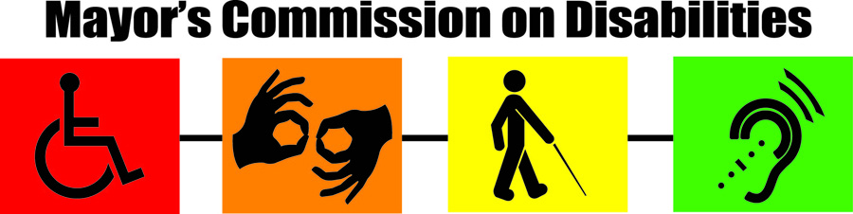*To arrange special accommodations (Interpreter, Hearing/Vision, Parking) contact by October 16th Dr. Nollie Wood @* [*Nollie.Wood@baltimorecity.gov*](mailto:Nollie.Wood@baltimorecity.gov) *or 443-984-3170.*