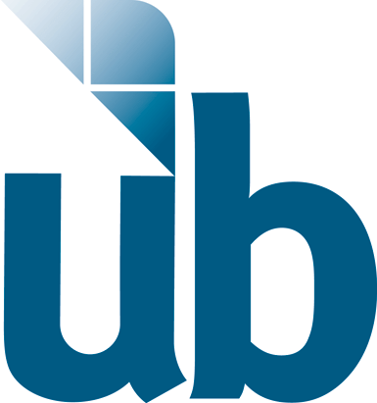

Ballot Marking Research Study at the University of Baltimore
Description: We are studying the accessibility and usability of a ballot marking machine for the State of Maryland. During the study, you will be asked to mark and submit a ballot using a machine that has assistive technologies. Participants will be compensated $80 to cover the costs of their time and transportation. The details of the study are listed below:

Time: By appointment. Study will take about an hour.
When: April 23rd-30th, 2014
Compensation: $80
Location: University of Baltimore
Academic Center Room # 205 S
1420 N Charles St
Baltimore, MD 21201

If you would like to participate:
Email: ubusabilitylab@gmail.com
Call: 410-837-1974
Or fill out our online questionnaire:
https://docs.google.com/forms/d/1LKgAszSrrx-WAewcOMq5dbtkFGIytPlz4SlDVY3e6gc/viewform

If you have any questions, please call us at 410-837-1974 or email us at ubusabilitylab@gmail.com

