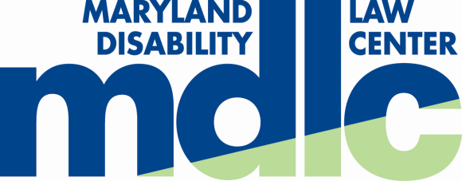

As a Marylander Voter, you have the right to:

Vote in an accessible polling place. Call your local board of elections or check on-line at http://www.elections.state.md.us/voting/accessibility.html to find out if your polling site is accessible to you. The on-line polling site locator will also confirm that you are registered. To request an accessible polling site contact your local board of elections by close of voter registration.

Vote at an early voting center in the county where you live. To find an early voting center near you, go to: http://www.elections.state.md.us/voting/early_voting.html

Vote by absentee ballot. Any registered voter may request to vote by absentee ballot. To get an application and to check deadlines, go to: http://www.elections.state.md.us/voting/absentee.html

Cast a private and independent ballot.

Receive voting assistance if needed. You may ask an election judge for help, or bring any other person to help you except your employer or union official.

Cast a ballot on an accessible voting machine. You may select a large print or high contrast ballot. You may also request an audio ballot, which requires the use of headphones and a keypad. The angle of the voting machines can also be adjusted for better access.

Cast a ballot as long as you are in line when the polls close.

Vote a provisional ballot if your name does not appear on the voter registration list or there is a question about your eligibility to vote.

It is a good idea to bring identification with you. Federal law requires that if you registered to vote by mail you must provide identification before voting for the first time in Maryland.

Voter Hotline

To report voting concerns that may be related to a disability (such as access to a polling place, voter assistance, or problems using a voting machine) contact:
Maryland Disability Law Center at 410-727-6352, ext. 2507; 800-233-7201, ext. 2507; TTY 410-235-5387

