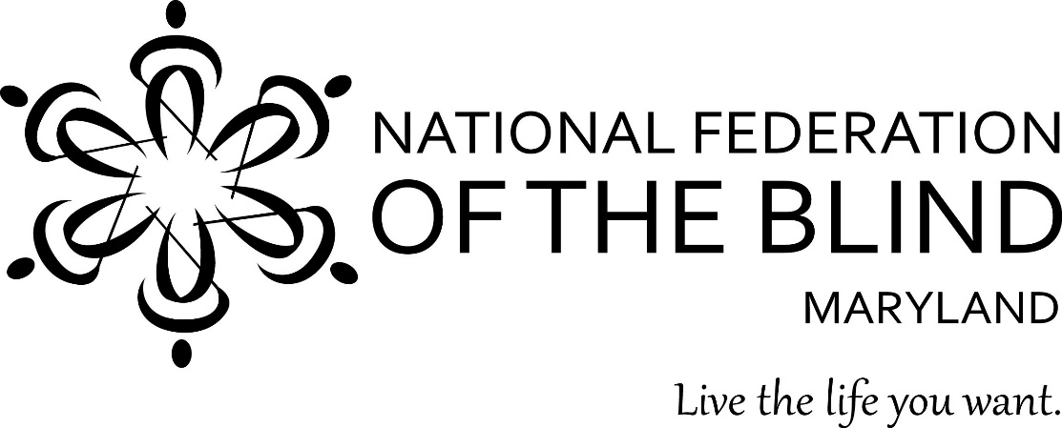

Wine Tasting
a benefit evening for
Greater Baltimore Chapter,
National Federation of the Blind

Saturday, October 15, 5:00-7:00

Spirits of Mt. Vernon
900 North Charles St.

Enter to win a raffle for a $250 gift certificate to Spirits of Mt. Vernon! You must be present to win. The Greater Baltimore Chapter of NFB invites you to join us for an evening of fine wine and good company.

