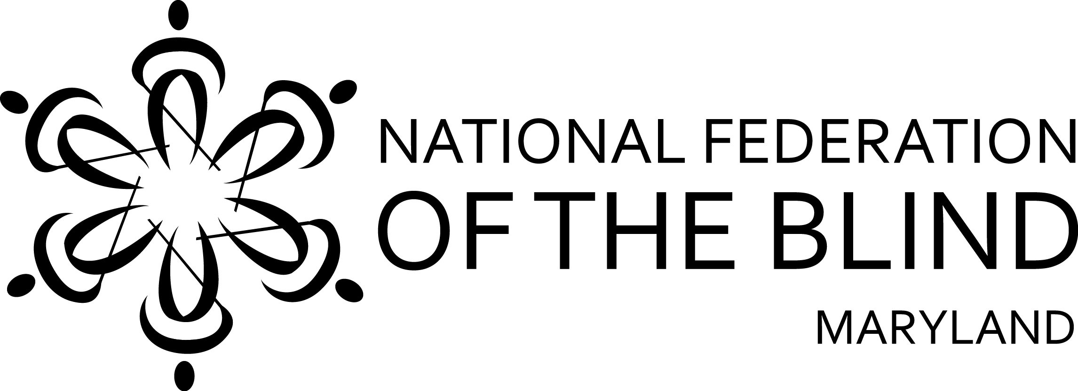
Request for Door Prizes
50th Annual Convention: October 28-30, 2016

August 15, 2016
The National Federation of the Blind of Maryland, an affiliate of the National Federation of the Blind, is an organization of blind persons working for equal rights and equal opportunities for the blind. We provide advocacy services for the blind, special training programs for parents of blind children, job referrals and placements for the blind, and public education programs. We offer scholarships to blind students and help the newly blind to acquire special techniques for maintaining productive lives.
The National Federation of the Blind of Maryland is a 501c3 nonprofit organization which depends on public support to carry out its programs. NFBMD Tax Id: 52-1301033.
The National Federation of the Blind of Maryland is holding its Annual State Convention on Friday-Sunday, October 28-30, 2016 at the Baltimore Marriott Inner Harbor at Camden Yards, 110 Eutaw Street, Baltimore, Maryland 21201. The expected attendance at this event is approximately 400 people.
We ask for your help in making our convention a success by contributing merchandise or gift cards to be used as door prizes. Your establishment will be recognized frequently by announcements throughout the convention.

Send Donations to: NFBMD
9013 Nelson Way
Columbia, MD 21045

For additional information contact Sharon Maneki, President, at (410) 715-9596 or nfbmd@earthlink.net
We appreciate any donation that you are able to make. Thank you for considering this request.

2016 Donation Receipt
NFBMD Tax Id: 52-1301033

Donated By:_____________________________________________

Date:_________________

Item Description:____________________________________Value:________________

RECEIVED BY NFBMD

Representative: ___________________________________________________________ Signature

