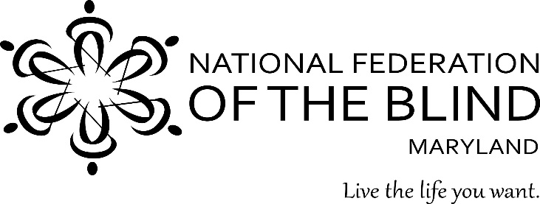
Sharon Maneki, President
9013 Nelson Way
Columbia, MD 21045
410-715-9596
nfbmd@earthlink.net

January 19, 2017

Maryland General Assembly
Legislative Priorities for the 2017 Session

Table of Contents

Page

Strengthening Nonvisual Access Procurement Requirements 2

Appropriation for the Center of Excellence in Nonvisual Access 5
(CENA) to Education, Public Information, and Commerce

Moving the Maryland State Library for the Blind and Physically 8
Handicapped (LBPH) out of the Maryland State Department of Education

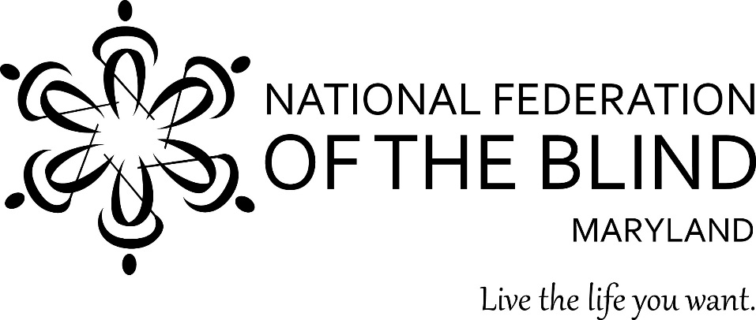

To: Members of the Maryland General Assembly
From: Members of the National Federation of the Blind of Maryland
Contact: Sharon Maneki, President
National Federation of the Blind of Maryland
9013 Nelson Way
Columbia, MD 21045
Phone: 410-715-9596
Email: nfbmd@earthlink.net

Subject: Strengthening Nonvisual Access Procurement Requirements
Date: January 19, 2017

THE PROBLEM
Maryland has excellent laws that require state government agencies to make information and communication technology (ICT) and technology services, such as websites, accessible to the blind. Unfortunately, these laws are poorly enforced and sometimes ignored all together. Consequently, blind citizens are denied access to information that is available to the rest of the public. Blind employees are often ineffective at their jobs because they do not have nonvisually accessible tools to do their work.

PROPOSED ACTION
In 1998 and 2000, legislation was enacted that incorporated nonvisual access requirements into the procurement process. The Maryland General Assembly should now strengthen these laws by assigning responsibility for their enforcement to an Access Technology Officer; by establishing penalties for noncompliance by vendors; and by updating the 2000 law to reflect changes in current technology.

BACKGROUND
Blind people can use special screen reading devices that enable them to read data and fill out forms by using synthetic speech or Braille output devices. These screen reading devices will work only if the websites, document formats, or other hardware and software are designed to accommodate nonvisual access. The methods for nonvisual access are well known and well documented. The first publicly available accessibility guidelines were published in 1995 and have been updated periodically. Yet, the problem of nonvisual access remains unresolved.
The executive branch of Maryland state government continues to discriminate against blind citizens by denying us access to public information and services. This discrimination persists even though there are specific state and federal laws requiring access for all citizens. These laws have been in effect for decades.
When the state of Maryland solicits bids from vendors, it requires the products in question to include nonvisual access. The concept used in state and federal laws of placing nonvisual access requirements in the procurement process is a good one. It is cost effective for the vendor to incorporate nonvisual access during the design phase of the product rather than having to go back later and redesign the product. Why does this problem remain?
- Maryland state government lacks a centralized authority to determine whether products really meet nonvisual access requirements.

Frequently, vendors just have to check the box on a proposed contract stating that its product is accessible. The state agency or department purchasing the product assumes that the vendor is correct, but has no way of checking the validity of the vendor’s claim. The procurement law should be strengthened by establishing a Chief Access Technology Officer (CATO) with the authority to review and evaluate all products before they are purchased. It is crucial that the CATO has sufficient authority and resources, because frequently the state of Maryland has ignored advice from the Department of Disabilities or other advisors attesting to the nonaccessiblity of a particular proposed product for purchase.

- The present procurement law includes no consequences for vendor’s failure to provide nonvisual access.

Currently, vendors have no incentive to comply with procurement accessibility requirements. Strengthening the procurement law by providing for vendor penalties will demonstrate the importance of the requirement to the vendor. Reasonable penalties, such as the following, will not have a detrimental impact on the vendor but will achieve the goal of nonvisual access.

- Requiring that all state contracts with vendors shall include a provision that, upon a determination within eighteen months from procurement or latest upgrade, if any access barriers are present, the CATO shall notify the vendor of such access barriers, and the vendor shall be required to remediate those barriers.
- Requiring the CATO to notify the vendor of the access barrier in writing at the vendor’s place of business and require the vendor, at the vendor's own expense, to remedy the defect. Should the vendor fail to remediate the access barrier within twelve months from the date of notice, a civil penalty shall be applied at the rate of 1% of the total purchase price of the contract for each day until the problem is remediated, or until the full price of the contract is refunded.
Vendors should not object because they have a year to fix the problem before any penalty is invoked. Placing a cap on the penalty which is the price of the contract, is fair to the vendor while helping the state to recoup its losses.

- The procurement law needs to be updated to accommodate technology changes.

Technology has improved and changed dramatically since the nonvisual access requirements in the procurement law was enacted in 2000. During these seventeen years, technologies have become more powerful and cheaper. For example, instead of buying a desktop system for thousands of dollars, customers can purchase an iPad Pro for $600. Currently, the procurement law allows a vendor to ask for an exemption to the nonvisual access requirement if adding the accessibility features would cost an additional 5%. Since it is cheaper to produce technology, the cost this exemption is too low. Raising the exemption to 15% would be a more reasonable reflection of the actual accessibility cost, and it is still fair to the vendor. Raising the exemption to 15% will close the flood gates that currently permit vendors to opt out of accessibility requirements.

The state of Maryland adopted the federal government’s section 508 nonvisual accessibility standards as its standards of operation. Since the federal government has recently updated these standards, the state of Maryland should adopt the same updates by January 1, 2018. This is a reasonable timeline because the standards already exist.
CONCLUSION
Nonvisual access to public information provided by the state of Maryland should be improving because the knowledge and tools now exist to provide greater access. According to state and federal laws, Maryland is not supposed to purchase information and communication technology products or services that are not accessible to the blind. Blind citizens do not currently have the same access to information as the rest of the general public, because Maryland does not enforce its laws. Maryland should be a model employer of persons with disabilities. However, Maryland ignores the accessibility laws and blind workers do not have the tools to perform their jobs efficiently. It is time to strengthen the procurement law so that nonvisual access becomes a reality.

To: Members of the Maryland General Assembly

From: Members of the National Federation of the Blind of Maryland

Contact: Sharon Maneki, President
National Federation of the Blind of Maryland
9013 Nelson Way
Columbia, MD 21045
Phone: 410-715-9596
Email: nfbmd@earthlink.net

Subject: Appropriation for the Center of Excellence in Nonvisual Access (CENA) to Education, Public Information, and Commerce
Date: January 19, 2017

PROPOSED ACTION

The Maryland General Assembly should keep the $250,000 appropriation in the Governor’s Budget for the CENA to Education, Public Information, and Commerce.

BACKGROUND

In 2014, the National Federation of the Blind (NFB) founded the NFB CENA. The CENA is a center of expertise, best practices, and resources that enables business, government, as well as educational institutions to more effectively provide accessible information and services to blind citizens. The State of Maryland, through the Maryland Department of Disabilities (MDOD), has an ongoing partnership with the CENA to support a series of projects collectively referred to as the Nonvisual Accessibility Initiative (NVAI) with an aim to establish Maryland as a leader in nonvisual accessibility.

PROPOSED PROJECTS FOR FISCAL YEAR 2017-2018

Accessible Academic E-Book Program
The HathiTrust is a consortium of institutions offering a collection of more than 10 million titles digitized from around the world, including textbooks. The NFB is working with the HathiTrust to make these books available to all blind and print-disabled persons, regardless of institutional affiliation. The project is a unique opportunity to create a nationwide accessible library for people with disabilities to obtain the materials they need, with the immediacy that they need it.

Accessibility Boutiques and Training Seminars
The CENA, with financial support from the NVAI, has produced a number of informal accessibility-specific boutiques and training seminars. The boutiques offered by the CENA have been hosted at the NFB Jernigan Institute, are several hours long, and are open to the public at no cost to Maryland citizens. Additionally, the NFB has produced several larger training seminars with support from MDOD and the NVAI grant. Training seminars are more intensive and take place over an entire day or several days. In 2017-18, the CENA will produce additional boutiques and training seminars, and will reach more participants in areas across the state.

Accessibility Switchboard
The Accessibility Switchboard is an online accessibility portal that will provide up-to-date information to consumers about accessible websites, emerging technology, as well as frequently encountered accessibility problems and solutions. It will be a point of contact for consumers who wish to voice concerns about barriers to nonvisual access, so that the CENA can evaluate and address these concerns. Moreover, it will provide information specific to government, corporate, and educational institutions on effectively building websites that comply with web standards, and information on the procurement of accessible technologies.

WayFinding Technology
Emerging nonvisual access navigation, or wayfinding technology, offers orientation and information solutions to a variety of public and commercial venues, including public transportation information. As Maryland reinvests in its public transport system through the Baltimore Link initiative, and upgrades its public spaces to incorporate new technologies, the time is right to ensure nonvisual access and provide additional access opportunities to its diverse populace by implementing the use of nonvisual wayfinding technologies to assist and provide greater access for citizens with disabilities and nondisabled citizens as well.

CONCLUSION
Access to information remains one of the greatest barriers faced by blind persons. To reduce these barriers the National Federation of the Blind established the CENA to provide information about best practices and to develop innovative techniques for achieving nonvisual access. The Maryland General Assembly should allow this state-of-the-art program to continue by approving the $250,000 appropriation in the Governor’s Budget under the Maryland Department of Disabilities.

To: Members of the Maryland General Assembly
From: Members of the National Federation of the Blind of Maryland
Contact: Sharon Maneki, President
National Federation of the Blind of Maryland
9013 Nelson Way
Columbia, MD 21045
Phone: 410-715-9596
Email: nfbmd@earthlink.net

Subject: Moving the Maryland State Library for the Blind and Physically Handicapped (LBPH) out of the Maryland State Department of Education
Date: January 19, 2017

THE PROBLEM
LBPH is part of the Division of Library Development and Services (DLDS), which is organized within the Maryland State Department of Education (MSDE). As a part of MSDE, LBPH cannot operate properly because it occupies an insignificant position within this large bureaucracy. Because of the low priorities that MSDE assigns to LBPH, LBPH is unable to support blind children in their development of literacy skills. LBPH is unable to properly serve blind adults in their need to obtain information about careers and other aspects of community life. Furthermore, LBPH is unable to adequately lend a helping hand to blind seniors who are losing vision and they have few opportunities to continue their life-long habits of reading.
PROPOSED ACTION
The Maryland General Assembly should enact legislation to create a new entity in the executive branch of state government, the Maryland State Library, which will be responsible for LBPH and other functions currently performed by DLDS.

BACKGROUND
LBPH, located at 415 Park Avenue in downtown Baltimore, serves patrons across the state of Maryland who are “legally blind and cannot see well or focus long enough to read standard print; who are physically disabled in that they have difficultly handling a book or turning pages; or who are reading disabled due to an organic dysfunction such as dyslexia.” Approximately 68% of the library’s patrons are senior citizens; 20% are between the ages of 21 and 60; and 12% are students. These patrons depend on LBPH because other public libraries lack the materials and expertise to serve this group of citizens.

LBPH is part of the network of state libraries operated by the National Library Service for the Blind and Physically Handicapped (NLS), Library of Congress. As a network library, LBPH distributes books and magazines in Braille and audio formats to patrons in Maryland. Because of this federal-state partnership, LBPH does not pay for Braille books or magazines. However, NLS provides LBPH with only one copy of each audio book it produces. As a network member, LBPH must then duplicate additional copies at its own expense to distribute to patrons. LBPH and the state of Maryland is responsible for maintaining its building, paying its staff, and providing for other operational needs such as computers, phones, and office equipment. The state of Maryland has never adequately fulfilled its role in this federal-state partnership.

In 2016, the Maryland Advisory Council on Libraries issued recommendations to transition DLDS to an independent state agency in the executive branch of Maryland state government. According to these recommendations, DLDS would become the Maryland State Library. The Maryland State Library is to be governed by the Maryland State Library Board. If the Maryland General Assembly follows these recommendations and creates this new state agency, the Maryland State Library will be responsible for the operation of LBPH. The entire library community supports this change in structure.

LBPH has been administratively part of the DLDS in MSDE for the forty-eight years of its existence. Throughout its history, LBPH has suffered under this administrative structure because it has never been able to manage its own resources. For the first twenty years, LBPH was housed in a substandard rented building that had a leaky roof and heating problems. These conditions damaged books and other materials. This situation was only remedied because of the advocacy efforts of the National Federation of the Blind of Maryland, not because of leadership from MSDE. LBPH moved to its own facility and current location in 1992. While having its own facility helped matters, problems with poor library services continued because of the administrative structure.

The Association of Specialized and Cooperative Library Agencies, which is part of the American Library Association, has established national standards for all network libraries in the Library of Congress Books for the Blind program. These standards outline such items as the number of staff these libraries should have based on the target population, the type of staff these libraries should hire, the hours of operation, etc. LBPH has never been able to meet the national library standards created for this type of library. LBPH experienced years of underfunding and staff shortages because MSDE was more interested in funding its other programs. LBPH did not even have its own line item in the DLDS budget until the Maryland General Assembly took action in 2014.

Unfortunately, having its own line item in the budget since fiscal year 2016 has not led to the expected improvement in services provided by LBPH. Bureaucratic delays within MSDE have caused delays in hiring needed staff, as well as delays in procuring essential equipment such as a new nonvisually accessible telephone system. MSDE officials frequently require redundant justifications and repeatedly demand answers to irrelevant questions. Locating LBPH in a structure with fewer layers of bureaucracy will enable it to use its funding with greater dispatch in order to improve services for the blind and physically handicapped citizens that it serves.

ADVANTAGES OF THE PROPOSED LEGISLATION

- Creating the Maryland State Library will lead to greater efficiency.
LBPH has a history of missed opportunities. Because of inadequate funding, LBPH has limited access to state of the art computers and software to fulfill its mission. The most glaring example of missed opportunity is the failure to adequately support the Accessible Textbook Coordination program for students and faculty in higher education. In 2007, the Maryland General Assembly requested that LBPH serve as the coordinator for the distribution of accessible textbooks so that blind and other reading disabled students in college can obtain textbooks on time and in a format they can use. This approach would not only benefit individual students, but also would eliminate duplication of effort by individual colleges throughout the state. Such efficiencies have never been realized because the State of Maryland has never adequately funded this program through LBPH. Once again, MSDE failed to provide needed leadership.

- Reorganizing LBPH into the Maryland State Library will not require significant additional funding.
Experience demonstrates that reorganization does not require significant additional funding, but does bring about a better quality of service to constituents. For example, on the federal level state libraries were housed in the Office of Library Programs in the U.S. Department of Education. During the 1990’s, libraries were moved out of the U.S. Department of Education and became part of the Institute of Museums and Libraries. In a study entitled Moving to Independence: A Case History of the Institute of Museums and Libraries (IMLS), the author, Dr. Trudi Hahn, Teaching Professor and Director of Academic Outreach at the iSchool, College of Information Science and Technology, Drexel University, states that:

“since separating from USDE and aligning with IMLS, the nation’s libraries have made tremendous progress both programmatically and financially. In real dollars, their budget has not expanded a great deal, but they have much greater control over their budget, a greater opportunity to educate elected officials, the ability to work with professional associations, greater visibility for themselves and for the library and museum community.”

The libraries in Maryland in general, and LBPH in particular, will benefit from reorganization just as the state libraries in IMLS did. The State of Maryland should continue to fund LBPH, according to the funding formula that the General Assembly established in 2014.

- Providing a new structure will enable LBPH to become a 21st-century library.
Due to advances in technology, libraries are becoming more dependent on computer hardware and software. This is equally true for specialized libraries such as LBPH. Having a streamlined structure will enable LBPH to purchase specialized duplication equipment to make copies of digital audio books. LBPH will also be able to hire a staff that has greater technical abilities. LBPH must have the flexibility to take advantage of new technologies to advance its service delivery system.

Every segment of LBPH’s customer base will continue to grow in the 21st century. Each year approximately 75,000 Americans become blind. Due to the war on terrorism and the wars in Iraq and Afghanistan, there has been and will continue to be an increase in the number of veterans who are blind and have other reading disabilities. Since people are living longer, more seniors are facing the loss of vision due to macular degeneration and other diseases. LBPH must also serve a diverse population of working-aged adults. Diabetes is the leading cause of blindness in adults. More and more Americans join the ranks of people with diabetes each year. Advances in medical technology have made the survival of more disabled children possible, which is another reason for expansion in the number of LBPH patrons. In order to plan for this patron expansion, LBPH must have a stable source of funding. LBPH also needs sufficient staff to conduct outreach programs to find the people who need its services. Creating a new state library structure is the only way to ensure that LBPH truly becomes a 21st-century library.

CONCLUSION

Blind and physically-handicapped patrons receive woefully inadequate services from LBPH. Since its establishment, LBPH has been plagued with inadequate funding and staff shortages. MSDE bureaucracy threatens the existence and stifles the growth of LBPH. The State of Maryland should not continue to deprive LBPH patrons of essential library services. It is time to loosen the stranglehold that MSDE exerts on Maryland’s Libraries by creating the Maryland State Library.

