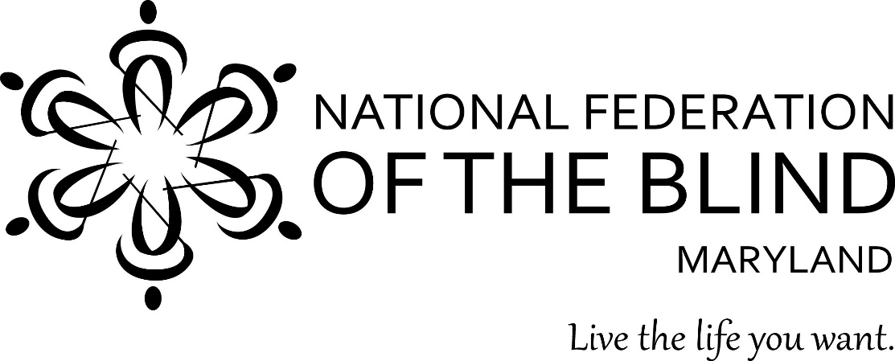

Wine Tasting
a benefit evening for
Greater Baltimore Chapter,
National Federation of the Blind

Saturday, October 13, 5:00-7:00

Spirits of Mt. Vernon
900 North Charles St.

Enter to win a raffle for a $200 gift certificate to Spirits of Mt. Vernon! The Greater Baltimore Chapter of NFB invites you to join us for an evening of fine wine and good company.

