Bernard F. Turner, III
Live the Life You Want Award Application
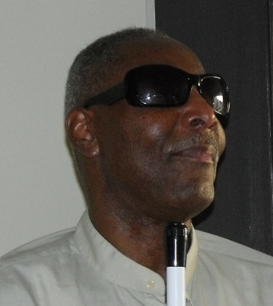
Bernard F. Turner Award Team
PO Box 54176
Washington, DC 20032-4176

Bernard F. Turner lost his sight at age 40. He learned the skills of blindness and went on to live the life he wanted. He went back to work and retired as an Instructional Technology Supervisor from the Arnold & Porter Law Firm.
Last Name______________________________ First Name____________________ MI_____
Address_______________________________________________________ Zip Code________
Date of Birth ________________________ Home phone #_______________________
Cell phone #___________________________
On a separate page write a brief essay, not longer than two or three paragraphs explaining how this award will help you to live the life you want and achieve greater independence. Be sure to include when you lost your sight, how you handle blindness, and how you will use the award.
Attach copy(s) of documents supporting the need for award funds (bill for technology, tuition, etc.) to this application. If you don’t have an actual bill, send a description and price.

Applicant’s Signature ___________________________________________________________

Eligibility & Guidelines
- This award is open to blind people who lost their sight between the ages of 18-60.

- Applicants must demonstrate the need for the award through a brief narrative and supporting documentation.

- One application per person.

- The National Federation of the Blind of Maryland (NFBMD) will advertise and encourage people to apply for this award. The winner is expected to attend the annual NFBMD convention, November 6-8, which will be virtual. The final decision on the winner will be made by the Turner family.

- Applications will be accepted from September 13, 2020 through October 16, 2020.

- The winner will be notified by October 31. The $200 award will be presented November 7 at the NFBMD convention banquet.

- When you submit your application, please send a separate note to Sharon Maneki, nfbmdsm@gmail.com including proof that you have preregistered for the State Convention. Please note her new email address. You may either mail your application to the address provided or send it electronically to nfbmdsm@gmail.com and we will make sure that the Turner family receives it.

